Epsom & Ewell F.C.
28
v
Ashford Town (Mx)
Saturday, 30th April 2016 – 3.00 p.m.
Good afternoon! We welcome the players, supporters and officials of Ashford Town (Middlesex) for our final home League match of the season, together with today’s match officials and our own regular supporters.

We have already met our opponents twice this season. In October, we won there 3-2 in the League but in January subsided rather meekly by three clear goals in the League Cup here at High Road.

Our last appearance here was an extremely unfortunate one, losing 3-2 to Camberley Town in a match of huge importance. Of course the score line doesn’t tell the story as anyone who was there will explain that we were well in charge at 2-0 up with just eight minutes remaining, only to concede three times in five minutes to lose the points and end our season. Then last Saturday we visited Hanworth Villa where we bounced back well with a 3-2 win which probably should have been larger. We led 3-0 before switching off in the final twenty minutes and conceding twice but it never should have been that close. The main highlight was Kyle Hough’s 200th goal for the club and more follows on this later in the programme.

The result against Camberley was obviously harsh, but over the course of the season these things even out and it must be remembered that we have pinched a few matches that we probably didn’t deserve either. My seasonal summary is included later on to remind you of the lows, but mainly the highs that this season has brought us. Let’s see if we can record another good memory today.

Today is your last chance to fill in a Player of the Year form. Remember, if you are a Club Member, your vote counts double!

Finally, our season concludes on Monday morning when we visit Chessington & Hook United with an 11.30 kick off. Please note that recent matches have been switched to other venues, so please keep checking with our website, especially if we have a wet weekend!

Following that at 3pm we will be having our end of season Presentation. Please note that this will be at The Famous Green Man pub in Ewell Village and not at our recent regular meeting venue, the Epsom Common Working Mens Club. If you want to come along, tickets cost £5 and include food and are available TODAY from Steve Dyke!

All that remains to be said is that we hope you have a great summer break and don’t get too depressed when England go out of the Euros at the first stage! Joking aside, I think we might actually surprise a few people this time. Interestingly, our own club will also be travelling to France this summer and more details follow later on in this issue.

Enjoy the game!

Rich

Please follow us on Facebook: www.facebook.com/epsomandewellfc Twitter: @EEFCOfficial
and on Instagram at: www.instagram.com/epsomandewellfc

Cover Photos by Gemma Jarman

- Kyle Hough scores his 200th goal for our club at Hanworth Villa on Saturday
- Dan Dean, Kyle Hough and James Taylor celebrate the moment

Cherry Red Records Combined Counties League
Premier Division Table 2015/16
inc Tuesday 26th April | P | W | D | L | F | A | Pts | GD | H | A
Hartley Wintney (C) | 40 | 32 | 4 | 4 | 121 | 36 | 100 | +85 | 0-1 | 3-3
Ashford Town (Mx) | 41 | 30 | 3 | 8 | 111 | 51 | 93 | +60 | - | 3-2
Camberley Town | 40 | 28 | 7 | 5 | 92 | 36 | 91 | +56 | 2-3 | 1-1
Epsom & Ewell | 40 | 25 | 8 | 7 | 98 | 44 | 83 | +54 | x | x
Knaphill | 40 | 23 | 4 | 13 | 100 | 60 | 73 | +40 | 1-2 | 1-1
Horley Town | 40 | 20 | 9 | 11 | 91 | 57 | 69 | +34 | 3-4 | 2-2
Hanworth Villa | 42 | 21 | 4 | 17 | 76 | 71 | 67 | +5 | 5-0 | 3-2
Colliers Wood United | 42 | 17 | 8 | 17 | 78 | 80 | 59 | -2 | 3-1 | 3-0
Spelthorne Sports | 41 | 15 | 10 | 16 | 75 | 81 | 55 | -6 | 2-1 | 6-2
Windsor | 41 | 15 | 9 | 17 | 69 | 77 | 54 | -8 | 2-2 | 1-2
Guildford City | 42 | 16 | 6 | 20 | 77 | 95 | 54 | -18 | 4-0 | 5-1
Farnham Town | 39 | 15 | 8 | 16 | 70 | 64 | 53 | +6 | 1-0 | 2-1
Westfield | 39 | 14 | 11 | 14 | 55 | 63 | 53 | -8 | 0-2 | 0-0
Bedfont Sports | 40 | 14 | 9 | 17 | 65 | 56 | 51 | +9 | 1-0 | 2-2
Raynes Park Vale | 41 | 16 | 3 | 22 | 70 | 95 | 51 | -25 | 3-1 | 3-0
AFC Hayes | 42 | 14 | 7 | 21 | 63 | 86 | 49 | -23 | 1-1 | 7-0
Chertsey Town | 41 | 13 | 7 | 21 | 57 | 77 | 46 | -20 | 0-1 | 5-3
Sutton Common Rovers | 41 | 13 | 6 | 22 | 66 | 83 | 45 | -17 | 3-1 | 2-1
Badshot Lea | 41 | 14 | 3 | 24 | 61 | 104 | 45 | -43 | 4-1 | 1-0
Redhill (R) | 41 | 11 | 6 | 24 | 64 | 86 | 39 | -22 | 3-0 | 1-0
Chessington & Hook (R) | 39 | 8 | 6 | 25 | 53 | 102 | 30 | -49 | 1-0 | 2/5
Cove (R) | 41 | 3 | 2 | 36 | 30 | 138 | 11 | -108 | 1-0 | 7-0

Lucky Day? - 30th April
Played 22 - W 9 D 9 L 4 - F 48 A 29 - PPG 1.64 - Above Average
Our Club record against Ashford Town (Mx)
Played 17 - W 4 D 2 L 11 - F 22 A 44 - PPG 0.82 - Awful
Largest wins and losses against Ashford Town (Mx)
26th October 2002 - W 3-0 - Isthmian League Division One South (H)
23rd November 2003 - L 0-5 - Isthmian League Division One South (H)
Their Last Visit
Tuesday 12th January 2016 - L 0-3 - Combined Counties League Cup Third Round

Club Manager – Glyn Mandeville
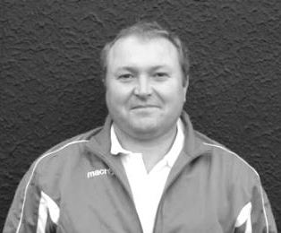
Good afternoon and welcome to all the players, staff and supporters of Ashford Town (Mx).

I hope you enjoy the game, in what has been a great campaign for both clubs. Although we can't go up we have had a good year, playing some great football and having some really good memories along the way.

Highlights for me have been the fantastic team spirit between the lads and getting to meet a few new faces along the way; you can never have enough good people around.

The worst has to be the standard of the officials, which I feel has cost us somewhat. Those of you that watch us every week will agree that we are not a dirty side but have found that our disciplinary record has been really poor this season.

I can understand if we went around kicking players and shouting our mouths off but we don't. It's been hard to take at times and believe this has cost us in some of our games, but hey, we move on.

We had a memorable moment last weekend. The lads played very well for 70 minutes and all helped Kyle Hough score a very good goal to get his 200th for the club. Well done mate, not an easy task. I would like to think the lads will stay together as I feel next year could be really good and it would be great to build on things from this season.

I would like to thank the players and especially Matt Smith a.k.a. Smudge for all your help. Also, big thanks to Mr McKay, Jimmy and Steve. With your help it has made the season very enjoyable for me. Also, a big thank you to the committee for all your help and support, and thanks to the supporters.

Enjoy the game and have a safe trip home. I’ll see you next season.

Manders

Some Club Achievements in 2015/16
We have set a new club record for the number of goals scored in away matches this season, currently sitting on 58 and with a trip to Chessington & Hook United remaining.

If we were to win at Chessington it would also break a record for the most points gained away from home in a season with 48 out of a possible 63. This is now the fourth season in a row with at least eleven away wins, which we have never done before.

Additionally, if we were to score five goals it would break another club record and would be the sixth time we had done it in the league this year.

If we were to secure two more points in our remaining matches, we would set a further club record for the most amount of points ever attained in a season, breaking the mark of 84 set in 1980/81; a season where we also failed to gain promotion!

Those who know this club will be well aware that we have had some incredible seasons in our history, so to break scoring records in particular are very rare occurrences indeed. Well done chaps!

Club Chairman – Pete Beddoe
Good afternoon to all of you and welcome to High Road for today’s final home match with Ashford Town (Mx).

What a season we’ve all experienced with high and lows both on and off the pitch. We lost every Cup match bar one, and that was a close call against Banstead in the League Cup. which we just won 7-6 on penalties after a 1-1 draw after 120 minutes.

But in the League it has been a different matter, being top four or thereabouts all season. Some notable performances have been a 3-2 win away at Ashford Town, a 5-1 win away at Guildford City where we had no regular goalkeeper available, and just recently a 7-0 win away midweek at AFC Hayes on a very heavy pitch. Those there would agree it was one of our best performances for a long time.

At the end of March we were given the opportunity of promotion because Hartley Wintney, the runaway leaders of the league were denied because of failing their ground grading inspection for the higher level. From that point, we won all of our matches until the one against one of our promotion rivals, Camberley Town. Despite the result we should be very proud of our team playing under very difficult circumstances. We shouldn’t judge them on the last 10 minutes of that game, but on their performance in the rest of that match and throughout the rest of the league campaign. They have been a credit to the Club, demonstrating excellent team work on the pitch, enthusiastic team spirit off the pitch. And by “off the pitch” also means at training where there was always a good attendance.

Last Saturday we put the disappointment of the Camberley match behind us and came back with a bang, continuing on our winning way. During this match it was a personal privilege to see Kyle Hough score his 200th goal for the Club – Congratulations and well done mate.

There is still a lot to play for in the last two matches against Ashford Town (Mx) today and Chessington and Hook United away on Monday and hopefully we can build on our success this term by performing even better next season.

That we have done so well on the pitch is due, to a great measure, to the experience, skill, and just good common sense of our Manager, Glyn Mandeville (“Manders”), and his football management team of Matt Smith (“Smudger”), Steve Eacott, Alex McKay (“Mr McKay”) and last but not least, our physio Jimmy Hendry who has performed miracles to get players fit. Personally I’d like to thank ‘Manders” for all his help on the administrative side of the Club.

Off the pitch there have been disciplinary issues which have taken an inordinate amount of our time and in this respect we all need to thank Steve Dyke for his impressive persuasive skills in communications & hearings at the SCFA, the FA and CCL to ensure any penalty was minimised. Without Steve’s efforts on behalf of the Club the season would have been a disaster. He, along with the rest of the Committee, never wavered in his belief that the Club would be successful at these hearings. I will not forget his reaction in driving through Ewell village when we learnt we had been successful in one of our appeals. I will leave it to Steve to give you the details!

As you know we now operate as a Committee where there is corporate responsibility for the Club’s administration. On behalf of the supporters, players and the football management team, grateful thanks are expressed for the members of the Committee. Steve Dyke has continued to maintain the financial viability of the Club, budgeting accordingly; Richard Lambert has expanded his role as Media Officer very resourcefully and is producing such an

excellent match programme and continuously updating the Club website under very difficult circumstances; Paul Marshall for all his excellent work with the kit both before and after the matches and of course assisting me in finding the venue for our away matches in deepest Middlesex; Mike Lovett for liaising so effectively with the Colts and his invaluable work on the relocating the Club back to the Borough (more later); and Mel Tough who deals with the club membership and issues arising from our FA Charter Standard.

Grateful thanks are also extended to those who have helped on match days, including George Holland on the PA and Nigel Pond who is also always prepared to give advice on traffic issues relating to our relocation; also Gemma Jarman our photographer, for her tireless work both home and way. She carries out her duties unobtrusively in a very professional manner.

We thank our landlords, Chipstead FC, for all their help on match days and in administrative matters. They are too numerous to mention but a special word has to be extended to Karen and her loyal band of helpers in the Tea Bar and for providing excellent refreshments and hospitality, Vic the groundsman for all his help in preparing the pitch and letting us know of any problems with it, Simon behind the bar on match days for all his help, and of course Heather, Terry & Geoff.

We also thank all the Officers of the Combined Counties League for their help, support and kind consideration throughout the season, while we must also thank our loyal band of supporters. Without you we cannot survive. Please continue to come along next season and encourage others to come as well.

Last but not least, the Limited Company should also be thanked for providing the funds to enable us to play at Chipstead F.C. and for being partners in our quest for relocation.

On the subject of the relocation of the Club back to the Borough, we have made steady progress throughout the year. I really do believe that this is the year when we can go public and announce something. We are in the process of discussing terms of use with the owners of our preferred site in the Borough, having satisfied ourselves that the access is viable and in obtaining revised figures on the expenditure of building the new facility.

Not long after next Monday‘s match against Chessington & Hook there will be a Presentation Afternoon / Evening at the Green Man to celebrate our season starting at 3pm. Please come along and relax in the company of the players and share their experiences of such a successful season. The details are elsewhere in the programme and I do urge everyone to support this.

After a well-earned rest the players are off to play a match in the middle of June in Chantilly. The England team are based there for Euro 2016 so you never know, we may meet up! The Borough of Epsom & Ewell are twinned with the town of Chantilly so it is incumbent upon us to make a good impression on and off the pitch. It will only help us in obtaining their support both morally and in our planning application for the new ground.

I think that’s all. It suffices to wish everyone an enjoyable break before pre-season starts at the beginning of July. This will of course include our tenth annual match in memory of our late lamented Secretary, Dave Wilson. For all the necessary information please keep visiting our Club website.

Up the Salts, Blues & E’s.

Pete

Club Captain - Sam Currie
Good Afternoon and welcome to High Road for today’s game against High flying Ashford.

We know this is a “Biggy” for them, but having fallen just short of second place ourselves, the boys will be looking to impress in the last home game of the season and still have a chance of affecting the second and third placed league order. Obviously this is extra important this season with the newly crowned champions Hartley Wintney unable to go up due to their ground grading failure - making this second place spot more relevant.

As I reflect on 2015/16 it has been a successful season for the squad challenging at the very top of the table, right up until our game here against Camberley two weeks back. Even now that game is indescribable with the events of that afternoon, having been two nil up in full control before losing 3-2 in the final ten minutes – but realistically it’s these types of games and strange results over the season which has seen us fall just short.

The home form has been indifferent, although the away form has been a lot better only losing once away in the League to Windsor which again was an off day, and goes to show you can’t afford to have these at this level.

The cup form was probably the most disappointing part of the season with only the League Cup offering any progress. The main FA competitions undoubtedly saw us given tough draws, but “in-house” we believe we didn’t give ourselves a good enough chance as we were not fully at the races on either occasion against Erith and Horsham.

However, we can be pleased and proud of what we have achieved this season and I strongly believe that on our day we have a squad capable of winning any game, while the spirit and quality of the lads within the squad means that the majority of time we have done this in the right manner and with a smile on our faces, enjoying our football.

So hopefully with these two games left we can finish off the season in the right manner before enjoying the summer break - regrouping and coming back stronger and more determined for next season.

All that is left for me to say is to thank the people that make the club tick and commit so much time to the Epsom and Ewell cause – including obviously the Gaffa, Smudge, Steve, Mrs Jarman (who somehow makes the boys look half decent in her photos throughout the season), The Chairman and Steve Dyke, all the Board and Kit Man Paul Marshall who tirelessly work behind the scenes.

Rich Lambert who provides some of the most amazing stats associated with the club along with the media side of things - match reports/website/twitter - and the programmes, including this whopper – which I think you would agree would not look out of place higher up the football pyramid and certainly is suited for a promotion or two!

And not forgetting Jimmy our physio who has been a god send this year, looking after the lads helping with all needs and requirements and in particular me and Ferds ;-)!

The final thank you goes to all of you for your continued support, which is always valued and we look forward seeing you at our final game on Monday against Chessington and Hook United. If you are free to come to the presentation afternoon following the game - there are still tickets available - it would be good to celebrate the end of another season with you all.

Have a safe journey home following the game today.

Sam

We came, We saw, We Conga’d!! – Steve Dyke
Saturday 2nd April was a big day for me and my colleagues at the club’s charity partners Mid Surrey Mencap .

Our visit to Guildford City was also to be the day of our attempt at breaking the record for the World’s longest distance conga. When we registered with the Guinness Book of World records our target to beat was 5.4 km, or 14 laps of the Spectrum Athletics track.

Unfortunately on the morning of Friday April 1st I found out that someone else had recently made a successful attempt at this very attainable record, increasing our target to 11.2 km, or 29 laps – and it wasn’t an April Fool, putting the record beyond the level of training I and my intrepid crew could manage.

With one participant in a wheelchair, one pushing, one just back from knee surgery and three more on their first outing since a bout of severe flu, we managed 10 laps, 4.0km and have raised about £1,000 in sponsorship so far.

Whilst we didn’t get a World record it was a good day out for everyone. We appeared on three radio stations and raised awareness of our charity works with local adults and children with learning disabilities, and has gone some way to pay for this year’s children’s play scheme.

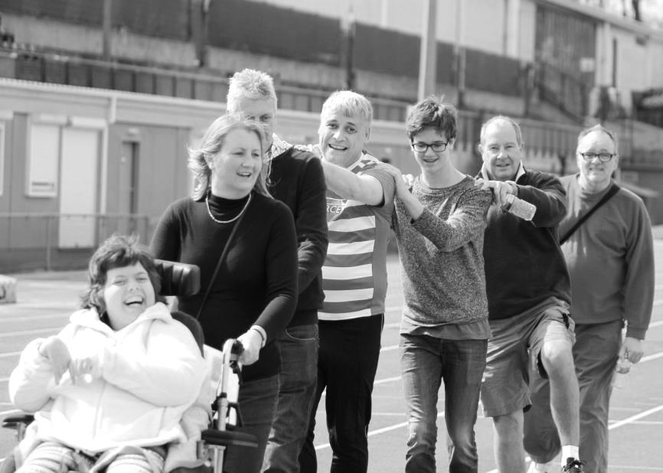
I would like to offer my thanks to all who generously donated on the day, George Holland and also Ciara Lawrence of national Mencap who helped set up some of the media and also Guildford City F.C. who were a great practical help on the day.

This just goes to show how local non-league clubs can be at the heart of their communities and all in all it was a very good event.

I would have liked to beat the old record by myself, but our super fit Manager and Assistant helped with a racing lap and that just about finished me off!!

Latest Results, and Remaining Fixtures This Season
Combined Counties League – Thursday 14th April
Chessington & Hook United | 1-8 | Horley Town
Played at Horley Town FC
Farnham Town | 1-2 | Westfield
Combined Counties League – Saturday 16th April
Chertsey Town | 1-0 | Hartley Wintney
Epsom & Ewell | 2-3 | Camberley Town
Guildford City | 3-2 | Chessington & Hook United
Horley Town | 1-1 | Farnham Town
Raynes Park Vale | 1-2 | Hanworth Villa
Spelthorne Sports | 0-2 | Redhill
Windsor | 1-2 | Ashford Town (Mx)
Combined Counties League Cup SF – Tuesday 19th April
Farnham Town | 3-1 | Cobham
Combined Counties League – Tuesday 19th April
AFC Hayes | 4-3 | Badshot Lea
Chessington & Hook United | 2-2 | Sutton Common Rovers
Played at Sutton Common Rovers FC
Cove | 2-2 | Colliers Wood United
Raynes Park Vale | 1-7 | Camberley Town
Spelthorne Sports | 1-4 | Knaphill
Westfield | 2-2 | Redhill
Combined Counties League – Thursday 21st April
Badshot Lea | 1-5 | Knaphill
Chessington & Hook United | 0-0 | Westfield
Played at Westfield FC
Redhill | 0-4 | Ashford Town (Mx)
Combined Counties League – Saturday 23rd April
Ashford Town (Mx) | 2-0 | Sutton Common Rovers
Bedfont Sports | 1-3 | Horley Town
Chessington & Hook United | 0-3 | Windsor
Played at Windsor FC
Farnham Town | 1-0 | AFC Hayes
Guildford City | 1-2 | Camberley Town
Hanworth Villa | 2-3 | Epsom & Ewell
Hartley Wintney | 10-0 | Raynes Park Vale
Knaphill | 3-0 | Cove
Latest Results and Fixtures
Combined Counties League – Saturday 23rd April
Redhill | 3-1 | Chertsey Town
Westfield | 2-2 | Badshot Lea
Combined Counties League – Tuesday 26th April
AFC Hayes | 2-1 | Sutton Common Rovers
Chertsey Town | 0-5 | Ashford Town (Mx)
Chessington & Hook United | 0-0 | Camberley Town
Farnham Town | 2-3 | Knaphill
Redhill | 3-2 | Hanworth Villa
Westfield | 0-2 | Hartley Wintney
Combined Counties League – Thursday 28th April
Chessington & Hook United | V | Farnham Town
Westfield | V | Bedfont Sports
Combined Counties League – Saturday 30th April
Badshot Lea | V | Redhill
Chertsey Town | V | Knaphill
Cove | V | Bedfont Sports
Epsom & Ewell | V | Ashford Town (Mx)
Horley Town | V | Chessington & Hook United
Raynes Park Vale | V | Westfield
Spelthorne Sports | V | Hartley Wintney
Sutton Common Rovers | V | Camberley Town
Windsor | V | Farnham Town
Combined Counties League – Monday 2nd May
Chessington & Hook Utd | 11.30 am | Epsom & Ewell
Hartley Wintney | 1.00 pm | Camberley Town
Westfield | 11.30 am | Farnham Town
Combined Counties League – Tuesday 3rd May
Knaphill | V | Horley Town
Combined Counties League Cup Final – Saturday 7th May
3.00 pm k.o - Stag Meadow, Windsor F.C.
Camberley Town | V | Farnham Town
Friendly – Saturday 18th June
Stade des Bourgognes , Chantilly, France
U.S. Chantilly | V | Epsom & Ewell

US Chantilly v Epsom & Ewell
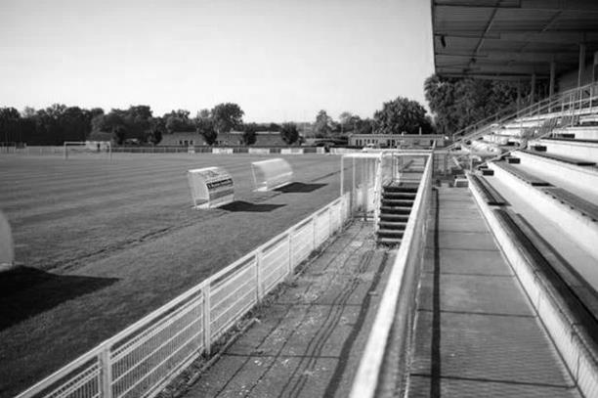
Our club has been invited to Chantilly in France during the Euros and we will play a match there, almost certainly on the Saturday 19th June against the local team, U.S. Chantilly. Because there are fewer teams in the French football pyramid than in ours, it is hard to work out an exact comparison between us and them, although they are currently in the Championnat de France Amateurs 2 Section which is split into eight regions across the country, so I would hazard a guess at a similarity with our own Step Four.

How did this happen? Well, England are going to be based in the town and the town of Epsom is twinned with Chantilly. The town is famous for its lace, but also for having a horse racing track and famous race the Prix du Jockey Club, which is one of their five classic flat races. You can see why we are twinned with them now!

So basically the Mayor of Chantilly originally proposed a tournament with four teams from across Europe, all of whom are also twinned. Logistical issues ruled that out, but they were keen to proceed with the match, and so were we! Founded in 1902 they play at the Stade des Bourgognes which is quite grand. (see picture below)

We’ll let you know how we got on in the new season. Or you could just look on our web site!

CCL Premier Division Club Directory
A.F.C. HAYES Telephone: 0208-845-0110 - Ground: Farm Park, Kingshill Avenue, Hayes, Middx. UB4 8DD - Colours: Blue and White Stripes/Blue/Blue

ASHFORD TOWN (Mx) Telephone: 01784-245908 - Ground: The Robert Parker Stadium, Short Lane, Stanwell, Middx. TW19 7BH - Colours: Tangerine & White Stripes/Black/Tangerine

BADSHOT LEA Telephone: 01252-320385 - Ground: Ash United FC, Shawfield Stadium, Youngs Drive, Shawfields Road, Ash, Hampshire. GU12 6RE - Colours: Claret/White/Claret

BEDFONT SPORTS Telephone: 0208-831-9067 - Ground: Bedfont Sports Club, Hatton Road, Bedfont, Middx TW14 8JA - Colours: Red & Black Hoops/Black/Red & Black Hoops

CAMBERLEY TOWN Telephone: 01276-65392 - Ground: Krooner Park, Wilton Road, Camberley, Surrey. GU15 2QW - Colours: Red & White Stripes/Blue/Red

CHERTSEY TOWN Telephone: 01932-561774 - Ground: Alwyns Lane, Chertsey, Surrey. KT16 9DW - Colours: Royal Blue & White Stripes/Royal Blue/Royal Blue

CHESSINGTON & HOOK UNITED Telephone: 01372-602263 - Ground: Chalky Lane, Chessington, Surrey. KT9 2NF - Colours: Blue/Blue/Blue

COLLIERS WOOD UNITED Telephone: 0208-942 8062 - Ground: Wibbandune Sports Ground, Robin Hood Way, Wimbledon. SW20 0AA - Colours: Blue & Black Stripes/Black/Black

COVE Telephone: 01252-543615 - Ground: Oak Farm Fields, 7 Squirrel Lane, Cove, Farnborough, Hampshire. GU14 8PB - Colours: Yellow/Black/Yellow

EPSOM & EWELL Telephone: 01737-553250 - Ground: Chipstead FC, High Road, Chipstead, Surrey. CR5 3SF - Colours: Royal Blue & White Hoops/Royal Blue/Royal Blue

FARNHAM TOWN Telephone: 01252-715305 Ground: Memorial Ground, Babbs Mead, West Street, Farnham, Surrey. GU9 7DY Colours: - Claret & Sky Blue /White/ Claret & Sky Blue

GUILDFORD CITY Telephone: 01483-443322 - Ground: The Spectrum, Parkway, Guildford, Surrey. GU1 1UP - Colours: Red & White Stripes/Black/Black

HANWORTH VILLA Telephone: 0208-831-9391 - Ground: Rectory Meadows, Park Road, off Hounslow Road, Hanworth, Middlesex. TW13 6PN - Colours: Red & White Stripes/Black/Black

HARTLEY WINTNEY Telephone: 01252-843586 - Ground: Memorial Playing Fields, Green Lane, Hartley Wintney, Hants RG27 8DL - Colours: Orange & Black/ Orange /Orange

HORLEY TOWN Telephone: 01293-822000 - Ground: The New Defence, Anderson Way, Court Lodge Road, Horley, Surrey. RH6 8SP - Colours: Claret & Sky Blue/Claret/Claret

KNAPHILL Telephone: 01483-475150 - Ground: Brookwood Country Park, Redding Way, Lower Guildford Road, Knaphill, Surrey. GU21 2AY - Colours: Red/Black/Red

SUTTON COMMON ROVERS Telephone: 01932-866386 - Ground: Sutton United FC, Gander Green Lane, Sutton, Surrey SM1 2EY - Colours: Yellow/Black/Black

RAYNES PARK VALE Telephone: 020-8540-8843 - Ground: Prince Georges Playing Field, Grand Drive, Raynes Park, London. SW20 9NB - Colours: Blue/Blue/Red

REDHILL Telephone: 01737-762129 - Ground: Kiln Brow, Three Arch Road, Redhill, Surrey RH1 5AG - Colours: Red and White Stripes/Black/Red

SPELTHORNE SPORTS Telephone: 01932-961055 - Ground: Spelthorne Sports Club, 296 Staines Road, Ashford Common, Ashford, Middx. TW15 1RY - Colours: Light & Dark Blue/Dark Blue/Light Blue

WESTFIELD Telephone: 01483-771106 - Ground: Woking Park, Kingfield Road, Woking, Surrey. GU22 9BA - Colours: Yellow/Black/Black

WINDSOR Telephone: 01753-860656 - Ground: Stag Meadow, St Leonards Road, Windsor, Berks SL4 3DR - Colours: Red/Red/Red

From behind the goal
Epsom & Ewell 2-3 Camberley Town
Combined Counties League - Premier Division - Saturday 16th April 2016

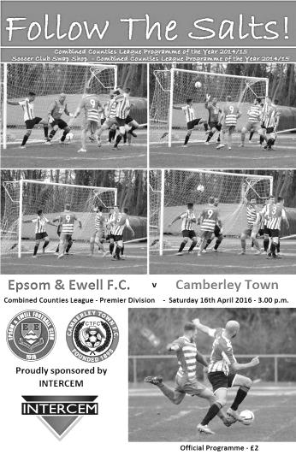
Late heartbreak for Salts after doing all the hard work

Football can be a cruel game at times and we certainly had to find this out the hard way as for the second time in a row Camberley Town pulled back a two goal deficit to steal the points away from us at High Road. Last time it was the Quarter-Final of the League Cup, a competition they went on to win last season, and now this league win might well enable them to achieve their next target, promotion to Step Four.

On a day with quite a number of talking points, many of which would have gone in our favour on another day, the facts remain that we did all the hard work, led 2-0 and were well in control, only to suddenly fold in the final eight minutes of normal time, conceding three goals to end our hopes of promotion this season.

Unsurprisingly we kept an unchanged eleven from our hugely impressive 7-0 win at AFC Hayes and it must be said, very little happened in the opening twenty minutes of the match, with much of the contest being played between the penalty areas. A Camberley header was glanced wide of the far post while Daryl Cooper-Smith hit a volley of a dipping ball but it didn't have enough on it to trouble Craig Bradshaw in the opposition goal and he saved it comfortably. Despite the lack of real action to that point we went ahead in the 26th minute. A clearance from a defender cannoned off the leg of Savvas 'Agi' Panayiotou and rebounded to Kyle Hough who went off to the left only to drill the ball low and back across Bradshaw into the far corner.

We then started to play with a bit more confidence before the first talking point of the afternoon occurred. Hough was running through towards goal and reached the ball just before Bradshaw who fouled him with an outstretched leg around a yard outside the penalty area. Most people's first thoughts were whether the visiting custodian was the last man back but there were defenders in the area, so even though Kyle may have had a yard on them, it is difficult to say for certain that he was clean through, as he had cut outside the keeper, which drew the foul but also gave them time to retreat. Was the challenge dangerous? This was a closer call and on another day he could certainly have seen a red card but the yellow was brandished and as is often the way with these things would go on to make some fine saves later in the match. Bentley Graham sent the resultant free kick just over the bar.

We continued to threaten with Cooper-Smith sending an audacious effort just wide from forty yards, although Michael Eacott was forced to take one for the team as he was fouled while collecting the high ball just in front of his goal line, requiring treatment. There was a large aerial bombardment whenever the visitors received the ball but Dan Dean and Craig Hastings were dealing with it very well. In fact we were very comfortable and should have been even more so had an incident just before half time been spotted. Taylor and Camberley's Perry Coles went to

ground and then suddenly Taylor was writhing around on the floor. Two separate witnesses who were closer than me advised that Coles had kicked out at our man and should have been sent off, but instead they both received yellow cards!

The Camberley Management were sufficiently concerned by our first half performance that they made two substitutions at half time, but we continued to look dangerous. Hough found space (admittedly by pushing his opponent over in the box) then laid the ball back to Matt Farrell who forced a stunning tip over from Bradshaw as his piledriver seemed bound for the roof of the net from just twelve yards. Although Eacott had to palm a dangerous looking free kick away for a corner we remained on top and Panayiotou clipped the ball goalwards with Cooper-Smith first to react between static defenders. He ran in on goal, cut outside Bradshaw and rolled the ball into an empty net to double our lead in the 61st minute.

A third goal could and probably should have followed three minutes later as Hough got a step ahead of Dale Webb but his shot from ten yards was excellently blocked by Bradshaw and Cooper-Smith following up, put the ball wide, although the fact that he was offside saved his blushes somewhat. He made another good run but his low shot didn't really trouble Bradshaw and Tom Neale replaced him after 70 minutes.

We had a scare after 80 minutes when Eacott gathered the ball after a bit of a scramble but Camberley's move to three at the back was enabling them to keep the pressure on as they fought for a way back, and after 82 minutes they found it. Graham conceded a foul in the middle of our half and was booked as a result. Despite having time to organise our defence, someone missed an assignment and when the ball was played into our box it was met by the head of the unmarked Matt Bunyan who gave Eacott no chance from ten yards out. Regrettably luck then turned against us a minute later as a loose ball was struck at goal by Carl Garstang. It was on its way out for a throw on, but then deflected of the backside of Coles and flew into the net! It would have been nice to see us close the shot down but you just can't legislate for those sort of incidents.

Despite the setback we pushed forward again and in the 86th minute Neale bravely got his toe to a ball before being completely wiped out by a defender for what appeared a certain penalty. However, it was not given and as we were coming to terms with the fact that the decision hadn't been given we were behind as Coles scored again on the counter attack. We now pushed for an equaliser and a couple of Alex McKay long throws caused problems but one shot on goal was blocked and from the second chance Taylor's shot was struck straight into Bradshaw's arms but would have given him little chance had it been a yard either side of him.

This was a sickening ending to the match, especially after the amount of work our boys had put into the game, although there are some small positives to take from it. In two meetings with the F.A.Vase Quarter-Finalists we have been the better side on both occasions and had we not had this bizarre ending I would have been writing about how well we had played. Although the result was disappointing, the standard of our play in the first eighty minutes should not be forgotten.

Without a doubt, on another day certain decisions may have favoured us and we might have gone on to win by more than the two goals that we were leading by. It was also frustrating that the two men who did so much to bring about our eventual downfall, Coles and Bradshaw, could and arguably should have been watching the match from the sidelines by that point, but football throws up these odd happenings from time to time and that's why we all love our National sport. Some days though, we don't always love it quite as much.

Team: Michael Eacott, James Taylor, Matt Tanton, Dan Dean (c), Craig Hastings, Bentley Graham, Savvas 'Agi' Panayiotou, Matt Farrell, Kyle Hough, Daryl Cooper-Smith, Reisse Griffin

Subs: Tom Neale for Cooper-Smith (72), Alex McKay for Tanton (91)

From behind the goal
Hanworth Villa 2-3 Epsom & Ewell
Combined Counties League - Premier Division - Saturday 23rd April 2016

Hough reaches 200 as Salts win away again

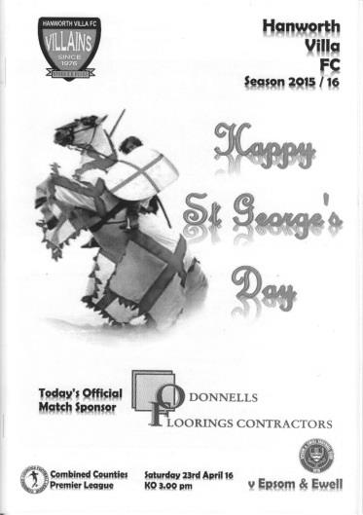
Having already set a new club record for the number of goals scored away from home in a league season, we added another three to that tally with a 3-2 win at Hanworth Villa that was thoroughly deserved, even if a little wobbly near the end. A win in our final match at Chessington would now set another mark for the most away wins in a season.

The highlight of the day of course, was a superb trademark finish from Kyle Hough to register his 200th goal for the club on his 350th appearance, but our complete domination in the first hour almost counted for nothing as the final twenty minutes were very poor and we nearly allowed a similar scenario to that which had happened the previous Saturday at home to Camberley, when we conceded three goals to lose in rapid time.

But at this stage of the season there is little point in spending time on critical analysis. I wanted to see a flowing Epsom performance, the sort we have been producing on a regular basis recently, Westfield excepted, and we got exactly that as our boys played as if their lives depended on it. This was all the more impressive as any realistic hopes of promotion had disappeared seven days ago and motivation could have been called into question, but it was never in doubt.

We took control in the middle of the park virtually from the start as the Villains, including former Salt Alex McGregor were able to do nothing about our constant possession and movement. An unchanged side for the third straight match tore into them from the beginning with Hough and Daryl Cooper-Smith making many good runs and leaving all sorts of space for the marauding Savvas 'Agi' Panayiotou and Reisse Griffin to attack them down the flanks or even sometimes through the middle. Panayiotou was denied in only the second minute by a saving tackle just as he was about to pull the trigger from eight yards out before Cooper-Smith, already receiving some grief from the vociferous stand that houses many of the home supporters, almost silenced them in style with an effort from 35 yards out that flew back off the joint of post and bar and back into keeper Harry Cushen's hands.

In just the eleventh minute Panayiotou also had a try from fully twenty yards but Cushen, maybe mindful of the previous strike, was not quite so far off his line this time and was able to tip the ball over the bar. He was in action again to smother a Hough attempt after being set up By Cooper-Smith and I firmly believe that if our striker had been allowed to play more alongside Hough this season we would have been celebrating a second place finish this season at the very least.

Next to try his luck was Matt Farrell. Hough put him through on the left and he reached the touchline, cutting back and then curling his shot over the keeper, only to see the ball bounce away off the crossbar for the second time. However, the home side were unable to clear the ball and Bentley Graham then beat Cushen from 25 yards with an imaginative chip in the 17th minute.

It was the least we deserved by that stage and seven minutes later the scoreline looked more accurate, with the only question being about the scorer. Panayiotou put Hough through on the left and his shot beat Cushen and may well have been going in, but inches from the line Cooper-Smith made sure by just getting to the ball first. Kyle's 200 would have to wait that little bit longer.

Graham tried his luck again with a low drive from distance but was denied by a full length save for a corner, but as we went off at half time the only real subject of discussion was how come the score was only 2-0 with the home side restricted to the occasional long ball forward to front man Levi King who had absolutely nothing in the way of support.

The second half continued in the same manner as the first and a great threaded pass to Hough on the left in the 53rd minute gave our man his chance. He cut in from the left and smashed the ball past Cushen into the roof of the net for our third goal and his 200th, becoming only the third player in club history to reach this incredible milestone after Reg Marlow and Tommy Tuite, two Epsom Legends. We have another legend now.

Unfortunately from the moment the third goal went in, our intensity dropped. Reisse Griffin was cautioned for a clumsy challenge before Cooper-Smith was replaced by Tom Neale up front. Hanworth Villa started to get some possession and we stopped pressing. We had a scare in the 70th minute when a left wing cross was headed wide from a good position but didn't heed the warning and within a minute we had conceded to a good King header from a right wing cross, although some marking would have been nice!

Neale nearly restored our three goal lead immediately after this, flicking the ball up and volleying it at goal but it just missed the far post and James Taylor had to make a hasty clearance as the home side pressed for a second goal. In the 76th minute they got it as a right wing cross was missed by everyone including Michael Eacott who missed his kick entirely. The ball was retrieved at the far post by Jesse Atiase and from a narrow angle he curled his attempt over everyone and into the far corner for an excellent finish.

Now it was all about digging in to preserve the points, despite the recent memory of the week before. It would have been an easier fifteen minutes had Hough hit the target from twelve yards after Neale had done really well to chase his opponent down, winning the ball off him and drawing the keeper before putting it on a plate for our star striker, but he went for the spectacular top corner finish with defenders on the line and the ball clipped off the Villa bar for the third time in the match.

Taylor was fortunate to avoid a yellow card, probably because his second leg got the ball after taking out his opponent with his leading leg, but we were then to pick up three yellow cards in the space of four minutes as the referee, memorable to us for a performance that won't be forgotten at Horley the previous season, started to make up for lost time. Maybe all that writing of names explains where the six and a half minutes of injury time came from! The card issued to Neale in the final moments for kicking the ball about a foot away was farcical, but when you score as many goals as we are right now, the other issues aren't quite so relevant and going forward we look superb with twenty-four goals in our last six matches and just two more required to reach 100 league goals for only the third time in history. Let's hope we can continue this fine form in the matches that remain.

Team: Michael Eacott, James Taylor, Matt Tanton, Dan Dean (c), Craig Hastings,
Bentley Graham, Savvas 'Agi' Panayiotou, Matt Farrell, Kyle Hough,
Daryl Cooper-Smith, Reisse Griffin

Subs: Tom Neale for Cooper-Smith (60), Sam Currie for Griffin (73),
Elliott Thompson for Graham (80)

Club Records - 30th April
Date | Day | Competition |  | Opponents |  | Scorers
30/04/27 | Sat | Surrey Senior League | H | Camberley & Yorktown | 3-0 | F.Behn (2), W.Challis
30/04/31 | Thur | London League | H | Tooting Town | 2-1 | H.Pattemore, C.Harvey
30/04/32 | Sat | London League | H | Dagenham Town | 6-2 | B.Williams (3), T.Dunne, L.Graves, T.Jones
30/04/35 | Tue | London League | A | Finchley | 1-0 | H.Pullen
30/04/38 | Sat | London League | A | Grays Athletic | 1-1 | o.g.
30/04/49 | Sat | London League | H | Edmonton Borough | 7-2 | K.Minter (2), F.Marshall, N.Griffiths, E.Watkins (2), F.Chitty
30/04/52 | Wed | Friendly | A | Leatherhead | 2-2 | B.Goddard, J.Hoy
30/04/55 | Sat | Corinthian League | H | Eastbourne | 1-1 | D.Ford
30/04/56 | Mon | Corinthian League | A | Maidenhead United | 5-1 | J.Berry (2), D.Hermitage (2), R.Colfar
30/04/57 | Tue | Corinthian League | H | Eastbourne | 2-3 | D.Hermitage, B.Jenkins
30/04/60 | Sat | Corinthian Memorial  Shield Final | N | Maidenhead United | 2-0 | S.Dunwoody (2)
30/04/68 | Tue | Athenian League 2 | A | Edmonton | 0-6
30/04/76 | Fri | Athenian League 2 | A | Eastbourne Town | 6-0 | T.Tuite (3), B.Denman, K.Eshelby, P.Butler
30/04/77 | Sat | Athenian League 1 | H | Rainham Town | 1-1 | T.Tuite
30/04/79 | Mon | Isthmian League 1 | A | Harlow Town | 0-0
30/04/81 | Thur | Isthmian League 1 | A | Maidenhead United | 5-2 | T.Tuite (3), J.Hunn, P.Gaydon
30/04/83 | Sat | Isthmian League 1 | A | Aveley | 0-1
30/04/88 | Sat | Isthmian League 2s | A | Ruislip Manor | 1-1 | N.Robson
30/04/94 | Sat | Isthmian League 3 | H | Kingsbury Town | 1-1 | N.Webb
30/04/96 | Tue | Isthmian League 3 | H | Wealdstone | 0-2
30/04/05 | Sat | Isthmian League 2 | A | Clapton | 1-1 | L.Oxley
30/04/13 | Tue | Combined Counties Prem | H | South Park | 1-1 | B.Hayward
Historical Decades
01/05/26 | Sat | Surrey Senior League | H | Weybridge | 2-1 | H.Streeter, o.g.
02/05/36 | Sat | London League | H | P.O.Engineers | 0-3
27/04/46 | Sat | London League | A | De Havilland | 4-1 | B.Peacock (2), F.Chitty, S.Scott
30/04/56 | Mon | Corinthian League | A | Maidenhead United | 5-1 | J.Berry (2), D.Hermitage (2), R.Colfar
27/04/66 | Wed | Athenian League 2 | A | Ware | 1-2 | K.Welham
30/04/76 | Fri | Athenian League 2 | A | Eastbourne Town | 6-0 | T.Tuite (3), B.Denman, K.Eshelby, P.Butler
03/05/86 | Sat | Isthmian League Prem | H | Wokingham Town | 2-4 | T.Tuite (2)
30/04/96 | Tue | Isthmian League 3 | H | Wealdstone | 0-2
29/04/06 | Sat | Isthmian League 2 | H | Wembley | 1-3 | C.Pritchard (pen)

History Corner - 30th April
90 years ago this week we celebrated our first ever Surrey Senior League title with a 2-1 win over Weybridge. The title had actually been confirmed in midweek following Farnham United Breweries draw with the same opposition and goals from H.S. Streeter and an own goal were all we required to get the win.

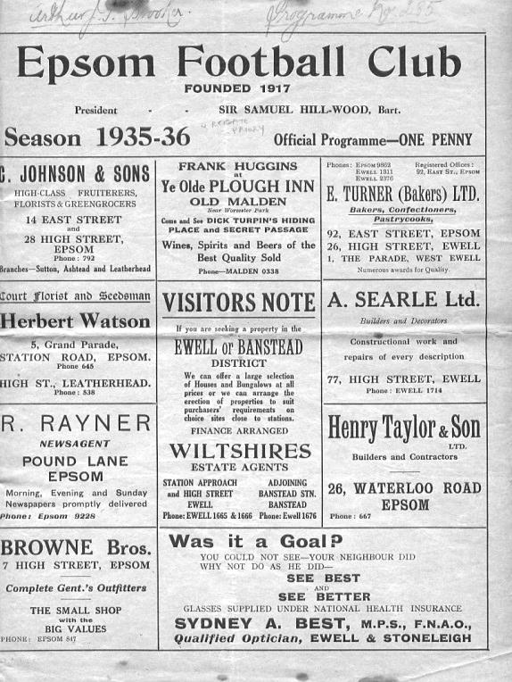
84 years ago today we battered Dagenham Town 6-2 in a London League match. Billy Williams scored three more in his exceptional season against the a team that were the main club in Dagenham, but who would fold before the war, only to be replaced in the late forties by the current team that now exist as Dagenham and Redbridge.

80 years ago this week we hosted the Post Office Engineers to conclude the most disappointing season in our history to that point. Our tenth place finish out of 13 was irrelevant when compared to the battle at the top, and the Engineers, having their best ever season, defeated us 3-0 at West Street. (see programme right). The Engineers would finish third, behind Leavesden and Finchley on goal average which was so tight that had the Wallington based Engineers scored just one more goal, they would have won the title!

40 years ago today we visited the Saffrons, home of Eastbourne Town for an Athenian League match. We used to meet regularly in the Corinthian League when they were just known as Eastbourne F.C. and when that League merged with the Athenian League, the Sussex side followed us down to Division Two in 1966; a year after we had been relegated. We then remained as regular opponents until being cast out into the Surrey Senior League in 1973 but following that had defeated them in the last 32 of the F.A. Vase in 1975 and by the time of the following season we were back in the Athenian League. Going into this final match of the season, we needed to avoid being beaten by seventeen goals and we would be runners-up and earn promotion to the top flight of the League. As it turned out we won 6-0 with Tommy Tuite scoring three and other goals coming from Barry Denman, Keith Eshelby and Paul Butler.

35 years ago today and exactly five years to the day after his hat trick at Eastbourne, Tommy scored another three, as we defeated Maidenhead United in a Thursday evening match at York Road by five goals to two. This time Jeff Hunn and Peter Gaydon were the other scorers.

30 years ago this week Tuite scored another two but in less happy circumstances at home to Wokingham Town. We had secured a good 0-0 draw at Hayes in midweek, but knew that we needed a four goal win, plus additional failings from clubs around us to survive in the Premier Division. We got neither and in fact we were behind in the opening five minutes of this match, eventually losing 4-2 and we were down. Our time with the big boys was over.

56 Years ago today
Epsom F.C. 2-0 Maidenhead United
Corinthian League Memorial Shield Final - Saturday 30th April 1960

Epsom F.C. with the Corinthian League Memorial Shield in 1960.
Back Row: Bill Kennedy, Tony Wells, Bernard Willis, Ray Ellis, Micky Williams,
Tom Tweedy, Tony Carroll, Steve Dunwoody
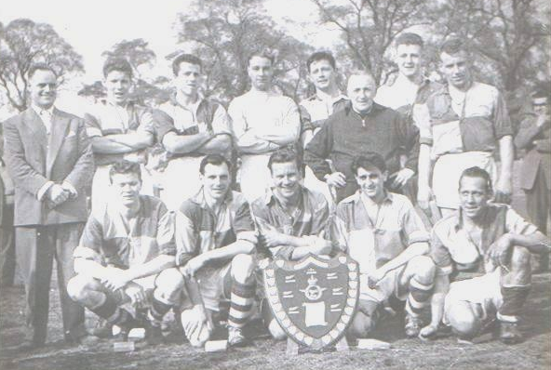
Front Row: Bill Hawkins, Ron Francis, Peter Wood, Tommy Millard, Norman Dearlove

Back in 1959/60 we had a decent but unspectacular team. Many of our best players had been enticed down the road to Sutton United and new Manager Bill Kennedy, the former Hibernian, Stirling Albion and Millwall player had the task of putting together a team for the upcoming Corinthian League season.

He was fortunate in having a new Chairman of the club at the helm. John Martin was what we would call these days a self-made entrepreneur, who had made money through the war from selling commodities. He was heavily involved with the Carnation Milk company and would occasionally travel to South America for business back in the days before regular travel was a reality for most people. Former Player Norman Dearlove recalled him attending matches in his green Rolls Royce and would be very happy to partake in what the Amateur footballers termed “boot money”. Although our players were Amateur, Norman would occasionally find a white five pound note in his boots after the game, especially if he had scored.

Norman was one of a group of players that started to arrive at the club around the same time as the money had! Steve Dunwoody had joined from Sutton United, while John Ryan and Scottish Amateur International Ken MacDonald came from Hounslow. MacDonald was a customs officer at Heathrow and apparently joined us instead of

Hendon as the travel time was better, but you have to ask if that was so important to him, why would he have left Hounslow in the first place? The answer was obvious and when Peter Wood joined from Southall and Dearlove followed from Banstead Athletic, another of Wood’s former clubs, our team looked superb. Costly, but superb!

Dearlove was a goal machine who had averaged about seventy goals a season at Merland Rise for Surrey Senior League Banstead Athletic, while Dunwoody had joined from Sutton and was the older brother of a former long term supporter, Danny. Bill Hawkins followed from Walton & Hersham, and it wasn’t long before the only regulars from previous seasons were Bernard Willis, Ron Francis, Micky Williams and goalkeeper Ray Ellis.

There was only one problem, which was that we were already well down the table by this point and league success was impossible having lost eight matches before Christmas. However, this appeared to be part of a long term plan on behalf of Martin and it was an exciting time to be a supporter.

As you would expect, League form improved as the club won six of its next nine. On 5th March 1960 the players travelled to the Park View Ground, home of Erith & Belvedere for the opening round of the Memorial Shield, and despite conceding an early goal, they recovered to win 3-1 with goals from Dearlove, MacDonald and Hawkins. In this sixteen-team league, the next round was the Quarter Final two weeks later, where the Blues were drawn at home to Leatherhead. The Tanners were in formative mode, having recently switched from the Delphian League, and would be a force in a year or two but were no match for a rampant Epsom, and Wood and Dearlove each scored twice in the second half of a 4-0 win in front of 1,000 spectators.

Maybe flushed with their success (or more likely just flush!) the club decided to advertise on television (becoming, we believe, the very first club to do so) and a fifteen second advert appeared on ITV advertising the next game that afternoon at home to Dorking in the Corinthian League. Approximately 1,100 attended to witness a real off day for the Blues as they crashed 0-4, but this was very much a temporary blip.

Fortunately the team had a week off the following Saturday and 16th April was the day of the Memorial Shield Semi-Final at home to Letchworth. Despite the visitors being ahead of Epsom in the League at this point, they were crushed 5-0 with Hawkins and Dearlove scoring twice each. Ken MacDonald scored the other goal but this victory came at a price. Both MacDonald and Ryan were injured and would be out for the season.

It didn’t matter too much though, as former Epsom player Tommy Millard rejoined from Leatherhead while another new player Tony Carroll both slotted in, and the club won three League games handsomely in the warm up for the Final. One of the wins was 3-0 at Wembley’s Vale Farm ground, so it was the ideal preparation for the Final against Maidenhead United, which was to be played there seven days later.

Ah, Maidenhead! They had defeated us back in 1957 in our last appearance in the Final of the Shield, 2-0 at Dorking F.C.’s Meadowbank ground and many supporters were looking at this game for a bit of revenge. They were to have their wish. Three coach

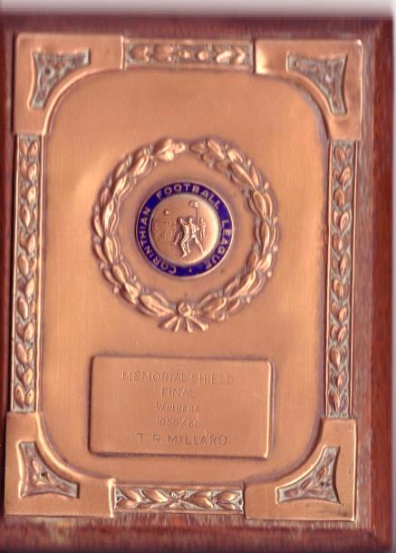
loads of supporters made the journey, boosted in the knowledge that Steve Dunwoody had been granted leave from his National Service to play in the game. He was the difference between the sides as he scored twice in the second half for Peter Wood to lift the trophy.

Since conceding that goal at Erith, the Blues did not concede another goal in the competition. It is also interesting to note that following that Dorking game, the club had won their remaining seven matches to end the season, and hopes were high for the following season and beyond. Alas, the team would break up rapidly and the sixties were to be a very bleak time for the club. Thirteen years of despair and debt would follow this cup win.

Was it worth it? At the time, maybe, but with hindsight it looks to me as though the club found the money burning a hole in their pocket, and eyeing fanciful notions of continued success, decided to “chase the dream”, as Peter Ridsdale, then Chairman of Leeds United described their actions a few years ago. A cautionary tale for all clubs.

John Martin would in the end cause a lot of difficulties for the club, as he soon tired of the executive toy he had purchased and when the 15 year lease on the ground expired in 1974 he tried to sell the ground for housing. Fortunately, that would turn out to be our most successful year and protest marches helped convince the Council to refuse planning permission at West Street. A few years later the ground was sold to Matthews Holdings under the more secure ownership of Ray Bloye, the Crystal Palace Chairman.

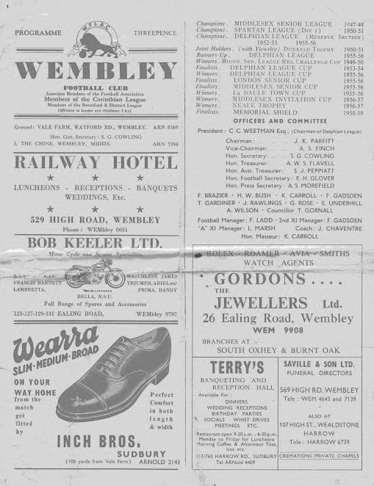
Above Left: A winners plaque from the 1960 Corinthian League Memorial Shield belonging to Tommy Millard

Below Right: A programme from the Memorial Shield Final against Maidenhead United

Club Statistical History - (including Hanworth Villa (A) on 23/04/16):
League: Played: 2,834, Won: 1,164, Drawn: 537, Lost: 1,133
For: 5,219, Against: 5,027, GD: plus 192 - Win Ratio 41.07%

CCL only: Played: 413, Won: 190, Drawn: 79, Lost: 144
For: 751, Against: 641, GD: plus 110 - Win Ratio 46.00%

Cup and Other (inc Abandoned Matches):
Played: 1,097, Won: 518, Drawn: 128, Lost: 443 Abandoned: 8
For: 2,376, Against: 2,055, GD: plus 321 - Win Ratio 47.22%

Under Glyn Mandeville: Played 83, Won: 44, Drawn: 11, Lost: 28
For: 173, Against: 131, GD: plus 42 - Win Ratio 53.01%

Total: Played 3,931, Won: 1,682, Drawn: 665, Lost: 1,576, Aban: 8
For: 7,595, Against: 7,082, GD: plus 513 - Win Ratio 42.79%

First Senior Match: 30th August 1924.
Lost 1-3 vs Dorking at our home ground at the time of Horton Hospital Grounds.

First Match Programme Issued: 15th September 1923.
Won 4-0 vs West Norwood Reserves - Friendly match at Horton Hospital Grounds.

Number of Official Home Grounds: Six.

Alexandra Recreation Ground 1918-1922,
Horton Hospital Grounds 1922-1925,
West Street 1925-1993,
Merland Rise 1993-2010,
Moatside 2010-2012,
High Road 2012- present.

Record Win: 12/10/1935 - 13-1 v Reigate Priory (H) - Amateur Cup.

Record Defeat: 14/02/1948 - 0-14 v Chelmsford City Reserves (A) - London League.

Longest Serving Manager: 1) Adrian Hill 853 1982-1985 & 1990-2003
2) Pat O’Connell 466 1973-1982
3) Lyndon Buckwell 407 2006-2014
4) Ricky Kidd 190 1986-1990

Record Appearances: 1) Graham Morris 658 1990-2004
2) Nigel Bennett 630 1989-2005
3) Tommy Tuite 582 1973-1987
4) Ernie Watkins 419 1945-1960

Record Goal Scorers: 1) Tommy Tuite 391 1973-1987
2) Reg Marlow 254 1924-1936
3) Kyle Hough 200 2007-present
4) Jimmy Jones 148 1933-1945

Most Appearances in a season: Tony Coombe and Tommy Tuite - 59 in 1980/81.

Most goals in a season: Reg Marlow - 65 (at least) in 39 appearances in 1926/27.

Senior League Titles: 5 - 1925/26 Surrey Senior League - 1926/27 Surrey Senior League - 1927/28 London League - 1974/75 Surrey Senior League - 1977/78 Isthmian League Division Two

Respect Campaign
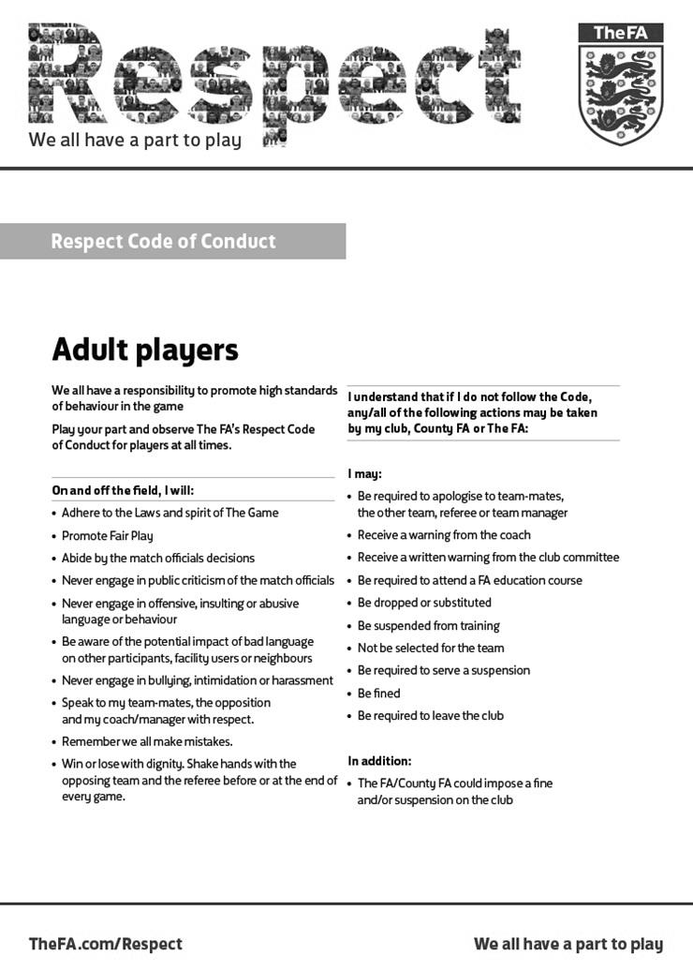

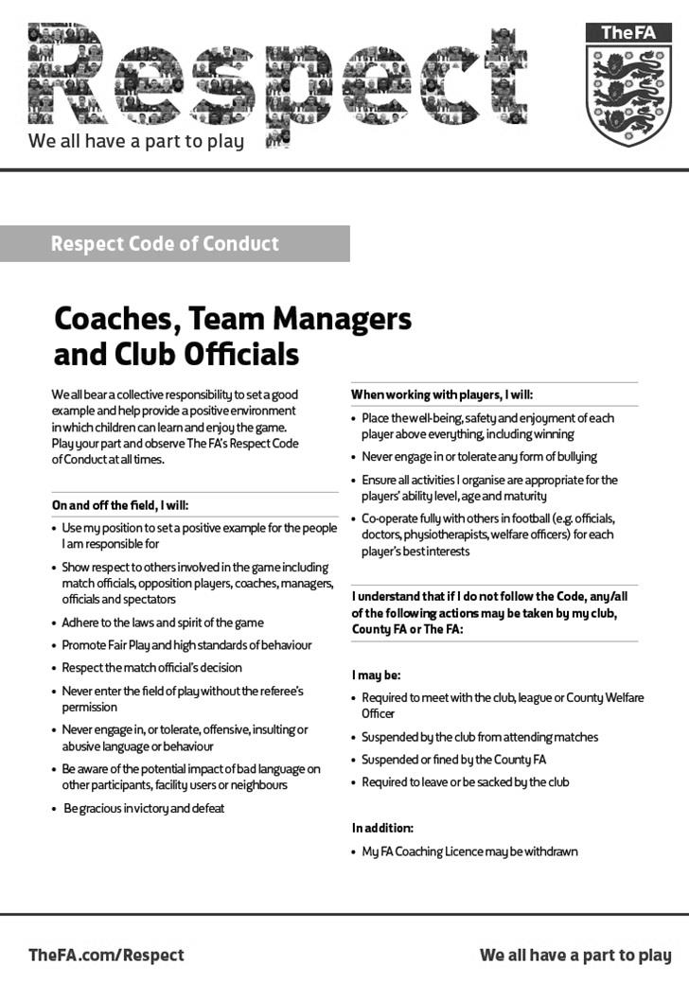

Latest Results Grid
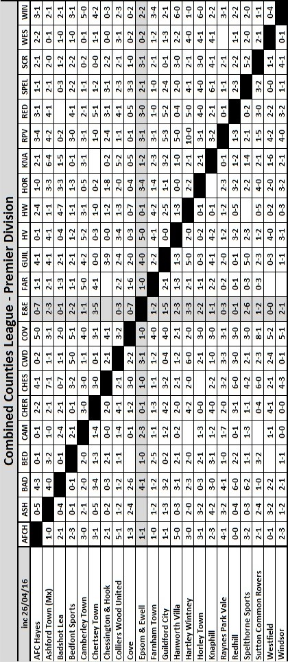

First Eleven Appearances - (max 45 including Hanworth Villa – 23/04/16)
Name | Debut | 2015/16 |  |  |  | Career Totals
 |  | App | Sub | Total | Goals | App | Sub | Total | Goals
AJAYI Tayo* | 22/08/2015 | 0 | 2 | 2 | 0 | 0 | 2 | 2 | 0
COOPER-SMITH Daryl | 03/01/2015 | 19 | 5 | 24 | 12 | 28 | 8 | 36 | 18
CURRIE Sam | 04/08/2012 | 21 | 6 | 27 | 1 | 129 | 15 | 144 | 3
DAVISON Conor* | 22/08/2015 | 1 | 2 | 3 | 0 | 1 | 2 | 3 | 0
DEAN Dan | 02/08/2014 | 30 | 3 | 33 | 1 | 66 | 4 | 70 | 1
DOWNS Carl | 17/09/2011 | 5 | 1 | 6 | 0 | 99 | 14 | 113 | 2
EACOTT Michael | 02/08/2014 | 37 | 1 | 38 | 0 | 83 | 1 | 84 | 0
FARRELL Matt | 02/08/2014 | 43 | 1 | 44 | 10 | 84 | 4 | 88 | 17
FERDINANDO Matt | 20/09/2014 | 26 | 2 | 28 | 8 | 53 | 6 | 59 | 14
GRAHAM Bentley | 09/02/2016 | 15 | 1 | 16 | 3 | 15 | 1 | 16 | 3
GRIFFIN Reisse | 08/08/2015 | 26 | 6 | 32 | 2 | 26 | 6 | 32 | 2
HASTINGS Craig | 08/08/2015 | 37 | 4 | 41 | 0 | 37 | 4 | 41 | 0
HATFIELD Jamie | 11/11/2006 | 1 | 0 | 1 | 0 | 249 | 13 | 262 | 6
HENDRY Rob | 08/08/2015 | 30 | 9 | 39 | 12 | 30 | 9 | 39 | 12
HOUGH Kyle | 14/08/2007 | 35 | 4 | 39 | 29 | 331 | 19 | 350 | 200
JONES Adrian | 06/08/2011 | 4 | 1 | 5 | 0 | 24 | 1 | 25 | 0
KURDZIEL Jakub* | 29/08/2015 | 1 | 0 | 1 | 0 | 1 | 0 | 1 | 0
MARVELL Dale* | 15/01/2000 | 8 | 4 | 12 | 1 | 269 | 49 | 318 | 86
McGREGOR Alex* | 08/08/2009 | 7 | 3 | 10 | 2 | 179 | 59 | 238 | 29
MCKAY Alex | 20/12/2008 | 23 | 3 | 26 | 0 | 108 | 29 | 137 | 8
MURPHY George | 19/03/2013 | 2 | 1 | 3 | 0 | 68 | 7 | 75 | 3
NEALE Thomas | 13/10/2015 | 16 | 17 | 33 | 10 | 16 | 17 | 33 | 10
NEILL David* | 03/10/2015 | 1 | 1 | 2 | 0 | 1 | 1 | 2 | 0
NORTH Rhys | 16/08/2015 | 17 | 7 | 24 | 1 | 17 | 7 | 24 | 1
OLIVER Beckett* | 29/08/2015 | 5 | 11 | 16 | 0 | 5 | 11 | 16 | 0
PANAYIOTOU Savvas | 03/01/2015 | 14 | 5 | 19 | 4 | 30 | 8 | 38 | 7
ROBINSON Sam* | 22/10/2011 | 0 | 1 | 1 | 0 | 54 | 5 | 59 | 13
ROWE Steve | 27/08/2011 | 0 | 1 | 1 | 0 | 24 | 3 | 27 | 0
SMITH Matt | 08/08/2009 | 0 | 0 | 0 | 0 | 91 | 43 | 134 | 10
TANTON Matt | 02/08/2014 | 37 | 0 | 37 | 0 | 55 | 4 | 59 | 1
TAYLOR James | 26/08/2013 | 28 | 4 | 32 | 3 | 84 | 12 | 96 | 6
THOMPSON Elliott | 09/02/2016 | 4 | 8 | 12 | 0 | 4 | 8 | 12 | 0
TURPIE Alistair | 31/03/2016 | 2 | 0 | 2 | 0 | 2 | 0 | 2 | 0
Own Goal |  |  |  |  |  |  |  |  | 1
* Player has left the club

Ashford Town (Mx) F.C. – History
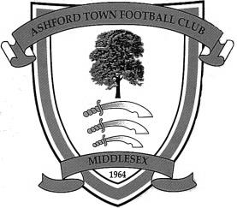
Until recently, it was assumed that Ashford Town Football Club was formed in 1964. However, new research has indicated the club was formed in 1958 as Ashford Albion and first competed in the Hounslow & District League. Albion won two consecutive promotions to reach the Premier Division of the Hounslow League and were still competing there when the club changed its name to Ashford Town in 1964. It was at this time that the club adopted its distinctive Tangerine & White colours. The club endured a difficult first campaign as the Town club and withdrew from the Premier Division, assuming the Reserve Team's place in Division Two.

Having rebuilt the club with a very young team, Ashford Town rapidly advanced through the various divisions of that League, absorbing Staines Youth Club FC on the way. Several individuals from that era have remained with the Club and now form the backbone of the Committee, including the Vice-Chairman and Secretary.

The Club were elected to the Surrey Intermediate League (Western) in 1967 and were promoted at the end of their first season. The Ash Trees were League Cup finalists in 1970-71 and League runners-up in 1972-73. In 1974-75, Ashford enjoyed their best season under the Management of ex-Fulham player Frank Reid, winning the League by three points from perennial contenders Merrow.

Although the championship eluded the Club in following seasons, it usually finished in the top four and prior to season 1982-83 an invitation was extended by Surrey County FA to become founder members of the Surrey County Premier League. The invitation was readily accepted and Ashford played their first match in the new league on 4 September 1982, drawing 0-0 away to Farleigh Rovers.

Almost from its foundation, the Club had aspirations to acquire its own ground and after one or two disappointments, this was achieved in August 1985, when a long lease was signed with Spelthorne Borough Council, enabling the Club to move to its present home at Short Lane, Stanwell. From what was nothing more than a field, the facilities were quickly developed, with the first match at Short Lane taking place in February 1986, following two postponements for snow. Floodlights were erected in September 1995, whilst the pitch is railed all round and partly walled, with standing covered accommodation, plus a purpose built 150-seater stand, built in 1998 (pictured). An additional 100 seats were installed on the opposite side of the ground to this stand in 2006, after the club won promotion to the Isthmian League Premier Division.

For both geographical and historical reasons, Ashford affiliate to both Middlesex and Surrey F.As and in 1989-90, their last season as an Intermediate Club, they reached the final of both County’s Premier Cup competitions, beating Farnham Town in the Surrey version, but losing to Willesden Hawkeye in the Middlesex final. Runners-up spot in the League was also secured and with it the opportunity to enter senior football, as members of the Combined Counties League, senior status having been granted in May 1990. It was at this point that the club changed its name to Ashford Town (Middlesex) FC, to avoid confusion with the Kent club of the same name.

During its ten year membership of the Combined Counties League, the Club never finished below sixth place, and after finishing 3rd and 2nd in seasons 1992-93 and 1993-94, it went on to win the League Championship for four successive seasons. It was a relative disappointment to only come 4th in 1998-99 even though the Club won the League Cup but a 5th championship in just six seasons was secured in 1999-00, along with the Middlesex Charity Cup, the first ever senior county cup honour. With the ground up to the required standard, Ashford took their place in the Isthmian League for season 2000-2001 and by finishing in 3rd place, secured promotion to Division 2 at the first attempt.

Further major improvements were made to the ground to enable the Club to be granted a B-grade and to take its place in the newly regionalised Division One of the Ryman League. A poor start saw the Club in the bottom echelons of the table but a number of new signings saw a significant improvement and a 17th place finish, which was an excellent performance after winning just one of the opening 16 league matches.

Further progress was made in 2003-04 as the Club finished 12th in Division 1 South. In the close season prior to 2004-05, the pitch has been completely re-laid to include both irrigation and drainage systems, at a cost of around £50,000, mostly financed by the Football Stadia Improvement Fund. Further medium term plans include new changing accommodation adjacent to the pitch, which will allow enlargement of the present clubhouse, and a hard surface floodlit training area.

The Club embarked upon new adventures in season 2004-05 in the Southern League for the first time, having been transferred over as a result of the FA restructure. The 4th Qualifying Round of the FA Cup was reached for

the first time and Mark Butler, renowned goal scorer in his day with Aldershot Town, Staines Town etc, was promoted from Assistant Manager to Manager following the resignation of Nathan Wharf in December 2004.

The play-offs were reached but resulted in a narrow defeat at Evesham United after extra time.

In 2005-06, Ashford went one better, finishing second in Division One West of the Southern League, to secure promotion to Step 3. This brought about a return to the Isthmian League for season 2006-07 and saw Ashford competing at their highest ever level. The season brought consolidation with the added bonus of reaching and winning the Westview (League) Cup Final when Ashford triumphed 4-1 over Dover Athletic at Bromley. The Reserves also lifted a trophy, securing the Middlesex Premier Cup.

Ashford built on this success, rallying from the foot of the table in November 2007 to narrowly miss a place in the promotion play-offs at the end of the 2007-08 season; a campaign which saw all of the club's senior sides challenge for honours.

The 2008-09 season saw Ashford begin the campaign in electrifying form, winning their opening six matches to top the table. Mark Butler's side followed this up with a fantastic FA Cup run which saw them come agonisingly close to eliminating Forest Green Rovers in the Fourth Qualifying Round at Short Lane. Rovers won the replay and went on to run Derby County close in the Third Round. Ashford endured a difficult winter, which saw them flirt with relegation, before a late resurgence saw the side safely into mid-table. The cup competitions added much adventure to the season, as Ashford followed up their exploits in the FA Cup with runs to the semi-finals of both the Middlesex Senior and Isthmian League Cups and end their campaign by defeating Conference Premier outfit Woking 3-2 at Metropolitan Police to win the Surrey Senior Cup.

The 2009-10 season saw Ashford make a reasonable start to the campaign, but the were shocked when manager Mark Butler tendered his resignation on Friday 23rd October, in order to take up the Manager's role at Margate FC, who were struggling at the foot of the table. Ashford appointed former Leicester City and Bradford City midfielder Jamie Lawrence as his replacement, and the Jamaican international immediately led his new charges on a twelve-match unbeaten run. However, issues off the pitch were causing problems for the club and a number of players, including leading goalscorer Byron Harrison left for Carshalton Athletic, where Mark Butler had accepted a coaching role after leaving Margate, where he had been in charge for just three months.

Ashford found scoring a problem after Harrison left and a dreadful run of form saw them go from the fringe of the play-off zone to battling relegation. Ashford went into their final match knowing a win would almost guarantee survival, while a draw would see them finish fourth from bottom - technically a relegation place, but certain to receive a reprieve owing to the demise of various other clubs. Sadly, a heavy defeat for Ashford, coupled with wins for Carshalton and Margate saw the latter two clubs survive - Margate receiving the reprieve for finishing fourth from bottom.

During the summer of 2010, the club were initially placed in the Central Division of the Southern League but were then offered the chance to remain at Step Three of the non-league pyramid. However, as this offer was as a direct replacement for defunct Southern League side Merthyr Tydfil, the decision was made that the vast increase in travelling would be too great a burden for the club and the club elected to remain in the Central Division. During this time, Bob Parker stepped down from his role as Chairman after twenty-eight years in the role. The club's home ground was renamed the Robert Parker Stadium in honour of Bob, who remains at the club as President.

The club entered a new era in the Central Division of the Southern League with Jamie Lawrence at the helm and with a mixture of established local players and new faces but the season was a challenging one. The club played some sparkling football at times and enjoyed an exciting run in the FA Trophy, reaching the Last 32 in the competition before losing at home to Dartford. However, League form was patchy and the club finished 16th. One bright spark was the club winning the Southern Combination Cup, defeating Hanworth Villa 1-0 in the Final.

Jamie Lawrence resigned as Manager in June 2011 and the club immediately appointed his assistant, Paul Burgess, to take the helm after more than 21 years at the club, including 683 First Team appearances. Despite having little time to do it and few resources at his disposal, "Burgo" assembled a young and exciting team. Although any hopes of a tilt at the promotion play-offs were dashed by a dreadful run where the club failed to win at home for four months, Ashford finished the season strongly, winning two Cup Finals in 48 hours. A memorable season was capped by the club being named winners of the Southern League Fair Play Award.

A relegation season followed in 2013/14 and Ashford returned to the Combined Counties League for 2014/15, but a slow start hampered their chances of an immediate return and they finished third.

Combined Counties League Premier Division Opponents
All-time Records
inc Saturday 23rd April | P | W | D | L | F | A | PPG | GD | Best  Win | Worst  Loss
Spelthorne Sports* | 5 | 4 | 1 | 0 | 15 | 6 | 2.60 | +9 | 6-2 | -
Sutton Common Rovers | 10 | 8 | 1 | 1 | 27 | 12 | 2.50 | +15 | 4-0 | 1-4
Horley Town | 28 | 19 | 5 | 4 | 62 | 30 | 2.21 | +32 | 6-0 | 1-3
Colliers Wood United | 21 | 14 | 2 | 5 | 45 | 28 | 2.10 | +17 | 4-0 | 0-3
Westfield | 18 | 11 | 3 | 4 | 39 | 29 | 2.00 | +10 | 6-1 | 0-4
Bedfont Sports | 9 | 5 | 2 | 2 | 13 | 10 | 1.89 | +3 | 3-0 | 0-4
Farnham Town | 13 | 7 | 2 | 4 | 23 | 22 | 1.77 | +1 | 3-1 | 1-4
Guildford City | 16 | 9 | 1 | 6 | 32 | 22 | 1.75 | +10 | 5-1 | 1-5
Raynes Park Vale | 26 | 13 | 5 | 8 | 57 | 36 | 1.69 | +21 | 6-1 | 0-2
Knaphill | 6 | 3 | 1 | 2 | 11 | 8 | 1.67 | +3 | 4-1 | 1-2
Hanworth Villa | 14 | 7 | 3 | 4 | 34 | 24 | 1.71 | +10 | 5-0 | 1-4
Cove | 34 | 15 | 9 | 10 | 75 | 55 | 1.59 | +20 | 7-0 | 1-6
Chessington & Hook | 27 | 11 | 9 | 7 | 52 | 41 | 1.56 | +11 | 6-0 | 1-3
Camberley Town* | 88 | 38 | 21 | 28 | 158 | 123 | 1.54 | +35 | 9-1 | 0-4
Hartley Wintney | 10 | 4 | 3 | 3 | 25 | 17 | 1.50 | +8 | 5-0 | 2-4
Badshot Lea | 17 | 7 | 3 | 7 | 31 | 33 | 1.41 | -2 | 4-1 | 0-4
Windsor | 47 | 18 | 12 | 17 | 87 | 88 | 1.40 | -1 | 4-0 | 0-6
Redhill | 33 | 14 | 2 | 17 | 63 | 69 | 1.33 | -6 | 7-2 | 2-8
Chertsey Town | 47 | 17 | 5 | 25 | 70 | 86 | 1.19 | -16 | 3-0 | 0-7
AFC Hayes | 8 | 2 | 2 | 4 | 16 | 15 | 1.00 | +1 | 7-0 | 0-3
Ashford Town (Mx) | 17 | 4 | 2 | 11 | 22 | 44 | 0.82 | -22 | 3-0 | 0-5
Total* | 494 | 230 | 94 | 169 | 957 | 798 | 1.58 | +159 | - | -
* includes one abandoned match v Camberley and one loss on penalties v Spelthorne

Matches against Ashford Town (Mx)
We have met Ashford Town (Mx) on 17 previous occasions, so I thought it was time to go through them in a little detail. It doesn’t make for happy reading if you are a Salts fan as our record doesn’t look good, although it is improving. Slowly!

Our first meeting came on Tuesday 5th October 1993 at Merland Rise in the F.A. Vase, following a postponement for a waterlogged pitch three days previously. Technically we were a level higher, plying our trade in the Isthmian League Division Three, while they were a Combined Counties League team, but in reality there was little between the teams. In fact, they were the second best team in that league, with only the short lived Peppard team denying them a League title this season. We were destined for a finish right in the middle of our own table that season, placing 10th out of 21 but were still somewhat unaware of the strength of some of the supposedly lower ranked clubs and probably went into the game a little over-confident.

Having said all of that, maybe we should have won the tie anyway. We were level at 1-1 and required extra time, but Graham Morris saw his penalty saved in the extra period (wasn’t low enough) and a replay was required.

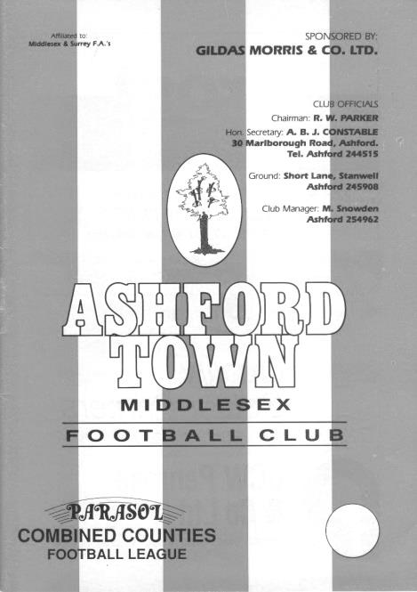
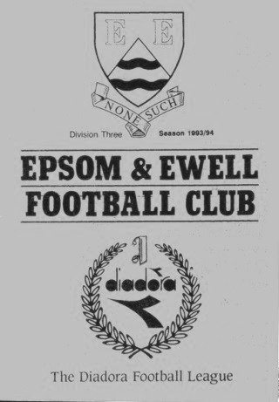
This is where the story starts getting a bit strange. For whatever reason we were not allowed to rearrange our League match at Cove on the replay weekend, even though you’d think that it would take priority as it does nowadays. As a result we had to play Cove on the Saturday, winning comfortable 5-2, before then travelling to Ashford’s Short Lane ground for the first time, just 24 hours later for a Sunday afternoon match. I don’t know whether our opponents faced a similar scenario, but for us, it caused all sorts of difficulties. (see programmes below)

Due to injury and eligibility issues we were unable to play either our regular keeper Dave Hyatt, who had fallen off a ladder on the Friday, or newly signed Trevor Jones, who was not with us at the time of the original tie and was therefore ineligible. Step forward 18 year old Lee Heywood who made his one and only appearance for the first eleven that day. Ray Purvis had put us ahead in the first half, but an equaliser in the second forced another extra period and Ashford came through 3-1 in the end!

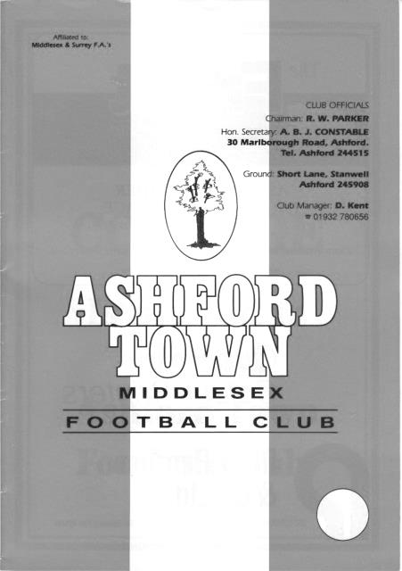
Our next meetings came in Southern Combination Cup ties, both at Short Lane. The first, on 7th May 1996 was a bit of a mismatch. Firstly, we were drawn at home but conceded home advantage as the season had finished at Merland Rise, so we were unable to play there! Secondly, due to fixture congestion earlier in the season leaving us with two fixtures on the same day, we had played the Reserves in an earlier tie at Leatherhead and had won. As a result it was felt only fair that the Reserves, including 40 year old Richard Strong who was playing in our Premier Division team ten years previously, took the field for this Semi-Final. We did have plenty of first team experience in the side though, with Andy Nimmo, Ricky Dymond and Andy Rawlinson all playing for us, together with future first teamers in Nick Cawthorne and Greg Harfield.

It was close for a while, going in level at 1-1 at the break thanks to a Dymond goal but we ran out of steam and lost 4-1 in the end.

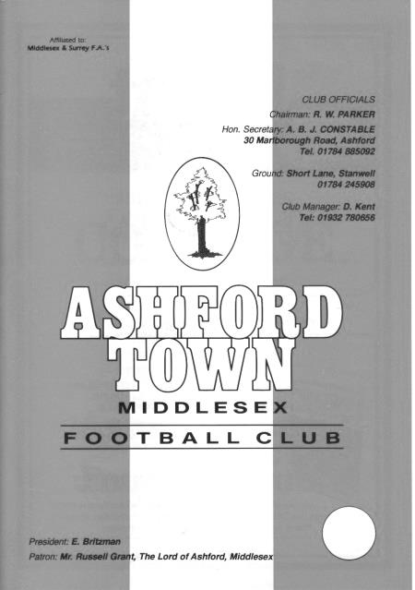
We were back there the next season with a stronger team, but by now Ashford were top dogs in the Combined Counties League, with this being the third of four title winning seasons in a row. We conceded home advantage once again and were brushed aside 5-2 on Tuesday 8th April 1997. (see programmes above)

Maybe it was just as well that we didn’t meet for a little while, but it was inevitable that

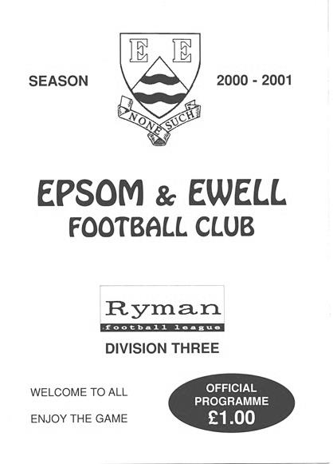
they would eventually make their way into the Ryman League, where we briefly met in season 2000/01. I say briefly as the Middlesex team were going to do what so many other new teams used to do in Ryman League Division Three, which was to go straight up through it! They went up in third place and under the circumstances our results were very credible. We lost 2-1 at Merland Rise on 14th October 2000 but won the return at Short Lane on 10th March 2001 by a goal to nil, thanks to a Nimmo penalty.

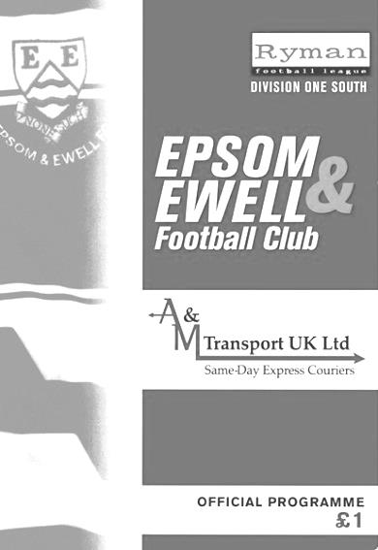
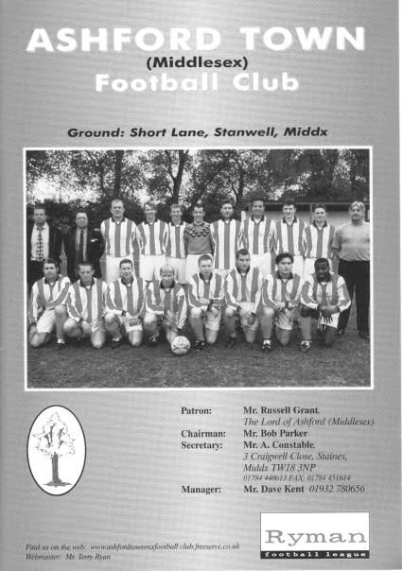
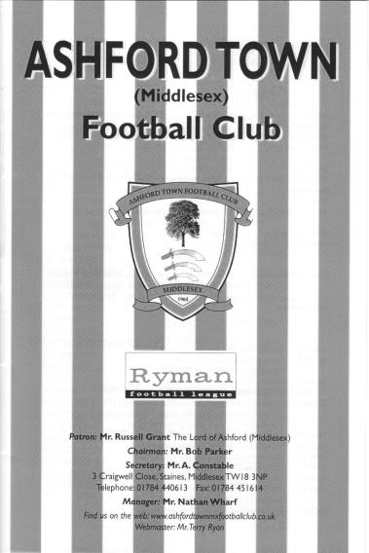
Our next meetings came following the reorganisation that resulted in a promotion of two divisions for our boys in 2002, following the expansion of Division One and Two into two regional Division Ones. We then met in the South Division at Merland Rise on 26th October 2002. We had got off to a flying start and had topped the table for a while before a defeat at eventual

Champions Carshalton Athletic. However, we still had too much for Ashford and won 3-0 in the League before surprisingly suffering a 3-0 loss just four days later in the Isthmian League Cup at the same venue. In fact it was less than a month before we played the return match, leading 1-0 on 23rd November before Simon Huckle missed an open goal after rounding their keeper with ten minutes remaining and inevitably we then conceded an equaliser to draw 1-1! (see programmes on previous page)

The following season was one of relegation and we crashed 0-5 at home on 23rd September 2003 before losing 2-0 at Short Lane on 6th March 2004. (see programmes below) We departed the scene with little more than a whimper and faced life in Division Two for a couple of seasons. Meanwhile, Ashford went up to play at Step Three, acquitting themselves well for a while.

We had two further meetings before resuming league activities last season and these both came in Surrey Senior Cup ties. In 2005 we suffered our first ever defeat in this competition against a team from outside Surrey when being beaten 3-1 on a chilly Tuesday evening 6th December 2005, despite a goal from Richard Ingham.

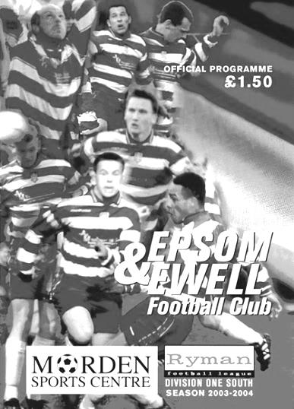
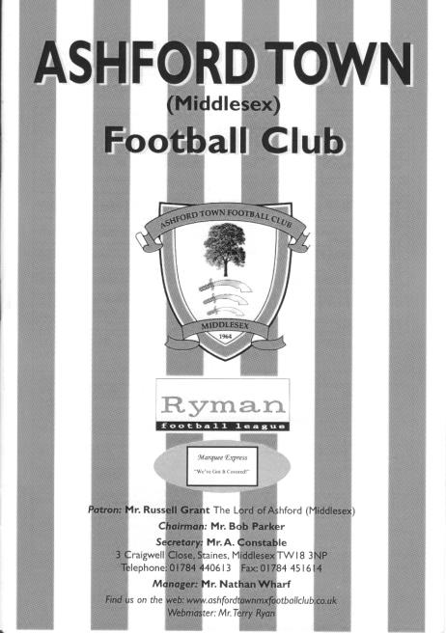
Four years later we met in the Semi-Final, following our wins over Horley Town, Sutton United, Redhill and Corinthian Casuals but the two division gulf in status this time proved too much and on a Thursday evening we were defeated 4-1 by the Isthmian Premier League team, although they wobbled briefly after Robbie Burns had reduced the deficit to 2-1. Ashford went on to win the Cup for the very first time. (see programmes over page)

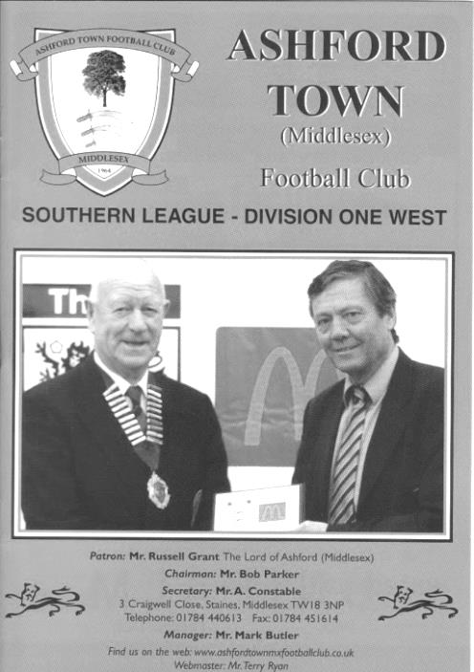
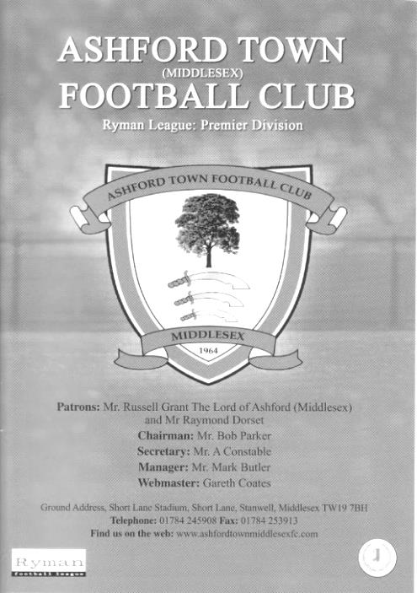
Our League meetings recommenced in 2014/15 and resulted in two goal defeats for the home team in each case. They won 4-2 at Chipstead on 18th October 2014 on a day that saw a classic own goal in our favour and the first for the club from Matt Ferdinando, but one of our better performances of last season came at Short Lane when we won 3-1 on 10th January 2015. They suffered an early sending off but the game sprung into life in the second half as we scored twice, through Kyle Hough and Agi Panayiotou and although they pulled one back near the end, Hough scored again almost from the restart. This was all the more impressive as they were pushing for promotion, while the only substitutes we had that day were our Manager and Assistant!

In summary, there are very few clubs against whom we have a worse record, but history only counts for so much and with two straight wins at Short Lane, maybe next year we could even win a third as we have done for the very first time at Chertsey; another club we have an appalling record against! Records are there to be broken, I was always told.

If, as is beginning to look likely, both clubs miss out on the promotion this season, I would expect our two meetings next year to be highly significant. With rumours abounding that the Hartley team are off to Farnborough or Camberley and with Ashley Nadesan leaving Horley a much weaker force, our two clubs will be the ones on most people’s lips when they are naming next season’s favourites. Wouldn’t it be great if we could meet up right near the end of the season again, this time with both clubs having something to play for!

This season’s matches are covered in the next section.

Our recent meetings
Ashford Town (Mx) 2-3 Epsom & Ewell
Combined Counties League Premier Division - Saturday 24th October 2015

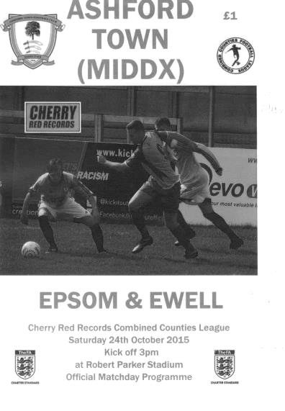
Away day joy tempered by injury to Hough

Under ominous, leaden skies we faced our first contest this season against a team in the top four when visiting the Robert Parker Stadium to do battle with table topping Ashford Town (Mx) but came through with flying colours, showing great attacking threat at first and great defensive cohesion when it was required.

The first item of note on the team sheet was that Dan Dean was still unable to play, having picked up an injury at Banstead. However, Sam Currie was back as was Matt Ferdinando, while on the left Beckett Oliver started the game and our two wingers gave us balance and width throughout the match. Dale Marvell and Alex McGregor were absent while Daryl Cooper-Smith was on the bench but not really ready to go as he was still troubled with injury too. Still, it was a lot better than our previous visit to Ashford in January when we just had the Manager and Assistant Manager on the bench!

We had a scare in the opening minutes when a clever one-two put their leading scorer Dan Fleming through but he pulled his shot across goal and out for a goal kick. It would not be long before he was regretting that miss as we then took charge for a while. Craig Hastings put a Ferdinando corner just over the bar whilst a low Currie cross from the right reached Matt Farrell but his shot was well blocked by the covering defender Samid Kazi.

Under the circumstances it wasn't surprising when we took the lead in the tenth minute and although Oliver's left foot cross had the pace taken out of it by a defender's header, it still had enough momentum to reach Farrell, lurking in space at the near post ten yards out and his header just dropped under the bar to put us one-nil up.

The home defence looked as solid as a house of cards on a windy day just then and less than a minute after conceding, a terrible decision by their defender to play a back pass had terminal consequences as Kyle Hough got there just ahead of Tyler Tobin, and in the ensuing collision between striker and keeper the ball bounced off Hough and dribbled over the line. Unfortunately Hough hurt his knee quite badly in the incident and took no further part in the game, and we just have to hope that he is able to play

again when we next take the field after our break.

At 2-0 up but now with Tom Neale on in place of our leading scorer we could have gone into our shell, but a challenge by Ferdinando set up Currie in the area and he ran on to the ball and casually smashed it into the top corner at the near post after 17 minutes to send the away fans into raptures.

Ok lads, 3-0 up, don't do anything silly to hand the momentum over. Oops! Just three minutes later Currie was at the other end but scuffed his routine back pass to Michael Eacott who was left totally exposed as Jack Beadle ran around him with the ball to open the home team's account. It was only the second goal we have conceded in the opening half of a league match this season, yet three minutes later they had another when a good break on the right ended with a shot smashing back out from Eacott's left hand post and when it was fed back in deeper, the ball was retrieved at the far post and the cross forced in by Kazi.

Game on! I was already thinking back to the last two games at Cove (1993) and Worthing (1984) where we had lost in ninety minutes after holding a three goal lead but I should have had more faith. Having said that, I suspect that if you had told anyone in the crowd that after a mad opening 25 minutes there would be no further goals in the game they wouldn't have believed you!

There were of course moments of concern. Matt Tanton and Fleming both picking up yellow cards on the half hour for the sort of thing that would have seen them sent off on another day, but if anything we were the closer of the two teams to scoring again after Alex McKay's long throw was headed less than a foot wide of the near post by Hastings with the defence flat footed.

The second half would teach us a lot about our players and whether they had the character and resilience to withstand the inevitable home barrage that was expected. The answer was a positive and resounding "yes". The excellent McKay and Farrell were everywhere, protecting our back four and hassling the opposition into mistakes and we actually created the better chances in the second half too. Rob Hendry intercepted a header back to Tobin and prodded his shot towards goal, only to see it roll agonisingly wide of the post. In fact, as they pressed for an equaliser we were frequently able to hit them on the break and probably should have extended our lead from one of those opportunities.

All in all though an excellent three points from our boys, and I must include a quick note for the opposition skipper Russell Canderton. With five minutes remaining and the home side desperate for an equaliser, McKay was injured and despite their situation, he sportingly knocked the ball out of play so that our man could receive treatment. A classy touch and we look forward to meeting them twice more later this season in League and League Cup matches.

Team: Michael Eacott, Sam Currie © Matt Tanton, James Taylor, Craig Hastings, Alex McKay, Beckett Oliver, Matt Farrell, Kyle Hough, Rob Hendry, Matt Ferdinando

Subs: Tom Neale for Hough (14), Reisse Griffin for Oliver (73)

Our recent meetings
Epsom & Ewell 0-3 Ashford Town (Mx)
Combined Counties League Cup – Third Round – Tuesday 12th January 2016

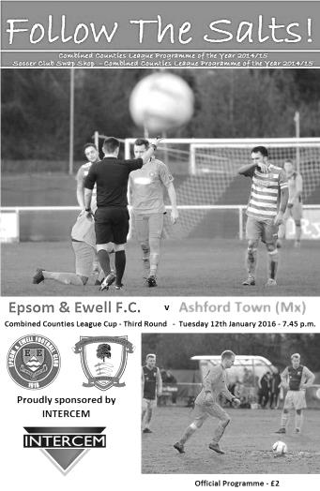
Salts depart League Cup with a whimper

After a two week break we came up against a very good Ashford Town side and were in the end comfortably defeated in this League Cup Third Round tie.

There were very few positives to take from this match in all honesty as we were caught cold by an early goal at the start of both halves, then conceded once more as we pushed to get back into the game. The visitors were well deserving of their victory and held the edge in every department, most notably up front where Dan Fleming scored all three of their goals, all of which were scored from inside the six yard box.

Upon looking at the team sheet it was disappointing to note the continued absence of Matt Ferdinando, Sam Currie and James Taylor, as their injuries have proven much more difficult to shake off than was at first thought. Taylor was on the bench as was Carl Downs, but neither came on. Throw in the suspended Matt Tanton and this left us without our first choice full backs for this important match. In place of Currie and Tanton were the versatile Alex McKay at right back, while our recently signed former Captain Jamie Hatfield would fill the left back slot, although by his own admission, he hadn't played for a while and it will take him a few weeks to get back to match fitness, lasting just under the hour before having to come off.

Under the circumstances it might have been better to face a team lower down the table but the League Cup had paired us with the league leaders and we were just going to have to make the best of it. However, we just didn't get going, and a break down our right flank ended up with a heavy touch from Matt Farrell who needlessly conceded a corner. From the short corner, one of many they exploited throughout the match, a low shot was sent in and it appeared that Michael Eacott was unsighted at first. Bearing this in mind, he did really well to get down and block the initial strike, but we didn't follow the ball in and there was Fleming, stood next to a visiting team mate who had the simple job of tapping the loose ball into the net while we looked forlornly at the Assistant Referee for an offside that wasn't there. We had only been playing for 100 seconds.

An early goal is always a concern, but you could argue that we were going to have to score to win the game anyway, so nothing had really changed, and we were nearly on level terms within a minute after a corner of our own was headed at goal by Craig Hastings, but Joe Green headed the ball off the line and from the half clearance Reisse Griffin sent a stinging shot a couple of feet over the bar from fully thirty yards.

Both sides looked dangerous going forward, with Savvas 'Agi' Panayiotou causing trouble with some early attacking runs, and the midfield battles were both combative and

competitive, but very little in the way of real interest really happened at either end with exception of a booking for either side. We then missed a chance to equalise in the 38th minute when from a free kick on the edge of the box was drilled in low by Rob Hendry and Griffin got a toe to it but poked the ball just wide of the near post with visiting keeper Tobin heading towards the far post.

As the half neared its end Griffin hit another powerful volley just over the bar from the angle of the penalty area after outmuscling a defender and Tom Neale saw his shot deflected for a corner after Farrell had originally broken through and challenged for a loose ball with Tobin. We did have a scare of our own in injury time when McKay sliced a ball across field and Fleming was onto it, just getting a toe to the ball ahead of Eacott, but his touch was heavy and the ball ran out for a goal kick before he could reach it.

If we thought we had got away with it after that narrow escape, those thoughts were crudely shattered within three minutes of the second half when we lost the ball in midfield after having a shout for a handball turned down and a ball over the top of our defence to their right winger enabled him to get to the line and pull the ball back across goal where Fleming was totally unmarked again and knocked the ball into the net in similar fashion to his first goal.

A similar move just moments later required a good save from Eacott and soon after Hastings was required to head clear a goalbound effort. We were struggling at this point but weathered the storm and in the 57th minute nearly got back into it when a Farrell cross from the left wing was caught and then dropped by Tobin under a bit of pressure from Neale. The ball fell to the ground and rolled in and just for a moment it looked like the goal had been given as there was no signal from either official before the referee just decided to award a free kick without blowing his whistle at any point. It was debateable whether there really was a foul by Neale, but those sort of incidents are usually ruled in favour of the keeper and so it went.

We were starting to exert a bit of pressure and when Neale and then Hough were fouled in the same move, the latter challenge earned a yellow card for the visiting skipper Canderton, but the move had been broken up which was the original intention and we were unable to make the set piece count. Neale picked up his own yellow card just after this before one of our substitutes Alex McGregor sent a strike towards the far corner but it was headed away by a defender and moments later the game was all over as another right wing cross was headed in by the unmarked Fleming at close range in the 77th minute with Eacott having no chance.

And they could have had two more as the visitors broke through again, but the first time the attacker was off balance the shot was sliced well wide and on the second, Eacott stood up well and made the save. Ultimately on a very cold night we produced a very cold performance and whilst it could be argued that we had been out of action for a week or two, we need to ensure that we improve for Saturday when Spelthorne Sports visit us for a League match or we will find our title chances slipping away as quickly as our cup chances did this evening.

Team: Michael Eacott, Alex McKay, Jamie Hatfield, Craig Hastings, Dan Dean, Savvas 'Agi' Panayiotou, Rob Hendry, Matt Farrell (c), Kyle Hough, Tom Neale, Reisse Griffin

Subs: Rhys North for Hatfield (53), Alex McGregor for Hendry (67) Beckett Oliver for Griffin (82)

Ryman League Division One South Table
Final Table | P | W | D | L | F | A | Pts | GD
Folkestone Invicta | 46 | 36 | 6 | 4 | 102 | 34 | 114 | +68
Dorking Wanderers | 46 | 27 | 9 | 10 | 99 | 56 | 90 | +43
Worthing | 46 | 27 | 7 | 12 | 96 | 56 | 88 | +40
Hythe Town | 46 | 27 | 6 | 13 | 74 | 49 | 87 | +25
Faversham Town | 46 | 25 | 8 | 13 | 76 | 45 | 83 | +31
Corinthian-Casuals (-3) | 46 | 26 | 7 | 13 | 75 | 52 | 82 | +23
Hastings United | 46 | 25 | 6 | 15 | 99 | 64 | 81 | +35
Herne Bay | 46 | 22 | 10 | 14 | 79 | 54 | 76 | +25
Molesey | 46 | 23 | 6 | 17 | 87 | 83 | 75 | +4
Carshalton Athletic | 46 | 21 | 9 | 16 | 83 | 74 | 72 | +9
South Park | 46 | 21 | 9 | 16 | 78 | 71 | 72 | +7
Ramsgate | 46 | 21 | 8 | 17 | 92 | 76 | 71 | +16
Guernsey | 46 | 21 | 5 | 20 | 94 | 88 | 68 | +6
Three Bridges | 46 | 20 | 6 | 20 | 59 | 67 | 66 | -8
Whyteleafe | 46 | 19 | 5 | 22 | 69 | 77 | 62 | -8
Walton Casuals | 46 | 18 | 6 | 22 | 74 | 85 | 60 | -11
Tooting & Mitcham United | 46 | 16 | 10 | 20 | 66 | 71 | 58 | -5
Sittingbourne | 46 | 16 | 6 | 24 | 63 | 77 | 54 | -14
Chatham Town | 46 | 13 | 7 | 26 | 61 | 70 | 46 | -9
East Grinstead Town | 46 | 12 | 7 | 27 | 55 | 84 | 43 | -29
Chipstead | 46 | 11 | 6 | 29 | 54 | 92 | 39 | -38
Walton & Hersham (-3) | 46 | 9 | 6 | 31 | 50 | 113 | 30 | -63
Whitstable Town | 46 | 8 | 2 | 36 | 52 | 118 | 26 | -66
Peacehaven & Telscombe | 46 | 6 | 7 | 33 | 48 | 129 | 25 | -81
Congratulations go to Folkestone Invicta who have been bouncing between Step Three and Four for some time now. Surely with this team they can retain their Premier status for a while.

The big story concerns our local adversaries Corinthian Casuals who were deducted three points just a couple of days before their big final match of the season at home to Three Bridges. The story as I understand it as that a suspended player, David Hodges was held out of a match against Sittingbourne, but when that was postponed, London FA confirmed that the next match; a County Cup tie would be the one that counted, so he missed it, apparently clearing the suspension.

However, after he then played in their next league fixture against Faversham Town, which they won, they were charged and despite the FA accepting that the club did nothing wrong, they were still fined and lost the points gained as the Ryman League had to follow the FA guidance!

There are no words I am allowed to put into this programme that could accurately describe how they must feel right now and the problem is that this could happen to any club. A similar situation nearly happened to us this year (see seasonal summary) and the rules HAVE TO be changed.

Anyway, on Tuesday Faversham Town took advantage of the unexpected bonus to win 2-1 at Dorking Wanderers but they now have to visit Worthing today, who were 7-0 victors over Hythe Town in front of nearly 1,000 people.

At the bottom Peacehaven & Telscombe, Whitstable Town and Walton & Hersham will drop to Step Five unless Walton get very lucky with reprieves which appears unlikely right now. We will almost certainly see them here next season in Combined Counties League action.

Evo-Stik Southern League Central Division Table
Final Table | P | W | D | L | F | A | Pts | GD
Kings Langley | 42 | 27 | 6 | 9 | 83 | 44 | 87 | +39
Royston Town | 42 | 25 | 8 | 9 | 99 | 46 | 83 | +53
Egham Town | 42 | 26 | 5 | 11 | 80 | 39 | 83 | +41
St Ives Town | 42 | 22 | 12 | 8 | 72 | 38 | 78 | +34
AFC Rushden & Diamonds | 42 | 23 | 8 | 11 | 81 | 44 | 77 | +37
Chalfont St Peter | 42 | 23 | 2 | 17 | 76 | 71 | 71 | +5
Northwood | 42 | 20 | 9 | 13 | 62 | 49 | 69 | +13
Aylesbury | 42 | 20 | 8 | 14 | 72 | 52 | 68 | +20
Beaconsfield SYCOB | 42 | 19 | 10 | 13 | 77 | 54 | 67 | +23
Godalming Town | 42 | 19 | 10 | 13 | 51 | 45 | 67 | +6
Ware | 42 | 19 | 6 | 17 | 67 | 69 | 63 | -2
Potters Bar Town | 42 | 16 | 10 | 16 | 62 | 64 | 58 | -2
Petersfield Town | 42 | 16 | 7 | 19 | 71 | 80 | 55 | -9
Bedford Town | 42 | 12 | 13 | 17 | 57 | 60 | 49 | -3
Uxbridge | 42 | 13 | 9 | 20 | 59 | 71 | 48 | -12
Arlesey Town | 42 | 14 | 5 | 23 | 48 | 87 | 47 | -39
Fleet Town | 42 | 12 | 9 | 21 | 55 | 78 | 45 | -23
Barton Rovers | 42 | 9 | 15 | 18 | 51 | 75 | 42 | -24
Aylesbury United | 42 | 11 | 7 | 24 | 45 | 81 | 40 | -36
Hanwell Town | 42 | 10 | 9 | 23 | 38 | 64 | 39 | -26
Leighton Town | 42 | 9 | 8 | 25 | 47 | 86 | 35 | -39
North Greenford United | 42 | 6 | 6 | 30 | 51 | 107 | 24 | -56
Over in the other southern half of Step Four, Kings Langley have now won three promotions in a row and will take their place in the Southern League Premier Division next season. Their win denied both Egham and Royston who met on the final day with a possibility of any one of three winning the title. They drew 1-1 to ruin each other’s chances!

And three days later they were both out of the playoffs! Egham Town were defeated 4-2 on penalties by St Ives Town, following a 2-2 draw at the Runnymede Stadium where they had led twice, while Royston Town were defeated by AFC Rushden & Diamonds 2-1 with their goal coming in injury time. So on Monday there will be a local derby as Cambridgeshire based St Ives host the better supported favourites from Northamptonshire.

At the other end, North Greenford United were down a while back and are probably headed to the South Midlands League, although you can’t totally rule out the possibility of a return to the Combined Counties League that they were promoted from in the first place.

Leighton Town are more unfortunate and an example of how other club’s fortunes miles away can have an effect without even realising. All season Farnborough have been threatened with a drop of two divisions if they had finished in the Ryman League Premier Division relegation positions. This would also have meant an extra Step Four reprieve and until Farnborough jumped out of the relegation places very recently they were holding on to that reprieve. It’s gone now!

They are not down yet though. All it takes is for one Step Five club to decline promotion as Flackwell Heath did last year, or for a club higher up to take a voluntary demotion or even fold anywhere in the Country and they would be the first club in the line to stay up. You never know.

Combined Counties League Division One Table
incl Tuesday 26th April | P | W | D | L | F | A | Pts | GD
CB Hounslow United | 30 | 22 | 5 | 3 | 69 | 25 | 71 | +44
Abbey Rangers | 31 | 22 | 3 | 6 | 71 | 32 | 69 | +39
Bedfont & Feltham | 30 | 22 | 2 | 6 | 85 | 39 | 68 | +46
Worcester Park | 32 | 18 | 5 | 9 | 79 | 40 | 59 | +39
Eversley & California | 30 | 18 | 4 | 8 | 80 | 47 | 58 | +33
Banstead Athletic | 30 | 16 | 6 | 8 | 71 | 46 | 54 | +25
Dorking | 32 | 15 | 1 | 16 | 64 | 61 | 46 | +3
Staines Lammas | 32 | 14 | 3 | 15 | 61 | 54 | 45 | +7
Cobham | 31 | 14 | 3 | 14 | 56 | 63 | 45 | -7
Ash United | 31 | 11 | 8 | 12 | 56 | 58 | 41 | -2
Frimley Green | 30 | 10 | 3 | 17 | 45 | 57 | 33 | -12
Sandhurst Town | 30 | 8 | 8 | 14 | 49 | 80 | 32 | -31
Sheerwater | 30 | 9 | 3 | 18 | 51 | 67 | 30 | -16
South Park Res | 30 | 7 | 6 | 17 | 49 | 80 | 27 | -31
Dorking Wanderers Res | 29 | 5 | 7 | 17 | 31 | 63 | 22 | -32
Epsom Athletic | 29 | 5 | 4 | 20 | 34 | 86 | 19 | -52
Farleigh Rovers | 29 | 6 | 1 | 22 | 33 | 86 | 19 | -53
Last time I reviewed the positions, I stated that the top three would come from the five clubs that were at the top back then. In fact two out of the top three at the time managed to stay there, with Eversley & California falling away and being replaced by Bedfont & Feltham, who always had games in hand to win the title but will, I’m sure settle for third place.

The main reason for this has been the consistency shown by CB Hounslow United and the superb form shown by League new boys Abbey Rangers, both of whom have now been promoted to Step Five for the very first time. The former are due to move into their new ground at some point next season, while the latter are not that far from us, sitting right on Chertsey Town’s doorstep.

Both will present an interesting challenge next term. Are they the next South Park? I’m sure that’s who they will both be looking to emulate in due course, although next season may well prove to be one of consolidation. The only club that came up to us this season was Chessington & Hook United and they are headed straight back down this season, so it is easy to forget how strong the standard at Step Five is these days.

At the wrong end of the table it has been a close battle, but right now it looks as though Farleigh Rovers could go from first to last, although there is still time to overhaul the clubs around them. We know Dorking Wanderers are leaving us this summer and that some new clubs will be coming up, but Farleigh, who have no floodlights, are especially vulnerable to an automatic relegation if the numbers get above a certain amount in this division, as they no longer possess a grading for this league.

Our friends Hoddesdon Town
Spartan South Midlands League – Premier Division
Incl Tuesday 26th April | P | W | D | L | F | A | Pts | GD
AFC Dunstable (C) | 40 | 31 | 5 | 4 | 116 | 32 | 98 | +84
London Colney | 39 | 27 | 8 | 4 | 93 | 30 | 89 | +63
Hoddesdon Town | 40 | 27 | 6 | 7 | 80 | 34 | 87 | +46
Berkhamsted | 40 | 22 | 7 | 11 | 90 | 58 | 73 | +32
Welwyn Garden City | 39 | 21 | 8 | 10 | 81 | 43 | 71 | +38
Hertford Town | 41 | 20 | 8 | 13 | 111 | 79 | 68 | +32
Biggleswade United | 41 | 20 | 7 | 14 | 64 | 53 | 67 | +11
Hadley | 39 | 20 | 4 | 15 | 72 | 52 | 64 | +20
Holmer Green | 39 | 20 | 3 | 16 | 79 | 80 | 63 | -1
Cockfosters | 40 | 16 | 13 | 11 | 73 | 61 | 61 | +12
Wembley | 41 | 18 | 6 | 17 | 71 | 59 | 60 | +12
Tring Athletic | 40 | 16 | 11 | 13 | 60 | 54 | 59 | +6
London Tigers | 39 | 15 | 9 | 15 | 59 | 69 | 54 | -10
Sun Sports | 40 | 15 | 7 | 18 | 72 | 79 | 52 | -7
Stotfold | 39 | 13 | 8 | 18 | 67 | 80 | 47 | -13
FC Broxbourne Borough | 39 | 11 | 7 | 21 | 56 | 92 | 40 | -36
Leverstock Green | 40 | 9 | 8 | 23 | 75 | 97 | 35 | -22
Oxhey Jets | 40 | 10 | 3 | 27 | 56 | 123 | 33 | -67
Harefield United | 41 | 9 | 4 | 28 | 41 | 99 | 31 | -58
St Margaretsbury | 40 | 7 | 9 | 24 | 53 | 95 | 30 | -42
Colney Heath | 40 | 8 | 5 | 27 | 35 | 85 | 29 | -50
Bedford | 41 | 8 | 6 | 27 | 57 | 107 | 27* | -50
* Bedford – three points deducted
There was a time not that long ago when Hoddesdon Town looked like they were going to win this division. After a poor season last year things had really turned around and a month ago they were top of the table.

But AFC Dunstable always had games in hand and they now become the second club from the town to enter the Southern League, following Dunstable Town, now plying their trade at Step Three.

They can however, sit back and look at a very successful season which of course included a run to the third qualifying round of the F.A. Cup, where they narrowly lost to Isthmian Premier League Brentwood Town after a replay.

Like us they have now earned an exemption to the First Round of the F.A. Vase and whilst we would not play each other in that round because of geographical boundaries, to be paired together in the Third Round would be a very interesting experience for both clubs.

From looking at the two league tables our two clubs would be very evenly matched!

Kyle Hough – 350 games and 200 goals!
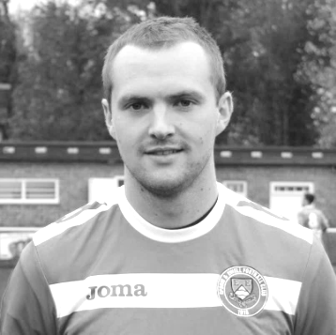
Against Hanworth Villa last Saturday, Kyle Hough made his 350th appearance for the club, becoming only the eighth player in club history to reach that milestone, and currently sits just five appearances from the sixth placed player, long serving Captain from the twenties George Mackesy and with former player and Manager Alan Webb between them on 352. Some very fine company to keep!.

Kyle has been with us for eight of the last nine seasons. He took a year out with Horley and had a try at Walton Casuals a few years back but for some reason didn’t have the success that we all thought he would, and their loss was our gain as he came back to us.

He was born on 8th December 1987 and joined us from Corinthian Casuals where he had played under Lyndon Buckwell before he became Manager of our club in the October of 2006. Kyle made his debut for us three days later than planned, on Tuesday 14th August 2007 against Colliers Wood United. It should have been at Chertsey Town on opening day but the game was postponed due to the referee being unhappy with the condition of the Alwyns Lane pitch following summer drainage works! We lost to Colliers Wood 2-1 on a very wet Tuesday evening and it took Kyle until his fourth game, ironically at home to Horley Town before he opened his account in our 2-1 win.

There were once many similarities with striking partner Robbie Burns, as they both made their debuts and scored their first goal on the same day as each other, but Robbie’s absence over the last few years has enabled Kyle to pull away from his former team mate.

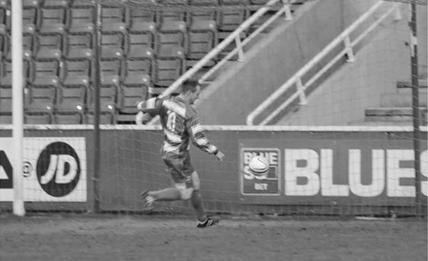
We have had very few players in recent years that are able to play in so many different positions, and Kyle often suffered for his versatility by being played out wide, but since being given the number 9 shirt midway through last season, he has found the net again frequently, and requires one more goal to reach the thirty goal mark for the third time in a season. It is the sixth time he has passed twenty goals; a huge achievement, especially when you realise that in his other two seasons with us he managed 17 and 18 and in neither of those seasons were we a top half team. Other legendary strikers at our club like Robbie, or further back Steve Hill and Jimmy Jones only had four seasons reaching that mark, so only Reg Marlow (7) and Tommy Tuite (10) sit ahead of him.

Kyle scores our first goal in the League Cup Final v South Park after 29 minutes on 10th May 2013

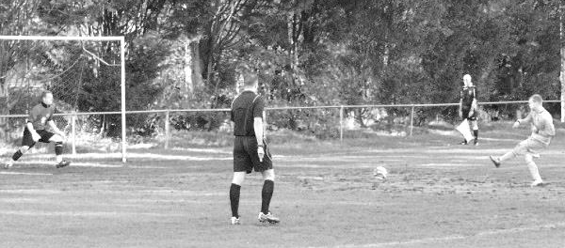
This is also reflected in the Club Hall of Fame, where Kyle sits proudly in third place out of the nearly 2,000 players who have appeared in our first eleven. It may be that he will always have these two prolific marksmen ahead of him, but Marlow sits “just” the 54 goals ahead as I write, so if Kyle remained with us and kept scoring at his current rate, he would pass him in 2018, by which time Kyle would still only be 30. It’s a tall order, but no longer is it an impossible dream.

Of course, mention also has to be made of Kyle’s complete re-writing on the history books with regard to penalties. Since his very first for the club in a 1-1 draw at Bookham on 4th September 2007 he has scored an incredible 55 penalties for our club out of 59 attempts. The previous record was 18!! He also holds another club record for scoring nine in a season, which he has done twice.

From a penalty save by Dean Cupit for Bookham on 16th February 2008 until he hit the post against Craig Bradshaw for Chertsey Town on 15th January 2011 he hit the mark 27 times in a row! The 26th of these was at Colliers Wood United and is shown below. Of all his penalties though, the most important ones came down in deepest Somerset when we edged Wellington AFC out by three goals to two after extra time and he scored twice from the spot.

He has scored seven hat tricks, including two in consecutive games at Hanworth Villa and Dorking and scored the opening goal in our League Cup Final win over South Park in May 2013.

When I reviewed Kyle’s 300th appearance in the Badshot Lea programme last season I wrote that Kyle hadn’t scored a home hat trick for the club and he promptly hit one that day. Kyle has never scored four times in a competitive match for us before, so that’s his next target set!

Achievement | Date | Against | Score
50th appearance | 03/05/08 | Horley Town (A) | 1-0
100th appearance | 18/04/09 | Bedfont Green (A) | 2-4
150th appearance | 28/08/10 | Flackwell Heath (H) | 3-2
200th appearance | 02/10/12 | Horley Town (A) | 1-1
250th appearance | 24/09/13 | Wembley (H) | 0-2
300th appearance | 07/03/15 | Cove (H) | 2-2
300th appearance | 23/04/16 | Hanworth Villa (A) | 3-2
50th goal | 27/10/09 | Ash United (A) | 1-4
100th goal | 05/01/13 | Ash United (H) | 5-2
150th goal | 13/12/14 | Badshot Lea (A) | 2-4
200th goal | 23/04/16 | Hanworth Villa (A) | 3-2

Brian Brumwell 1927 - 2016
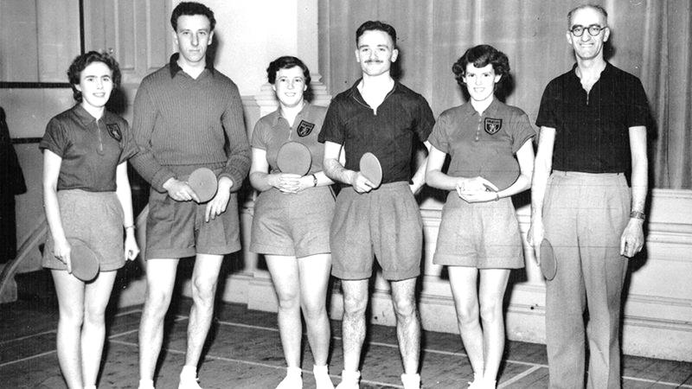
Very few of you will be familiar with a former Epsom player Brian Brumwell, who has recently passed away at his home in Essex at the age of 88. He had to be a good footballer to play at this level, but it wasn’t even his best sport! He was also very talented at cricket, but it was as a table tennis player that he excelled, playing for Essex and England, and entering the World Championships which he did in 1948, 1954 and 1955 and the British Open every year between 1950 and 1963, reaching the last 16 on three occasions. He made his debut for England in February 1950 (see picture below).

The local papers also referred to him beating the former World Champion Johnny Leach in late 1953, just two years after Leach, still our last British World Champion, had secured his second title. He was at one point ranked number 5 in the country and as Captain of the England Junior team in 1961 was also the person who recognised the precocious ability of Chester Barnes, the famous British player, having seen him at the age of fourteen. He resigned from the post on principle when they didn’t accept his suggestion to put Barnes in the England Junior team, but by the age of fifteen he would be ranked number one in the Seniors!

Frank Brian Brumwell was born in West Ham on 10th June 1927 and spent his whole life in Essex. He joined us at the age of 25 from Clapton, following an issue over training. Our new Player / Manager the England Amateur International Pat Lynch was made aware of this and secured his signing. It was a bit of a trek over in those days, with Brian and his wife Sheila getting the train to Waterloo Station where they would meet up with the Manager, coming down from his own home in North London, and travelling down to Ewell West together and walking the few minutes to West Street.

He made his debut for us on 8th November 1952 as we defeated Corinthian League and Cup Champions Hounslow by four goals to one at West Street and unsurprisingly kept his place in the return a week later when we handed out a complete thrashing 6-2 at

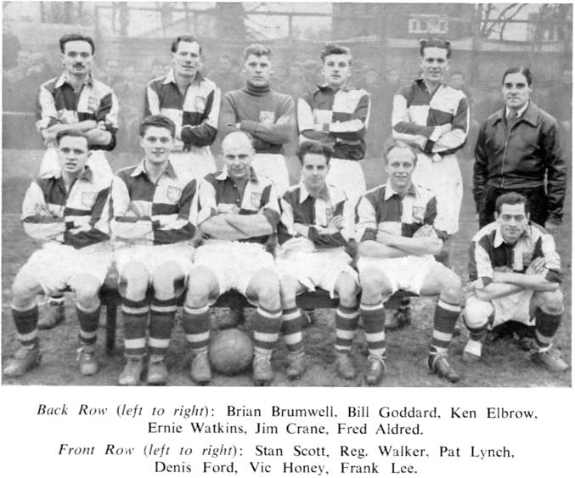
Denbigh Road. Whilst all the talk at the time was about Bill Goddard who was on an incredible run of scoring that would culminate with his fifth straight hat trick seven days later, Brian was almost overlooked playing at right-half in an old style 2-3-5 formation, but he became a regular in the first team, missing just the two matches until the end of the season. He even found time to score in our 4-2 home win over Maidstone United on 7th February 1953.

The Epsom team line up in November 1952 at the West Street end of the ground.
Back Row: Brian Brumwell, Bill Goddard, Ken Elbrow,
Ernie Watkins, Jim Crane, Fred Aldred (Physio)
Front Row: Stan Scott, Reg Walker, Pat Lynch, Denis Ford, Vic Honey, Frank Lee

In 1953/54 great things were expected of the team, following their third place finish the previous season. It didn’t start well as Goddard was replaced at first by Henryk Mikrut the former Wealdstone striker, but then more successfully by Bill Wiles who came from Woking. We added a couple of players from Lynch’s old Hendon days in Glyn Hinshelwood and Bobby Avis while Ron Holloway joined from Walthamstow Avenue after losing his place to another versatile footballer who was better known for achievements in another sport; Trevor Bailey the famous cricketer.

Despite these additions Brian remained in the team, although the travel was a bit difficult and in January of 1954 he left for Barking. However, he returned a month later saying that he preferred the atmosphere here! He made a further 26 appearances, scoring twice more against Grays Athletic in a 4-2 home win on 14th November 1953, and at home to Edgware Town in a bizarre 4-5 defeat on 24th April 1954. However, there were bigger matches on the horizon as the Surrey Senior Cup Final had been

reached after a pulsating two matches with Dulwich Hamlet in front of eye-wateringly large crowds at Plough Lane and Sandy Lane respectively. It was to be at Selhurst Park against Corinthian Casuals but unfortunately we were defeated 2-0. (see picture below)

For a while it looked like it would prove to be his final match for the club as he left at the end of the season, but then returned in November “after seeing service with several clubs” according to the local papers. He made a further nine appearances, scoring twice at Maidenhead in a 2-2 draw on 8th January 1955 from an inside right position where he found himself positioned occasionally. This match was also notable for an appearance in goal from former Manager and long serving player Ray Chenery.

But this season was one of struggle for the team. In October 1954 Hinshelwood was declared a professional, due to earnings received while at Eastbourne and a week later the great Pat Lynch was dropped by selectors, despite him being on the Selection Committee!

Although he returned to the side, we were struggling to avoid the wooden spoon and

matters came to a head when Lynch was dropped again for the League match at home to Maidstone on 19th March, after a run of 20 league matches without a win since the opening day of the season. The selectors wanted him to watch the match from the stands. He did just that and Epsom promptly won 2-1 against the team placed second in the league! The writing was on the wall and whether he knew it or not, Lynch had already played his final game, retiring shortly afterwards to run his business in Crouch End.

However, this match against Maidstone also proved to be Brian’s last for the club, providing him with a final tally of 62 appearances and five goals during his three seasons with us.

He left to play football for the Old Boys of East Ham Grammar School and cricket for Wanstead, to whom he gave service as Captain for six years in the 1960s, winning numerous trophies. He was an unorthodox but very effective top order batsman who once scored a century before lunch against a powerful Lensbury side. He also bowled, regularly having success when the front line bowlers were struggling.

But his first love always appeared to be table tennis and he continued playing regularly, eventually becoming President of the Ilford Table Tennis Association when he finally retired from playing Nationally.

I was very fortunate to meet Brian and his wife Sheila in January of 2015 in Loughton, Essex, following a chance discovery on the internet. They were both very pleasant and welcoming and although Brian was frail, he was keen to talk about his time at the club, with Sheila also able to fill in details. It is so difficult to chronicle our history without getting a chance to meet people. The local papers will list the results and the scorers, but won’t tell you about the people themselves. Brian became the fifth person from our 1954 Surrey Senior Cup Final team that I have met now, and I will be forever grateful for that too.

Although a talented footballer and cricketer, the final words must come from the obituary for Brian recently provided by Table Tennis England.

“In closing, how will we remember this great man? He was ferociously competitive, a visionary who was responsible for the golden age of Essex table tennis in the 1960s, but more importantly, he was a true gentleman, with a heart of gold.

“May you rest in peace Brian and thank you so much for everything you have done.”

Centre page for results

Centre page for results

Every Opponent A-Z
Over the years we have played many, many different opponents. Exactly how many is a difficult question, as it all depends on your definition. Are Camberley & Yorktown different to Camberley Town, or are Epsom Town different to Epsom F.C. or Epsom & Ewell F.C.?

In my analysis I have classed them as the same team, and will work through them all from A to Z. Some we have played many times, whilst others we have met just once or twice. Enjoy!

Southall: Played 31 - W11 D7 L13 - F51 A47 - PPG - 1.29 - Below Average

Despite Southall’s much missed ground at Western Road not being that far away from us, the first of our 31 meetings did not occur until 1975. The other statistic of note here is that the matches took place at eight different venues, which along with Dulwich Hamlet is the most different number of grounds we have played a particular opponent at.

Co-incidentally, one of our first meetings with Southall actually took place at Dulwich as we were drawn together in the F.A. Cup for 1975/76. At that time known as Southall & Ealing Borough, a brief change that did them no favours whatsoever, they were playing in the higher of what was then two divisions of the Isthmian League. We were three leagues below them in the Athenian League Division Two but had of course just returned there after our F.A. Vase exploits of the previous season.

Still, we weren’t expected to beat them, so a Trevor Lee goal in the first half provided hope, even if the tie finished 1-1 on our first visit to Western Road. Four days later on 17th September 1975 we entertained them at West Street where an entertaining match ended 3-3 after extra time. We finally subsided 5-1 in the second replay, played at Champion Hill and our goal, scored by Phil Walker would be the last he would ever score for the club before both he and Lee were signed by Millwall. The opposition weren’t too shabby either and in their ranks they had a young Alan Devonshire, who would go on to earn legendary status at West Ham over the next decade.

Our next meetings came in 1978/79 as members of the Isthmian League First Division. We had just won the new Second Division, while Southall had been relegated that season from the Premier Division but they would finish bottom and suffer a second straight relegation, although still defeated us 3-2 at Western Road in February 1979. Fortunately, we had already beaten them 4-0 in December at West Street with two goals from Tommy Tuite and Gerry Archer and we met them twice more the following season in the F.A. Trophy, drawing 0-0 there but winning the replay 4-0 again at West Street in October 1979.

Our paths were headed in different directions as we headed up to the Isthmian League Premier Division while they plodded along in Division Two. However, their illustrious history was to have one more successful chapter added to it with the arrival of Manager Gordon Bartlett. We first encountered him and his team on Tuesday 7th March 1985 in a London Senior Cup Quarter-Final when despite being two flights above them, they battered us 4-1 at West Street. Although it wasn’t reflected in the League table this team were built for cup success and in 1986 would reach Wembley Stadium in the F.A. Vase; a feat that Bartlett would repeat with Yeading four years later, replacing the losers medals with winners ones. Success and Southall would never be paired again.

By 1987/88 we were back down into the Isthmian Division Two South and we met for regular League meetings for twelve of the next fourteen seasons. We completed the double over them in 1987/88, with the away match being marked by a sponsored walk from Epsom to Southall by four supporters, myself, Darren Shaw, Gary Vickers and future Epsom and Ewell player Nick Cawthorne.

We even met Tommy Tuite in Hounslow High Street on the way there as he was playing a Vase tie at Hounslow in his one season as a Molesey player and happened to be walking down the street!

In 1988/89 and 1989/90 they did the double over us, with not even a goal to our credit in those four losses. In 1990/91 we secured two draws but at the end of that season, they went into Division Two and we dropped to Division Three when the leagues were reorganised.

But not for long as two seasons later they were relegated into Division Three themselves and the meetings, mostly low key, continued. By now, both clubs had lost their iconic grounds. We played Southall at Harefield United in an Associate Members Trophy match in 1992/93 and for our league meetings in 1993/94 they were playing at Tring Town, moving in 1996/97 to Kingsbury Town’s ground and in 1998/99 to Yeading.

These were difficult times for both clubs, but especially for Southall, and our trip to Silver Jubilee Park, Kingsbury on 21st March 1998 was watched by just 15 spectators, the lowest crowd for an Epsom First team match in history. Yes, I was one of them! By now they were regulars at the wrong end of the table and we won 5-0 and 6-0 at Merland Rise in consecutive seasons, both of which, in 1995/96 and 1996/97 ended with them finishing bottom of the Isthmian League.

They improved slightly but were back at the bottom again in the season of our final meetings in 1999/00. They finished with just 14 points, twenty adrift of nearest club Clapton and we won 4-0 at home and 3-0 at The Warren as they finally left for the Combined Counties League.

Five years of unspectacular football followed there, mostly in midtable but with a high point of fourth in 2003/04, although in 2005/06 they appeared to have turned the corner, leading the league in November of 2005, but by March they had been expelled from the league due to financial irregularities and never returned.

They weren’t quite dead though. They cleared their debts, dealt with another Southall club that existed briefly, and worked their way back. They currently play at Step Six in the Spartan South Midlands League, ground sharing at Reynolds Field; home of Hanwell Town.

The ground at Western Road was a little gem. Terraced all the way around with a couple of rather vulnerable looking stands perched there, it had real character that you just don’t see very often nowadays. It lost some terracing in the mid-eighties, then closed in the early nineties but didn’t actually disappear under housing for a few more years. It’s always sad when a ground goes, as any old Epsom supporter will confirm, but this ground was equally grand and unique.

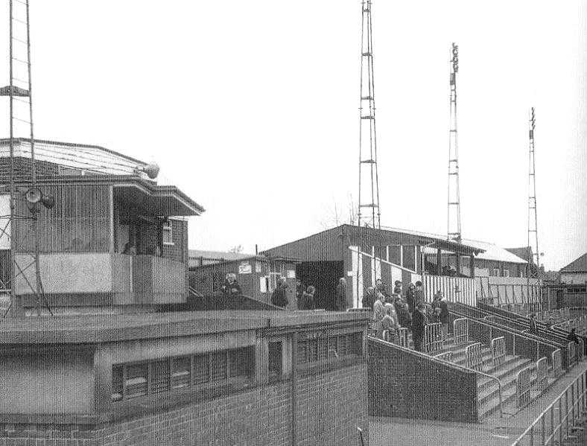
The popular side at Western Road

Malcolm Shelbourne – Looking back
Our kit sponsor Intercem’s Chief Executive is Malcolm Shelbourne. What people may not be aware of is that Malcolm was a player for us back in the late sixties. Here is Malcolm’s view of his time at the club…

-------------------------------------------------------------------------------------------------------------------------------------------------------------------------------------------------------------------------------------------------------------------------------------------------------------------------------------------------------------------------------------------------------------------------------------------------------------------------------------------------------------------------------
I joined the club, if I remember correctly, (it’s a long time ago) in the Summer of 1969. The idealistic 60’s were coming to an end and the materialistic 70’s were just about to start.

Epsom and Ewell were going through a difficult period, results weren’t great and the club needed a “shot in the arm”. This appeared in the appointment of Peter Norris, a master at the local Glyn School. Now Peter Norris was not one of your modern touchy-feely type coaches, he was from the old school of hard physical work and had a very, very loud voice.

Glyn School had a very successful football setup and several players joined the club from the school including Graham Peterson, Kelvin Gregory and Alan Payne (who coincidentally, remains my accountant to this day). However, the Athenian League in those days was not really a place for callow youth, it was a tough league populated by players who were not inclined to take too many prisoners. I think it would be fair to say that we also had one or two of those, Graham Hemphrey being one of particular note.

West Street was a “down at heel” stadium that had seen better days but still retained a charm which is missing from the modular grounds of today. The significant slope going away from the West Street end was particularly painful if you were down at half time and needed to flog “up the hill” to get a result in the second half.

My first game was in the Reserves against Horsham away and I remember being very nervous before the game. The club had a kit which for some strange reason that I was never able to fathom, was blue with black edging on the neck and sleeves. Anyway, we lost in my first game, I think it was 4 2 or something similar, perhaps Richard knows. My recollection of Horsham’s ground was of a very long covered terrace which took up the whole of one side. Like many others it has long since been demolished.

Pre-season training had been held at Headley Court in Leatherhead and as I indicated earlier, the military nature of Peter Norris’s preferred fitness techniques were given full expression during very painful sessions on hot late July evenings. When the season settled down, we trained at West Street or behind the ground in the local park.

There were no floodlights at this time, only training lights that were mounted on the top of the dressing rooms. Actually, to say there were no floodlights is

technically untrue, there were lights, but they lay motionless on the ground, lacking the finance to install them and put them to good use.

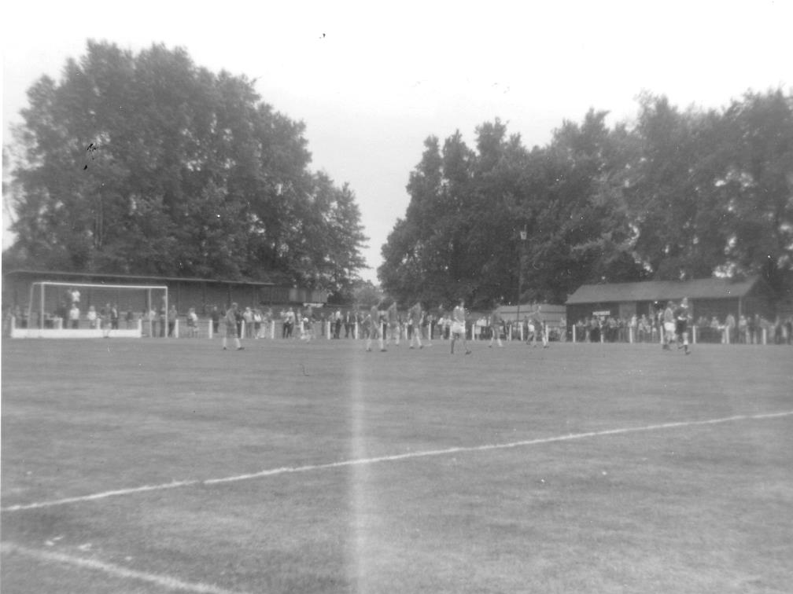
I remember that season for the long running saga of games against Whitehawk. I am reliably informed that there were three replays (no penalty shoot outs in those days) before we finally won through in the Amateur Cup, only to lose in the next round to Tooting & Mitcham United.

Another highlight of that season was an away game at Hemel Hempstead which was played in a very thick fog. The fog was so thick that I only knew we had equalised when John Farrington came swirling through the mist celebrating his goal. It earned us a point that day.

I enjoyed my playing time at the club, which is why I am involved today as a sponsor. It wasn’t a particularly successful period but I remember it with great fondness. In writing these few words I realise there is a much longer article to write. Unfortunately, I don’t have the time to devote to this at the moment but may return at some stage in the future, to finish the story.

Below: The West Street end in the early seventies. Note the covered terrace which was flattened in the mid-Seventies and replaced by the new Clubhouse

Our Kit Sponsors – Intercem
Established in 1985, INTERCEM is the global leader in events devoted to market developments, production, trading, transportation and handling of cement, clinker and related products.

INTERCEM ’85 was the world’s first independent, international conference dedicated exclusively to the global cement sector. In the years since, INTERCEM has continued to be “where the international cement industry meets”. No other similar cement industry meeting consistently attracts the numbers of senior, decision-making delegates found at INTERCEM meetings.

Totally independent and with all our time dedicated only to producing the market-leading conferences on cement, INTERCEM continues to lead the way for conferences in the industry.

Since the beginning, over 25,000 delegates have attended our meetings in 50 different cities across the globe. From Hong Kong to Houston, Beirut to Berlin and Mumbai to Marrakech, INTERCEM has created opportunities for the international cement industry to meet, open doors into new markets and face new challenges together.

As the market-leading conference for the cement industry, INTERCEM not only allows delegates to meet, discuss, debate with and learn from many of the most influential and experienced industry leaders, but to come away with new ideas and new contacts for growing and expanding their business.

INTERCEM for the future

The global cement industry has changed significantly since the first INTERCEM meeting at The Royal Garden Hotel in London in December 1985. Many factors have been instrumental in evolving the face of our industry, from globalisation to changing technologies, and from international financial crises to the emergence of new growth markets. Through this, INTERCEM’s commitment to the global cement industry has remained unwavering. In more than 50 cities across 6 continents our conferences have reflected the times, analysing and evaluating the changing opportunities and challenges facing the industry.

Our conferences continue to adapt with the times, and tackle the topics that are important to your business. In 2012 we launched the first dedicated forum for cement and clinker shipping, to allow attendees to explore this key subject in far greater detail than had previously been possible in the main conference programme.

It is our guarantee that INTERCEM will continue to bring you all the latest insight, analysis, forecasts and developments in the cement sector, as well as provide our delegates with the opportunity to meet, network and build business relationships face-to face in all regions across the globe.

INTERCEM will continue to be the market-leader for the cement sector, attracting more of the industry’s leading names, and gathering more senior delegates than any other independent meeting, and will remain “where the international cement industry meets”. We look forward to welcoming you to one of our forthcoming meetings either within or outside your region.

Date For Your Diary
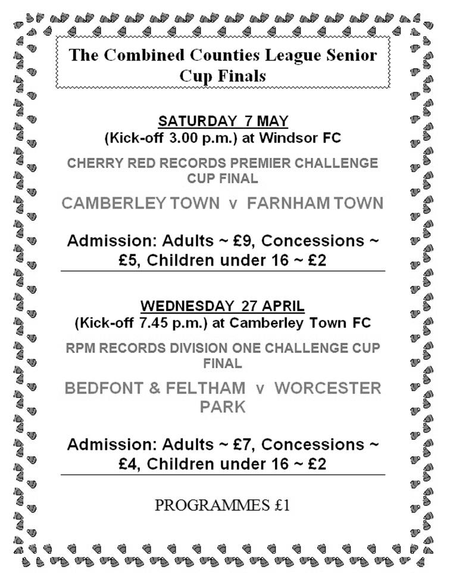

Where are they now? - Colin Bell
For those who do not recall the old days at Epsom, Colin Bell was a regular player. He played at the club for an almost unbroken run of 20 years from 1962 until 1982, while his father Noel was Chairman in the late sixties and older brother Robert was Secretary.

For those wondering what he is doing, Colin emigrated to Australia in 1985 and has lived there ever since. However, he visits occasionally, keeps in touch regularly and has written an article for the programme, explaining a little about his new life “down under” and his old life back in the days when much of it was spent at West Street.

------------------------------------------------------------------------------------------------------------------------------------------------------------------------------------------------------------------------------------------------------------------------------------------------------------------------------------------------------------------------------------------------------------------------------------------------------------------------------------------------------------------------------

AUSTRALIA, THE COUNTRY I LEFT ENGLAND FOR

In the Southern Hemisphere there is an Island surrounded by 3 Oceans, namely: Indian, Pacific and the Southern Ocean, and 4 Seas: Tasman, Coral, Timor and Arafura. In the Northern part, although not classified as seas, there is the Gulf of Carpentaria and the Great Australian Bight. This island, being the largest in the world, encompasses the UK and all of Europe including Russia. We call it “Australia” and after 43 years of living in England in November 1985 my family and I made this island our home.

Australia, part of the Australasian Continent, only has 18 cities, lots of towns and 23.5 million people spread out over the country. The majority of the population live in the cities and suburbs, but there are many who choose to live in the country, commonly known in Australia as the outback or bush. Its countryside is rather arid and shrubby due to the intermittent rainfall.

Our climate varies, we can get very hot and very cold weather, for example, in Windsor, New South Wales near where we last lived for four years, we had 4 degrees in winter, yet in the same year the temperature soared to 44 degrees! The fluctuating temperatures are due to its geographical location and inconsistent weather from all around the globe.

The one thing you can be sure of is that in the mountains south west of New South Wales, near Canberra, Australia’s capital city, and in Tasmania, we get SNOW! During the winter, skiing and other winter sports are very popular just as much as surfing is around our coast. Unlike the winter sports, surfing is an all year round sport, which is probably the reason why Australia produces such strong, fast swimmers. Because of the climate Australia also enjoys a lot of outdoor activities, which is why most Australians excel in sport.

We have more rain than England but it seems to come in a rush, more like sheet rain. However, unlike the UK it’s all over in a few minutes and gone, evaporated by the sun. It can rain steadily for a few days or even a whole week. From mid-spring (October) to the start of Summer (December/January) we experience periods of extreme heat, strong dry westerly winds and storms with this come the bush fires that affect all the States, some more severely than others. Sadly, during these hot dry spells, some of the devastating fires are started by arsonists. These fires can destroy homes, livestock, fauna and flora in a matter of days. Miraculously, the Eucalyptus trees can be charred to nothing and look like they’re dead, yet in a matter of days green leaves start to

sprout giving them a fluffy look and by next spring the trees have grown back as if nothing had affected them. The only sign giving these trees away are the blackened tree trunks. There are over 600 known species of Eucalyptus trees, commonly referred to as Gum trees. Then there are the Acacias, of which one is the Wattle bearing bright yellow flowers, most are very fragrant and is the National Emblem of Australia.

Then, of course, there are the friendly critters that inhabit this unique country of ours, namely: Koalas, Kangaroos, Wombats, Duckbill Platypus, Possums - the list goes on. None of these animals exist naturally in other countries, although some of Australia’s inhabitants are to be avoided where possible. These species are extremely dangerous and when bitten must be attended to imminently otherwise the bite could prove fatal. These creatures are: spiders like the funnel web, snakes particularly the brown, lizards, the frill neck has very sharp teeth, fish, especially the sharks and saltwater crocodiles. However, I can honestly say in the 31 years we have lived here we have only seen three dangerous snakes and they were more interested in getting away from us and into the bush. We see lots of redback spiders so called because of the bright orange/red mark on its back, if exposed by chance it freezes [you can’t see me, he he] non-aggressive easy to splat but still mildly poisonous!

Since arriving in Australia we have done a lot of caravanning which is great. We imported one caravan from England, but before we could use it, the Van had to be modified to meet the Australian safety standards. The other caravan, brand new, bigger, same brand {SWIFT} we bought here in Queensland. With this caravan we travelled all the way to Port Douglas/Cairns and back to Sydney, a distance of about 7,000 kilometres. The trip took us about three months, stopping at most of the towns on the coast and visiting friends and relatives on the way. Most retired people who own caravans, mobile homes, fifth wheelers and even trailer tents or tents who live in the cooler states when Winter comes migrate North to the hotter weather, the temperature is so different it’s well worth it.

Before I arrived in Australia, my brother-in law had already enrolled me into the local team called The Blaxland Redbacks [over 35s]. Three years running we won our league and cup. Several of us were getting fed up seeing the same faces each season so with two others from the team, who were German, I was encouraged to join a German team called “Concordia”. They had their own club in Sydney and were in The New South Wales State League. They also had an over 35s team. I stayed with them for 10 years.

Each year we took part in pre-season competitions on the Gold Coast, Queensland. We drove up on a Friday, which took about 14 hours. We played two matches on Saturday, and in the evening there would be a dinner and dance at the ANA Hotel where we stayed at discounted rates. Sunday we played two more matches and a final, if we reached it, and on Monday we drove home. On two occasions we stayed on at the Hotel, still at the lower rates, for a further week as a holiday. This worked in reverse at the end of the season when they and other teams would come down to Sydney and take part in a competition here, same system.

Because we have so many different nationalities in Australia it was easy for one club to

organize one called the “World Cup”. I played in this several times for the Germans, the South American teams disliked us and it was obvious by the draw as we always ended up playing the stronger teams which made it very hard to win the competition.

Alas, my football playing career came to an end in 2009 at the age of 67, due to having a hip replacement, followed by another replacement three years later (same hip) after contracting a very serious infection from the Hospital that ensued from a minor “so-called” day surgery to remove a calcified muscle, making it very painful to walk.

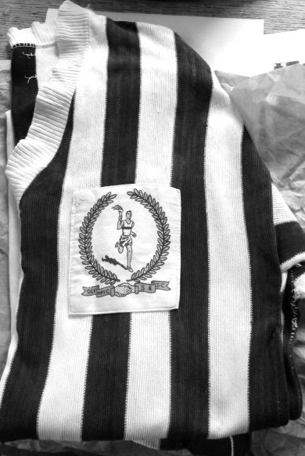
Now I will go back in time and tell you about my experiences playing for Epsom. I never kicked a football until I was 14 years old. Whilst I was at school, I preferred athletics and cross country running. I excelled in long jump, winning the Surrey County Youth Club long jump at Motspur Park with a jump of 20ft 6ins, unfortunately, I never got any better! Football came to the fore, playing for my father and brother’s team “The Olympics”, so called because of the year in which it was started (1956). We had an all age team and under 18s. (see picture above – Colin is second from the left at the back) (Also – see shirt, courtesy of Derek Harper)

The under 18s were good and won the Surrey Youth Cup in our last year together, however, at the final at Leatherhead’s ground, we were watched by Scouts from several senior clubs including Crystal Palace, who wanted the whole team to go for a trial, but when he heard the average age of the whole team was 18, they didn’t want to know. Epsom, however, were interested, so those of us who were keen went to see what it was all about. Ray Chenery was the Manager at the time, and during my time at the Club I saw 10 Managers come and go, but the best of all had to be Pat O’Connell, who was a very well-liked person, great personality and knew football inside out.

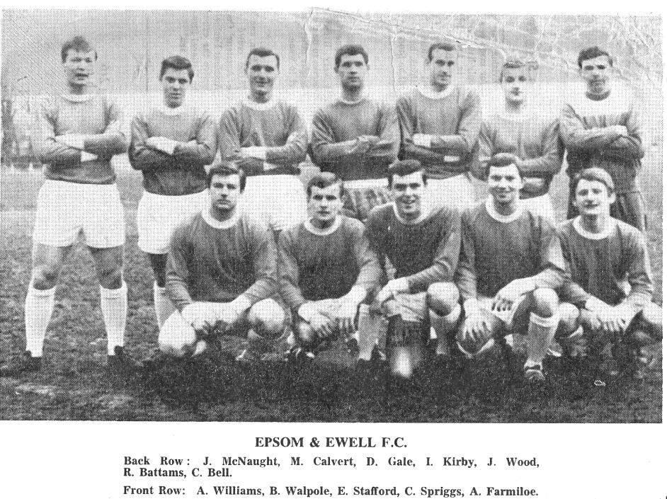
Colin is top right in this picture, the first team photo I have with him in, dated 11th February 1967. Note also Tony Williams our Player / Manager who went on to be responsible for the creation of the Non-League Yearbook
Below Colin lines up at Merland Rise for the Reserves in the Surrey Senior League Cup Final against Malden Town

I spent 20 years playing for the Club, but as I got older the games I played got fewer. Unfortunately, no-one was interested in the Reserves’ fixtures and results so no records were kept until Dave Wilson took up the challenge in 1973 and went with the Reserves to every game; what a lovely man he was. From memory I have put together as best as I can, my own playing career:

First team appearances approx: 157 subs: 6 cup matches unsure
Reserves team appearances: 339 subs: 3 cup matches unsure
Reserves representative inter county games: 3 (one against Middlesex League, another against Surrey Intermediate League Western Division and Surrey Intermediate League South Division.

I also took part in nearly all the cricket matches played against Ewell Cricket Club they were great fun.

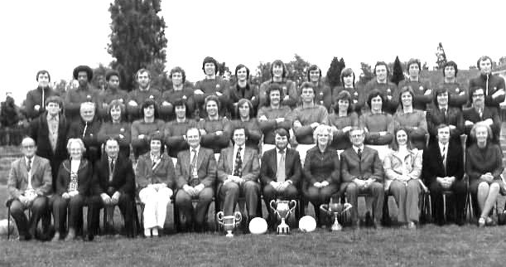
The big 1975 picture showing everyone who mattered at West Street back then.
Colin is sixth from the left in the middle row
x
My father and brother both served on the Committee as Chairperson and Secretary their respective wives served in the canteen and helped out wherever possible. My sister in-law’s father [Douglas Cox] was also Treasurer, while other Olympic Committee Members joined Epsom, namely: Derek Harper, Chas McLaughlin and Bill Carrick. The Club was running into debt and could not afford to pay the players their expenses. To alleviate the problem a player/friend called Chas Phillips and myself would cut and mark out the pitch and clean the dressing rooms every week. We built a lean-to on the side of the Dressing Rooms and modified the interiors.

In March/April 1967, I went to Montreal, Canada to drive one of the two Route Master Buses backward and forward to the site of the World Fair that went from the centre of town. I worked for London Transport as an auto-electrician and was selected to join the team. Between the five of us we drove and maintained the vehicles working seven days

Colin lines up in a 1976/77 pre-season first and reserve squad photo,
taken by Gemini Reynolds, the wife of our Chairman at the time, Beau.
Can you spot some other well-known faces, Tony Coombe and Marvin Hough?

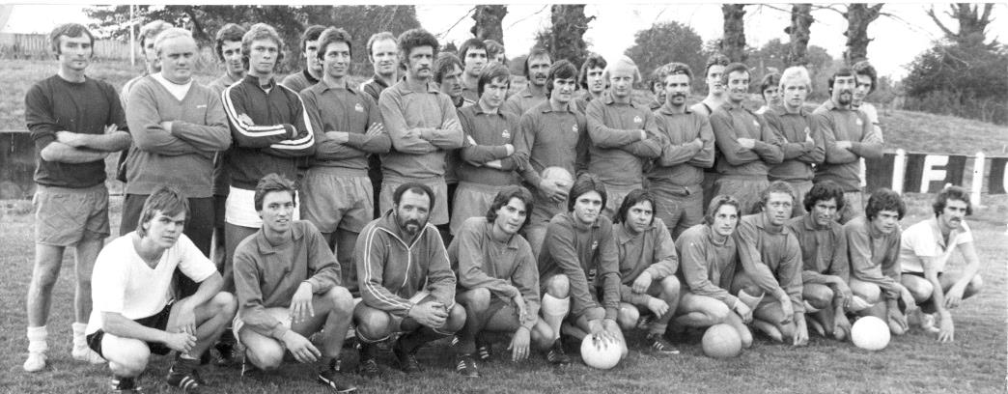
a week for over a period of six months. In that time we conveyed over 3/4 of a million people for free!

When I returned home in December 1967 my first game was on 9th December 1967 against Lillyshall St Heta in a Surrey Intermediate Cup. I scored a goal and Tony Seymour scored the other, winning us the match. It was at this point in time we were told we could have Wimbledon’s old 55ft floodlights as they were turning Professional. I spent all my spare time removing them and transporting them to our ground never to see them put to use and eventually they were sold to Windsor. (Ed – these were the ones Malcolm Shelbourne referred to in his earlier article)

Epsom and Ewell is a great Club, but it’s only as good as the people who run it and the players who play for it. Commitment and love of the Club is the essential ingredient!

COME ON YOU SALTS!
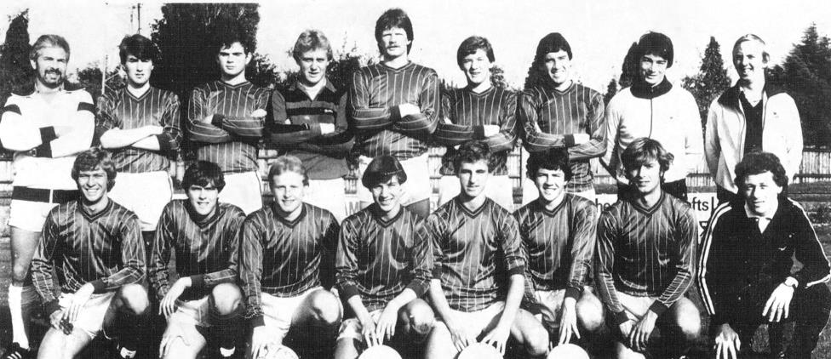

Colin’s final team photo on the left at the back before our Reserves defeated Sutton United Reserves 3-2 in the Suburban League at West Street on 23rd October 1982

Seasonal Summary
Following last season’s seventh place finish, my hopes for the upcoming season were limited.

This might seem an odd thing to say, but I made the cardinal sin of looking at our new players and judging them on where they had come from. Instead of previous players joining with Ryman League experience, there were a few new faces, but all from clubs that were of a lower level.

In place of the departing Anthony Panayi, Sam Robinson, George Murphy and Alex McGregor, all four moving up to Ryman League clubs, we had Craig Hastings and Reisse Griffin from Cheam, Beckett Oliver from Bookham, Rhys North, Rob Hendry, and of course it wouldn’t be a new season without an appearance from Dale Marvell! However, none of these new players, simply by virtue of their previous clubs was particularly impressive in my opinion. I am more than happy to admit being completely wrong on this as every single one of them contributed significantly to our team’s top four finish!

Other players like Dan Dean and Matt Farrell, the spine of the team, had good seasons while Matt Tanton and Matt Ferdinando would also prove to be extremely important to our cause during the months ahead, as was Daryl Cooper-Smith but more about him later!

Arguably the most important “capture” of the season was Kyle Hough. He had advised that he was probably going to stop playing with a third child on the way even though he was only 27, but there he was at the very first friendly of the season in the familiar blue and white hooped shirt. It was almost like we had signed him from another club!

And it was business as usual as he came on at half time in our first friendly against Banstead Athletic and scored within 14 seconds of the restart! The match finished 2-2 on a shocking surface at Surbiton Town and for future friendlies there we would be very quickly out to choose the left hand one of the two pitches; in truth it was little better!

We defeated Broadbridge Heath 2-0 before hosting Hoddesdon Town both at Surbiton Town. Although just a friendly it was our first meeting since the Vase Final in 1975 and had been negotiated at Wembley Stadium when officials from both clubs were invited by the F.A. to see the 2015 Vase Final and we just all got talking about a rematch!

We beat them 5-3 with Hough scoring four times and of course with Kyle in your team there was every chance we would have a good season. Lingfield were then dispatched 4-0 before a slip up at the Croydon Arena where we lost 2-0, largely down to a shortage of players. This was a concern, especially as we had needed to pull out of a friendly at St Francis Rangers the previous Saturday due to a lack of numbers. However, by the time the season started, those thoughts were forgotten.

We went into the season by retaining the Dave Wilson Trophy for the first time. Our third win in nine tournaments was secured with a come from behind 2-1 victory over our landlords Chipstead, who admitedly looked very poor on the night. “They’ll go down with that side” I recall saying to anyone who would listen after the match.

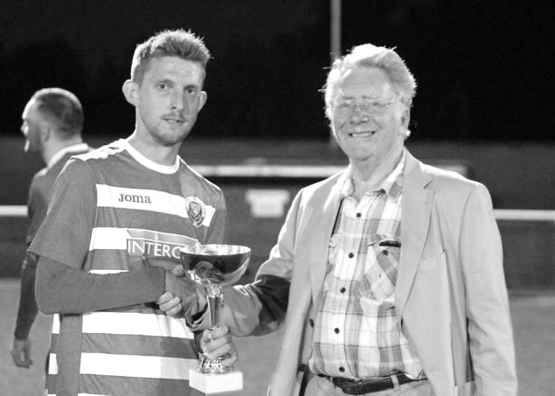
Sam Currie receives the Dave Wilson Trophy for the second time from our Chairman Pete Beddoe.

But that wasn’t our concern. We were looking forward to our opening match of the season at home to Windsor, one of the six clubs that had finished above us the previous year, 12 points higher, so we knew they would provide a real test. An even game on a sunny day appeared to be going our way when Rob Hendry scored on his debut with a nice volley. However, it all turned around in the opening minutes of the season half as we then conceded twice and required a rather fortuitous late penalty to secure an equaliser.

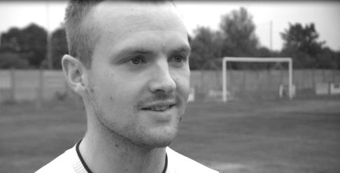
Kyle had of course scored the penalty, but he and Captain Sam Currie had no idea at that point that they would be on television within a week! The BBC had chosen us as their team of the round for the upcoming F.A. Cup tie at home to Erith & Belvedere and wanted to interview a couple of players for a seven minute segment on BBC London News and Sport. So on Tuesday, before our first league visit to Redhill for thirty nine years had kicked off, they came out for an interview about the game! Fortunately it didn’t put them off and it was Hough again who secured the points with a goal on the hour mark that was one of few chances in the game.

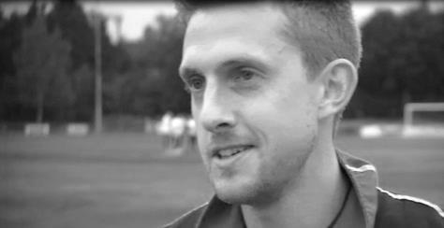
Our big match at home to Erith & Belvedere was a massive disappointment. We knew this would be a difficult tie against a team that reached the Quarter-Finals of the Vase last year. What we didn’t expect was that we would be trailing within 19 seconds and never recovered, conceding almost as quickly in the second half and eventually losing 4-0 at High Road. It was a chance to promote the club’s profile but a crowd of 151 just saw us fluff our lines badly. They were a good side, but we had to bounce back quickly.

On paper we couldn’t have asked for a better fixture to come up next. Sutton Common Rovers were now back in their home Borough after years at Cobham, sharing with Sutton United on their new astroturf surface. However, we had won our previous eight

matches against them and looked good to make it nine when Matt Farrell scored a great goal after some clever interplay between him and Hough. We should have had a penalty in the second half but Cooper-Smith made it 2-0 soon after with a neat finish. However, we conceded almost immediately and then near the end had a rather dubious penalty given against us with just four minutes remaining. Fortunately Michael Eacott guessed correctly to deny former Salt Jay Holden and the three points were ours.

If we were concerned about the refereeing display that day it was rapidly forgotten seven days later with a performance of a really low quality in a 0-0 draw at Westfield and I’m not talking about the players, although neither team on show were that good either! Decision making was poor and the game descended into farce. We also picked up our first red card of the season as Matt Ferdinando received two yellow cards and were then denied a Hough winning goal near the end for offside as he knocked in a rebound from an Epsom free kick. He may well have been offside, but because of some of the decisions that had already been made in the game, you just couldn’t be sure!

Still, it had to be said that we hadn’t really deserved all three points and our performances were well below last season’s high standard to this point, even though we had eight points out of twelve. An improvement was required for the visit of Raynes Park Vale on a torrential August Bank Holiday Monday but our first concern was who would go in goal. Eacott was working, so we had signed Conor O’Hara as cover; a keeper recommended by our former player Dave Tidy and who had apparently played for Portsmouth briefly. We’ll never know how good he was though, as he never turned up!

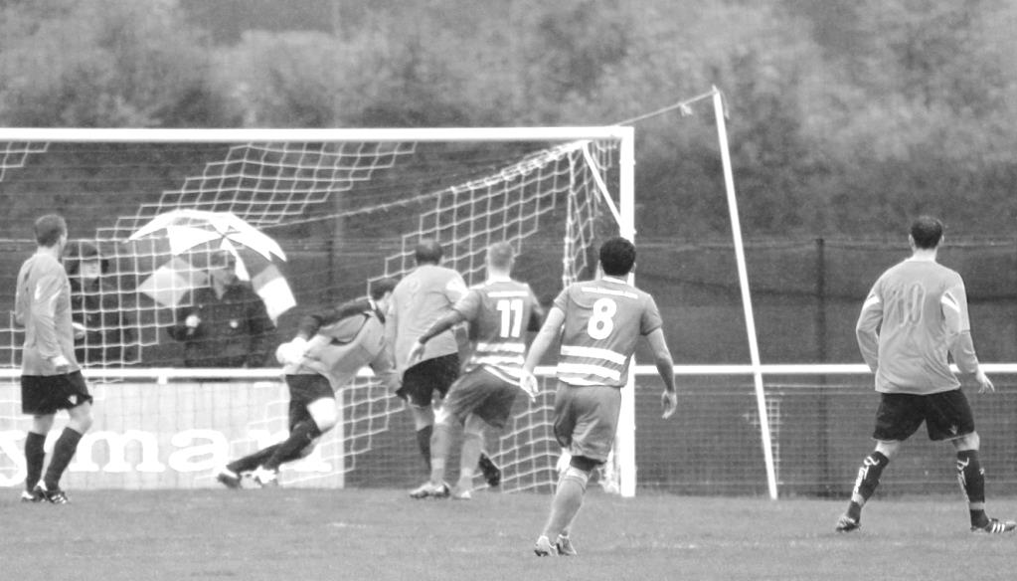
As spectators arrived they were confronted with a line up containing Cooper-Smith in goal. However, we needn’t have worried. Despite the horrible conditions for a keeper he dealt with the few things that came his way superbly and wasn’t at fault for the goal

that we conceded at the end, by which time we already had three to our credit, one of which was a comedy own goal to set us on our way (pictured on facing page).

It was a good time to produce our best display of the season to that point as we faced a horrible Vase tie at Horsham, played on the Sunday, due to their ground share with Horsham YMCA; recently relegated from the Ryman League and hoping to return immediately. Unfortunately we were unable to progress as we condeded early in the second half and despite Kyle having an equaliser rules out near the end, two late goals for our hosts secured our fate.

Ultimately, as a supporter these Cup defeats didn’t matter too much to me. The draws were horrible and we had arguably pulled out the best sides in Kent and Sussex at this level that we could, so there was no disgrace in defeat, even if there were to be no cup runs this year.

We were back in league action just two days later as we hosted Colliers Wood United and again won 3-1. Things got better still when we visited Spelthorne Sports on the Saturday. We knew they were struggling in the early part of the season and were able to take full advantage, winning there 6-2 and leading to a change of Manager for the home side as a result. Some of the goals scored that day were brilliant, not least a great volley from a corner at the far post from Hendry for our fourth goal (pictured below).

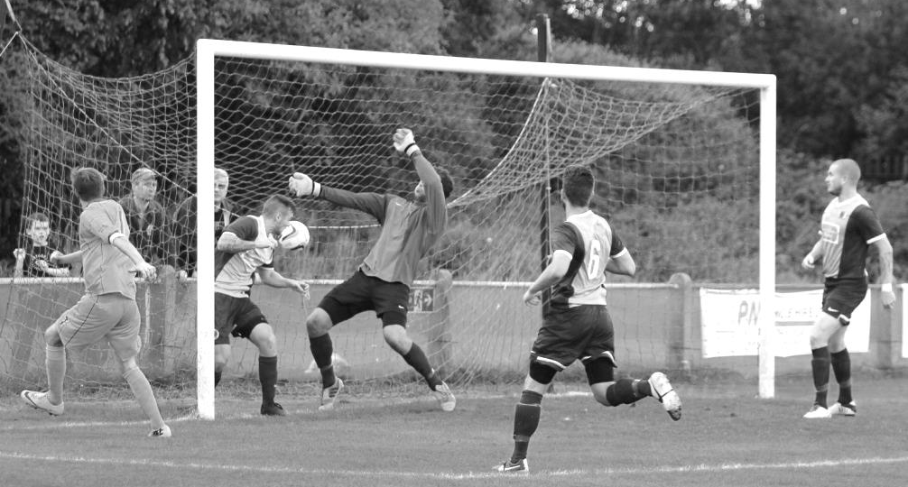
Although Spelthorne had been weak, we had been clinical and it remained to be seen how we would deal without leading scorer Hough who was to be away for two weeks for family reasons. As it turned out Matt Farrell put us ahead at home to AFC Hayes but a defensive miscommunication led to an equaliser that the visitors probably deserved before we hosted Farnham Town the following Saturday. This was a memorable match for two main reasons. The first of which was quite simply the best strike I have ever seen in my nearly 35 years watching Epsom & Ewell from Matt Ferdinando as Farrell’s cross was finished by an acrobatic overhead kick from 12 yards out that flew into the

top corner. The second was the decision of a red card for Craig Hastings, for a professional foul after 28 minutes, although if the referee had waited a few seconds, the Farnham striker would have gone on to score. I think both teams would have preferred the goal to stand, but we had to see the game out with ten men. As it turned out though, Farnham never did score and we held on to win the match 1-0.

Our next match was at Cove. They had lost a number of players and so it was important that we took advantage of their weakness. We did just that, scoring seven times at Oak Farm, only the third time we had achieved that many goals away from home since World War Two! Hough scored a hat trick while Hendry scored two and missed two golden chances at the end. It was men against boys but some of the goals were again quite brilliant. Kyle’s hat trick goal is shown here as he received the ball from a throw in and casually curled it over the keeper.

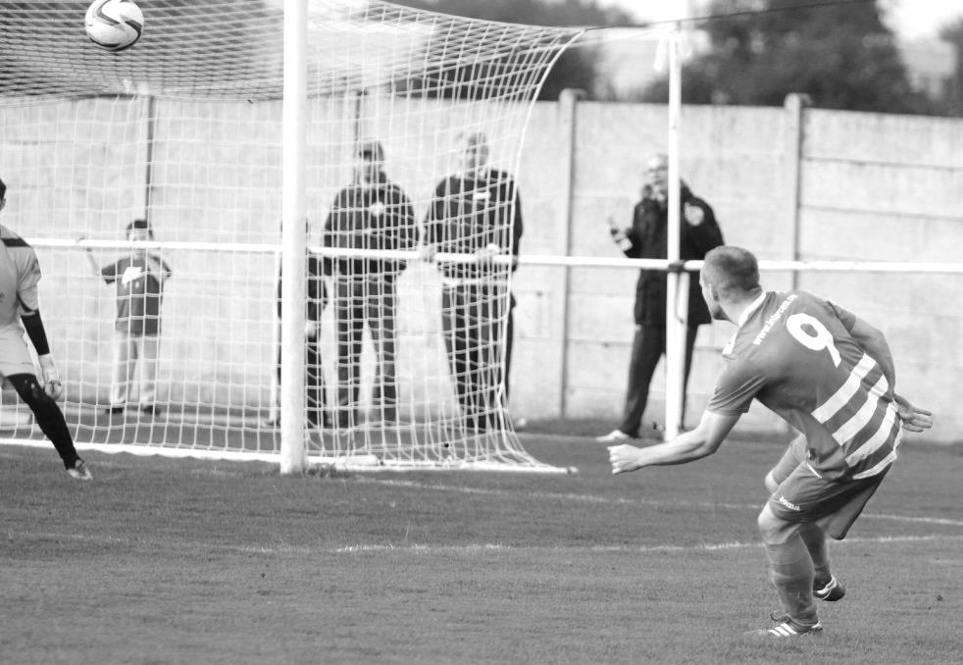
The match was won and no one really noticed the absence on the day of Daryl Cooper-Smith. However, unbeknown to most people even to this day, he had actually been suspended by the Surrey F.A. It transpired that he owed money from a couple of bookings he had received while playing briefly for Ashtead early the previous season. They had raised it with the County F.A. who then decided to suspend him, and then fine us for playing a suspended player, with the inevitable loss of points that would surely follow if this case were proven. We had no choice but to leave him out for this match.

This frankly was a joke. Daryl had joined us from the Army so there was no way our people could have known about this. In the meantime though, he had been booked at Molesey for us back in January and then sent off at Chertsey, so surely they should have told us sooner. It transpired that their administration was five months behind, yet our

club, manned solely by volunteers was about to be fined for their error. They even had the front to assume that the reason they hadn’t received the booking against Molesey was because the referee had listed Daryl as “Darren Smith”. We then were threatened with playing a player under an assumed name and te effect this could have on our Chartered club status!! Fortunately, to counter that threat, our Chairman and Secretary Pete Beddoe had retained the original team sheet to confirm that this was not the case.

Still, we were fined for “playing a suspended player” and Daryl was given a five match ban, an incredibly harsh punishment. Our club decided that enough was enough and took the incredibly brave decision to stand up to this farcical administration, appealing directly to the Football Association. In December both Steve Dyke and Pete Beddoe had to take time out to appear at Wembley Stadium in December where our appeal was upheld and the Surrey FA were instructed to pay the costs of the appeal! The final chapter came in January when we had to appear before the League on the basis of the original guilty verdict, but the league also realised where the actual error lay, applied common sense and gave us a suspended penalty instead.
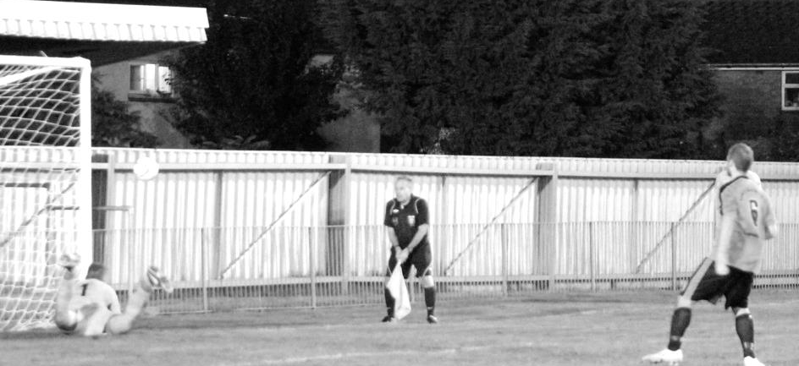
I could go on for a long time about this whole situation. It is extremely disappointing that the body that we pay to look after our welfare, chose to be so vindictive for something that we could not possibly have foreseen. So vindictive in fact that when I criticsed them on my private Twitter account, they even banned me for three games and fined me £75 under their wide ranging misconduct laws! If they had admitted their error right at the start then we could have all got on with our lives, but Pete and Steve incurred an enormous amount of their time in having to deal with this charge and should be highly commended for their work that essentially kept our season alive.

We had a Saturday off following the Cove win due to Hartley Wintney’s F.A. Cup exploits and then visited Banstead Athletic for a League Cup tie the following Tuesday where Alex McGregor put us ahead and everything looked fine. However, a late equaliser for the home side forced us into extra time and ultimately penalties, where we prevailed 7-6 to progress. It was an unpleasant game though and both Dan Dean and Sam Currie were out for a while afterwards. Eacott saves their first penalty in the picture below

There was no disguising that it had been a flat performance though and we followed it up with another on Saturday at home to Chertsey Town, losing our first league match of the season 1-0 to an excellent free kick fifteen minutes from time. Three days later our cup draw luck continued as high flying Ryman South Division new boys Dorking Wanderers visited for a Surrey Senior Cup tie and thrashed us 6-1 at High Road.

We then faced a trip to Ashford Town (Mx). They were top of the table at the time and in good form. It was therefore surprising to be 3-0 up inside 20 minutes at Short Lane as we cut them to pieces. Farrell, Hough and then Sam Currie put us ahead and although the home team scored twice to leave the score at 3-2 after 25 minutes, that’s how the match finished. Hough was brave in scoring his second goal and collided with the keeper in the process, dislocating his knee cap. He would be out for a little while and would remain hampered by the injury from time to time throughout the season.

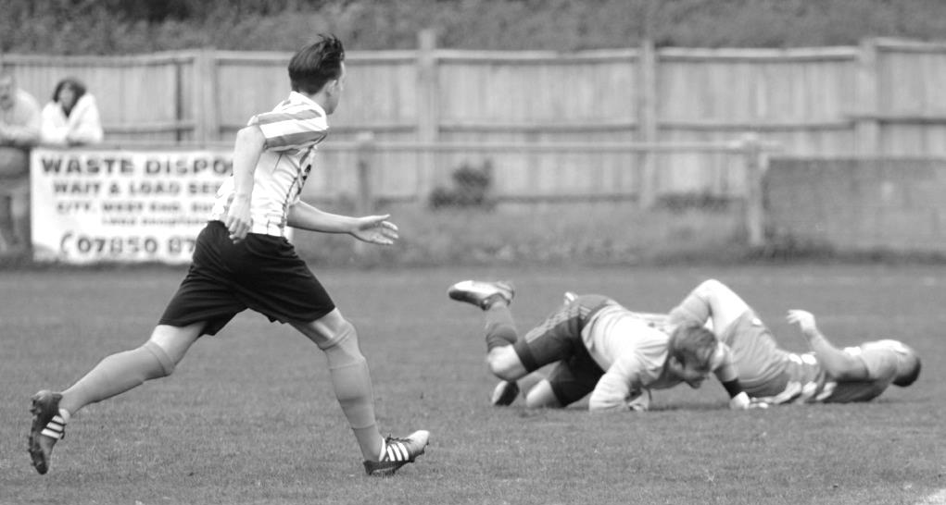
Kyle lies on his back, unaware that he has just scored our second goal against Ashford

After another Saturday off, we then hosted Chessington & Hook United the following Saturday, requiring a very late goal from new boy Tom Neale to clinch the 1-0 win. Two good performances followed but with only two points to show for our efforts as we led Knaphill for much of the game, only to concede a late equaliser, and then on the Tuesday 17th November when we secured a 3-3 draw at Hartley Wintney. On an extremely windy day we went behind fairly early but were level minutes later after a 45 yard strike from Ferdinando. Despite being the better side we went 3-1 down in the second half to a penalty and an own goal but a free kick from Ferdinando gave us hope and Neale scored another late goal which was the least we deserved on the night.

Hanworth Villa were dispatched by five clear goals at High Road before we visited Bedfont Sports for a fixture that would blight our season from that point onwards. It was apparent early on that our players were getting no protection from a poor set of officials and both sets of players started to get frustrated by the lack of decisions.

Despite this a Cooper-Smith header broke the deadlock early in the second half before we conceded a penalty for an handball by Matt Tanton, allegedly seen by the Assistant. It actually hit him “lower down” but the referee sent him off and the penalty was scored. We were then fouled in the middle of the park and Bedfont Sports scored directly from the breakaway.

We were feeling well and truly conned by this point and when Hendry’s left wing cross dropped over the keeper for a fortuitous equaliser, relief and anger in equal measure spilled over. Cooper-Smith was sent off for something he said and on the way off the field he pattted the Assistant on the shoulder. This innocuous contact proved to be a big mistake, as the Assistant then reported him for alleged violent conduct!

With all of the ongoing matter surrounding the earlier issue with our striker, the Surrey F.A. must have thought it was their birthdays and threw an 84 day ban at Daryl. This was apparently “reduced” from a higher amount due to mitigation but was still completely unfair. To have any ban for a number of days leads to imbalance because it is not an equal penalty. If Daryl had received this penalty while playing for Chessington & Hook he would have been suspended for 5 matches. If he had been a Camberley player it would have been 18! For us he missed 14 matches, while both Glyn Mandeville and Matt Smith were sent off, and also received misconduct charges.

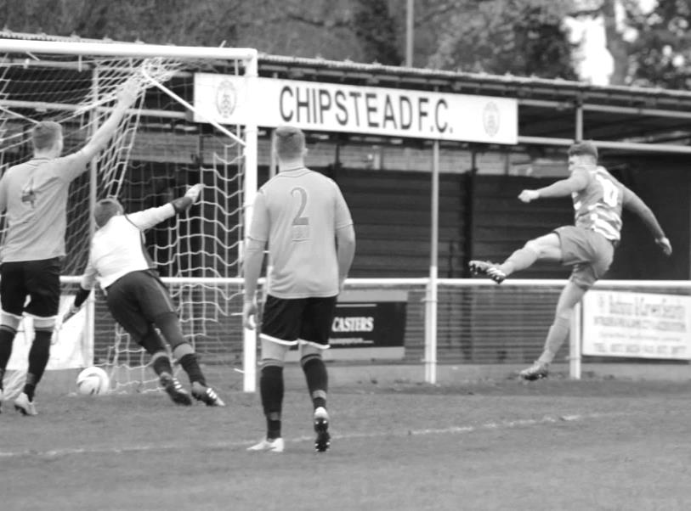
Before the suspension came through there was still time for Cooper-Smith to “sign off” with two superb goals in our 3-0 win at Colliers Wood United and we followed this up with a quite stunning first half display to defeat Guildford City 4-0 at High Road. A superb Ferdinando free kick gave us the points at Badshot Lea before three goals in the early part of the second half broke Sutton Common Rovers’ resistance with a 3-1 win. This marked the first time in club history that we had ever scored fifty goals in the League before Christmas! The only blot was a second yellow card for Tanton who would serve a two match suspension for his second sending off.

Tom Neale opens the scoring for us in our 4-0 win over Guildford City

Our Christmas fixture took place on 28th December and was a typically feisty affair at Horley Town. We trailed deservedly at the break but two penalties gave us the lead, following a Horley sending off and under the circumstances it was disappointing to be reeled in for a draw when conceding a penalty of our own towards the end.

We then departed the League Cup with an insipid 0-3 home defeat to Ashford Town (Mx) before losing our unbeaten away league record at Windsor. This was strange as we had led and were well in control but somehow lost 2-1! Still, we had nome narrow escapes during the season so I suppose they even out over time!

We defeated Redhill 3-0 in a League match before travelling to Camberley Town without Hough who was still feeling the effects of his October knee injury and needed some time off. Considering this, we played extremely well to secure a 1-1 draw and several chances were missed that could and should have given us the points against a team preparing for a trip to Hereford in the Quarter-Finals of the F.A. Vase.

Tom Neale scored the only goal at home to Bedfont Sports but our title challenge received a mortal blow when Hartley Wintney visited and won by the only goal in a tight match with Ferdinando being sent off towards the end for retaliation on former Salt Joe Paris. Then Horley came to High Road and defeated us 4-3 in a match where the scoreline definitely flattered us, trailing 4-1 at the half with only two late goals making the score look respectable.

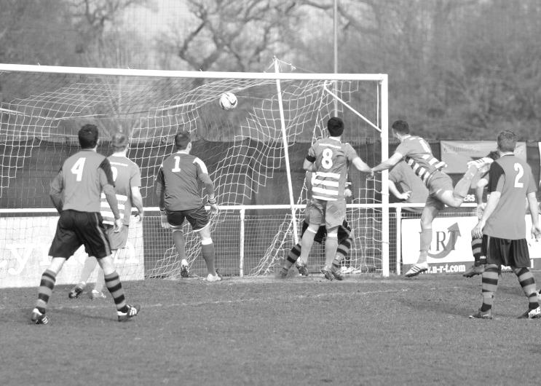
Another great Ferdinando free kick gave us the points in a narrow 2-1 win over Spelthorne Sports at High Road as we appeared to play as if the season was over. Far from it. Rumours started to suggest that Hartley Wintney would not be making the grading for promotion, leaving the door open for three teams to battle it out for second.

We then beat Chertsey Town 5-3 at Alwyns Lane in a match where we conceded two late goals, but then our discipline let us down again at home to Knaphill, where we led with a great move, finished off by James Taylor (pictured left) only for stand in keeper Adrian Jones to concede a penalty and red card for kicking out once he had already caught the ball. Step forward Dan Dean to take the jersey on, and he

then watched the penalty go wide. Incredibly he would then save a second half penalty too but the ten men were undone in the last twenty minutes by a fluke cross that dropped over everyone and a good move finished off with a thumping header to give them the points.

A 91st minute header from Matt Farrell gave us a 1-0 win against a rejuvenated Cove team who had failed to fulfil the fixture in December, while the following Tuesday at Farnham we were equally poor and required a superb final minute winner from new boy Bentley Graham in our 2-1 win at the Memorial Ground. (pictured below)

It was therefore disappointing, but not entirely surprising when we produced our third weak performance in a row and subsided 2-0 at home to lowly Westfield; their first ever win at Epsom in ten attempts.

We had seven matches left and needed to win the lot. The first four went well as we won 3-0 at Raynes Park Vale, 5-1 at Guildford City and 4-1 at home to Badshot Lea, before repeating our scoring achievement from October in a 7-0 win at AFC Hayes.

Unfortunately no one needs reminding of our 3-2 defeat at home to Camberley Town just two weeks ago, but we bounced back on Saturday with a 3-2 win of our own against Hanworth Villa and this will always be remembered as the venue where Kyle scored his 200th goal for our club.

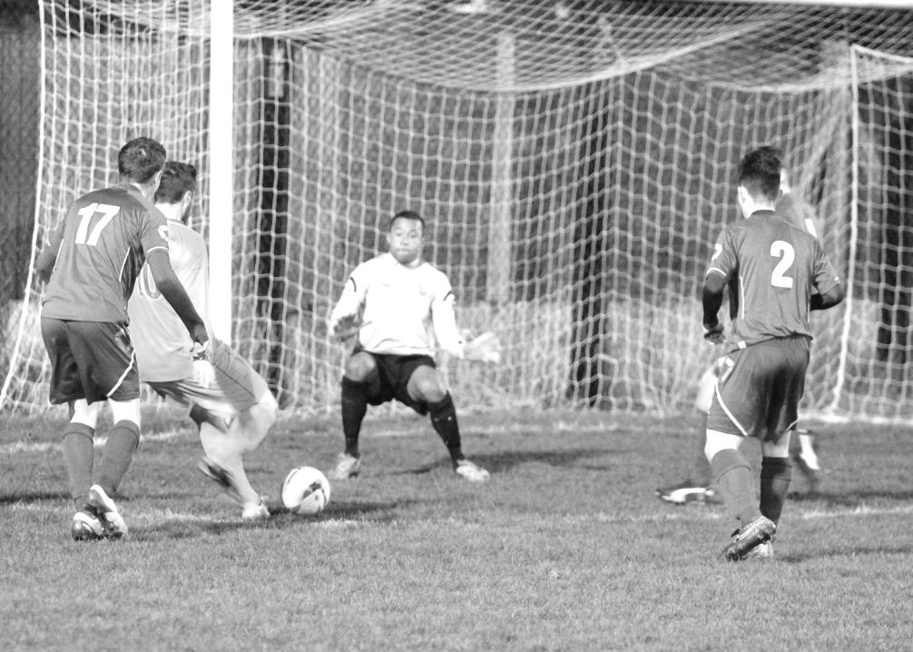
It should be remembered that this has been an exceptional league season so far and we also know that due to the Vase exemption it has earned us, we won’t be meeting Horsham in the Preliminary Round again! If we can keep a similar squad next year, and can keep a handle on our discipline, we have every chance of a title run next season.

Player Profile – Number 21 – Alex McKay
Our latest profile is from our versatile defender, Alex McKay.

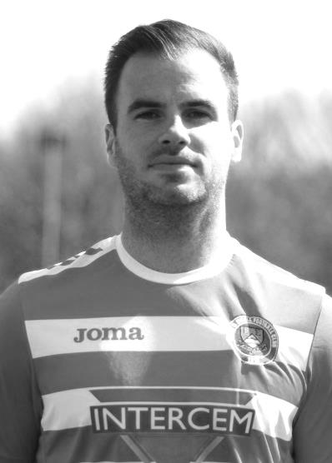
Age: 29

Position: Centre-Back

Club supported: Arsenal

Favourite Meal: Fillet Steak and Chips with Peppercorn Sauce

Favourite Film: Back to The Future trilogy

Messi or Ronaldo: Thierry Henry!

Favourite Drink: Lemon San Pellegrino or Havana Club & Coke

Favourite Ground played at: Stamford Bridge

Best moment for Epsom:
- Winning the Combined Counties League Cup in 2013
- Scoring the last minute winner against Windsor in 2014

Describe the Gaffa in three words: The - Train - Driver

Alex’s Playing Stats: First Team Debut : 20/12/2008

Appearances: 108 - Sub: 29 - Total: 137 - Goals: 8

Player Profile – Number 22 – George Murphy
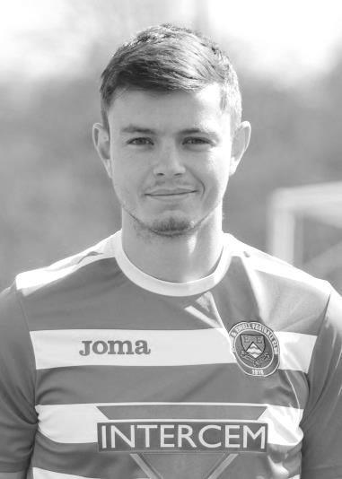
Our latest profile is from our recently rejoined defender, George Murphy.

Age: 24

Position: Centre-Half

Club supported: West Ham United

Favourite Meal: A good Steak and Chips

Favourite Film: White Chicks

Messi or Ronaldo: Messi

Favourite Drink: Baileys

Favourite Ground played at: Maidstone United

Best moment for Epsom: Winning the Combined Counties League Cup in 2013

Describe the Gaffa in three words: Big - Girls Blouse

George’s Playing Stats: First Team Debut : 19/03/2013

Appearances: 68 - Sub: 7 - Total: 75 - Goals: 3

Player Profile – Number 23 – Rhys North
Our latest profile is from our reliable defender, Rhys North.

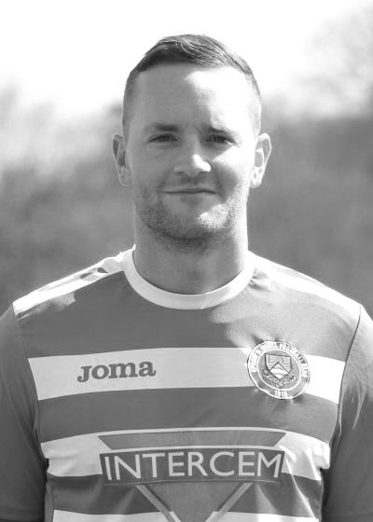
Age: 28

Position: Right-Back (versatile though!)

Club supported: Chelsea

Favourite Meal: Roast Dinner

Favourite Film: The Business

Messi or Ronaldo: Messi all day!

Favourite Drink: Dissarano & Coke

Favourite Ground played at: Got to be Chipstead!

Best moment for Epsom: First League goal against Horley in February 2016 – 35 yard screamer!

Describe the Gaffa in three words: Simply - Red - Crazy

Rhys’ Playing Stats: First Team Debut : 16/08/2015

Appearances: 17 - Sub: 7 - Total: 24 - Goals: 1

Profile – Our Mascot Today – Thomas Stonard
The final profile of the season is from our mascot today, Thomas Stonard. Thomas is also the cousin of our keeper Michael Eacott.

Age: 7

Position: Goalkeeper

Favourite Meal: Hot Dogs

School: St Paul’s Primary School, Hook

Football Team: Cobham Jets FC – under 8’s

Club Supported: Chelsea

F.A. Vase
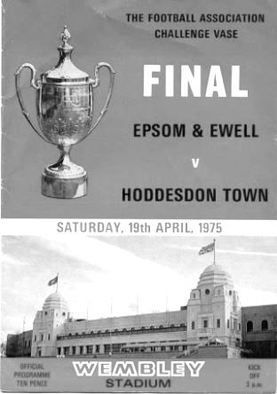
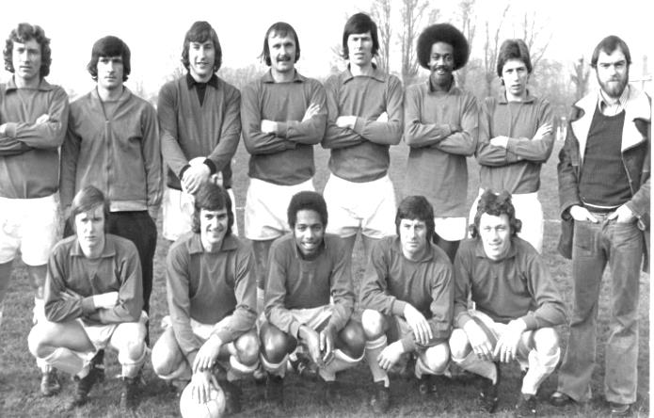
Fourth Round
Cleethorpes Town | 2-1 | Alvechurch
Hereford | 6-0 | Leicester Nirvana
Morpeth Town | 2-0 | North Shields
Coleshill Town | 1-3+ | Dunston UTS
AFC Wulfrunians | 2-3 | Nuneaton Griff
Sunderland RCA | 3-2 | Sleaford Town
Newton Aycliffe | 2-0 | Marske United
Bowers & Pitsea | 3-0 | Sutton Common Rovers
Kidlington | 3-2 | Knaphill
Newport IOW | 1-2+ | Ashford United
Moneyfields | 0-2 | Bristol Manor Farm
FC Romania | 1-2 | Camberley Town
AFC Dunstable | 0-3 | Salisbury
Berkhamsted | 4-2 | Hullbridge Sports
Hartley Wintney | 3-1 | Bradford Town
Bodmin Town | 1-3 | Ipswich Wanderers
Fifth Round
Ipswich Wanderers | 1-1+ r1-2 | Bowers & Pitsea
Sunderland RCA | 2-3 | Bristol Manor Farm
Camberley Town | 5-0 | Newton Aycliffe
Berkhamsted | 1-2 | Morpeth Town
Cleethorpes Town | 1-2 | Kidlington
Nuneaton Griff | 0-3 | Salisbury
Ashford United | 1-1+ r3-2 | Dunston UTS
Hartley Wintney | 1-4 | Hereford
Quarter Final
Hereford | 3-2+ | Camberley Town
Salisbury | 3-0 | Ashford United
Morpeth Town | 2-0 | Bristol Manor Farm
Bowers & Pitsea | 3-3+ r4-0 | Kidlington
Semi Final (two legs)
Hereford | 1-0 - 2-1 | Salisbury
Bowers & Pitsea | 2-2 - 1-2 | Morpeth Town
Final at Wembley Stadium - Sunday 22nd May
Hereford | V | Morpeth Town

Surrey Senior Cup
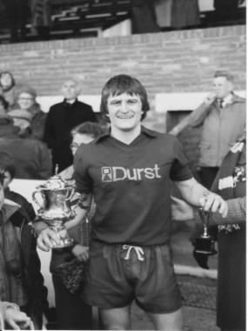
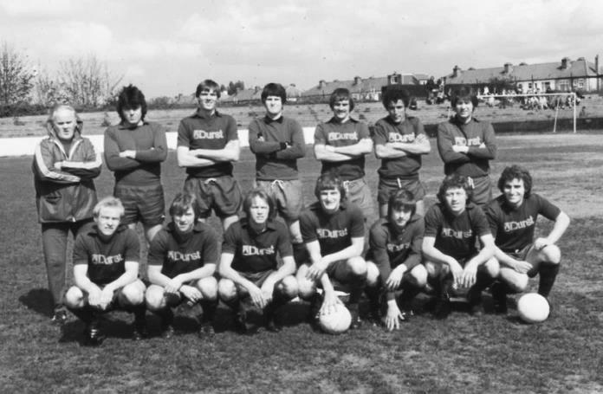
Second Round
Knaphill | 4-3 | Ashford Town (Mx)
Chipstead | 4-1 | Chessington & Hook United
Colliers Wood United | 1-3 | Whyteleafe
Corinthian Casuals | 1-1 CC 4-2p | Egham Town
Croydon | 3-3 F 3-2p | Farnham Town
Godalming Town | 1-0 | Guildford City
Horley Town | 2-2 BL 4-3p | Badshot Lea
Leatherhead | 3-0 | Carshalton Athletic
Merstham | 3-0 | South Park
Met Police | 3-2 | Dorking Wanderers
Molesey | 2-1 | Raynes Park Vale
Redhill | 0-3 | Tooting & Mitcham United
Sutton United | 3-0 | Walton & Hersham
Walton Casuals | 1-1 K 9-8p | Kingstonian
Westfield | 2-0 | Chertsey Town
Woking | 10-0 | Sutton Common Rovers
Third Round
Godalming Town | 1-2 | Tooting & Mitcham United
Godalming Town reinstated as Tooting & Mitcham United played an ineligible player
Whyteleafe | 6-0 | Farnham Town
Kingstonian | 0-1 @ LFC | Leatherhead
Badshot Lea | 1-5 | Merstham
Westfield | 1-4 @ Woking | Woking
Met Police | 0-1 | Molesey
Knaphill | 3-0 | Chipstead
Corinthian Casuals | 1-3 | Sutton United
Quarter Finals
Molesey | 1-3 | Woking
Knaphill | 0-1 @ Sutton | Sutton United
Whyteleafe | 0-3 | Godalming Town
Leatherhead | 0-4 | Merstham
Semi Finals
Sutton United | 1-3 | Godalming Town
Woking | 1-3 | Merstham
Final at Woking F.C. - Wednesday 4th May
Godalming Town | V | Merstham

EL Records Premier Challenge Cup
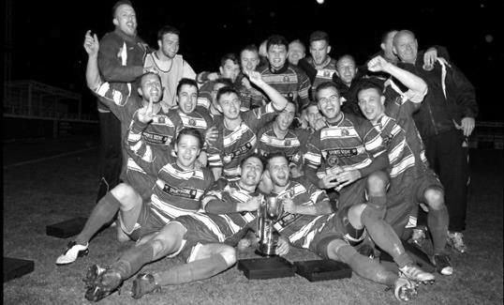
Second Round
Dorking Wanderers | 2-1 | South Park Reserves
Westfield | 1-0 | CB Hounslow United
Bedfont & Feltham | 1-5 | Colliers Wood United
Dorking | 0-3 | Knaphill
Badshot Lea | 2-4 | Spelthorne Sports
Hanworth Villa | 1-2+ | Chertsey Town
Ashford Town (Mx) | 2-1 | Epsom Athletic
Hartley Wintney | 4-2 | Horley Town
Banstead Athletic | 1-1+ | Epsom & Ewell
Epsom & Ewell won 7-6 on penalties
Sheerwater | 3-3+ | Frimley Green
Frimley Green won 8-7 on penalties
Farnham Town | 3-2 | Abbey Rangers
Camberley Town | 4-2 | Eversley & California
AFC Hayes | 0-1 | Banstead Athletic
Redhill | 3-0 | Sutton Common Rovers
Worcester Park | 1-5 | Chessington & Hook United
Cove | 1-6 | Cobham
Third Round
Camberley Town | 5-1 | Spelthorne Sports
Cobham | 3-0 | Frimley Green
Redhill | 0-2 | Farnham Town
Raynes Park Vale | 0-2 | Westfield
Epsom & Ewell | 0-3 | Ashford Town (Mx)
Colliers Wood United | 6-0 | Dorking Wanderers Reserves
Knaphill | 2-1 | Chertsey Town
Hartley Wintney | 0-1 | Chessington & Hook United
Quarter Finals
Camberley Town | 2-1+ | Colliers Wood United
Chessington & Hook United | 0-3 | Ashford Town (Mx)
Match played at Ashford Town (Mx) FC
Cobham | 2-0 | Westfield
Knaphill | 1-3 | Farnham Town
Semi Finals
Ashford Town (Mx) | 0-3 | Camberley Town
Farnham Town | 3-1 | Cobham
Final at Windsor F.C. - Saturday 7th May
Camberley Town | V | Farnham Town

90 years ago!
The 1925/26 season was of huge significance to our club. Not only did we open the season at our new ground in West Street, but we were able to commemorate it with our first Surrey Senior League title.

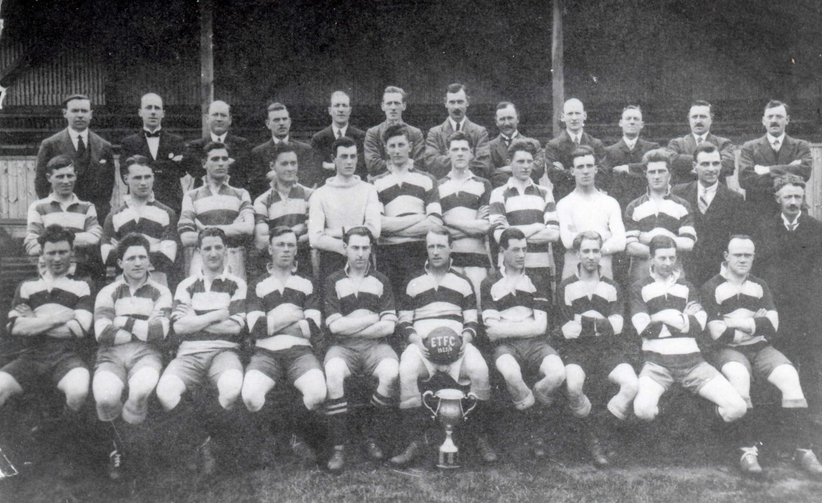
The players and officials are pictured in May 1926 in front of the main stand at West Street with the Surrey Senior League Trophy.
Sid Bristow, our Captain is pictured in the centre holding the football.

Following an appeal by Club Chairman Hugh Bradley during the 1924/25 season, our first as a Senior status football team, it was announced on 23rd May 1925 that we had completed negotiations for a private purchase of the Ewell Football Ground at a cost of £1,250.

The purchase was not without controversy. Originally the site of the Ewell Football club; a team that had reached the Final of the Surrey Senior Cup in 1899, it was used from 1890 until they folded in early 1905. Until the World War One in 1914 it was then used by the Old Boys of the City of Westminster School, better known as the Old Citizens.

During the war not much appeared to happen and when a new Ewell FC was formed in 1919 they were able to move in and play there for a few years. Indeed Epsom Town’s first visit there came as far back as 1922 when the two clubs met as members of the Sutton & District League Premier Division.

The controversy came because Ewell were still playing there at the time we purchased the ground and we effectively threw them out, providing a sweetener of £50 as some form of compensation, although this was quite an amount back in those days so maybe our club were either getting bad press or just felt guilty. Either way, this was a huge step for us, as with an enclosed ground, which our previous one at the Horton Sports Ground

was not, we were able to grow.

Of course, this would not have been possible without one other man by the name of Robert Bradshaw. He was one of four sons of Admiral Bradshaw and was a Principal of the brewing firm Taylor Walker & Co. He had heard Bradley’s appeal and was able to help, providing £500 towards the costs outright, and loaning the club the remaining £750 interest-free on the basis that it would be paid off within 21 years. Bradshaw was a former Captain of Epsom Golf Club and would have been familiar with the two talented golfers that were also proving themselves adept at football, the Sperring twins, Ernie and Reg. Both were the main drivers behind the formation of our football team.

The Epsom Herald reported the acquisition of the ground as follows:

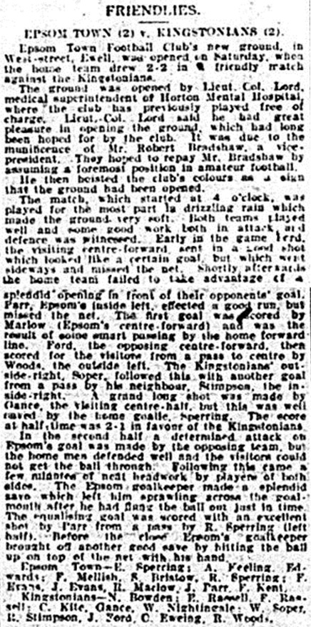
"If appreciation of what Mr Bradshaw has done is shown as it should be shown, and the lead he has given, followed, then the Ewell ground will again be the scene of fine senior football, as it was in the days when the brothers Walters and other brilliant players made the tree-encircled space, the objective on a Saturday afternoon of many people who loved the real sporting football to be witnessed there"

The Brothers Walters were full England International players, long before the Nevilles or indeed the Charltons had been born. It was a tough act to follow but our people were up to the task as the venue would remain in use for a further 68 years.

The ground was officially opened with a Friendly match against Athenian League Kingstonian F.C. on 5th September 1925. Our President, Lieutenant – Colonel J.R. Lord C.B.E. the Superintendant at Horton Hospital declared the ground open on a rainy day that curtailed his opening speech. The report of the match is pictured here:

"I have much pleasure in raising this flag to celebrate the opening of the new ground so long hoped for by the Epsom football club, a ground so necessary for the club's further advancement. It is largely owing to the munificence displayed by Mr Bradshaw towards the club that I have the opportunity of performing the ceremony, and I look forward to the time when Mr Bradshaw will be repaid for all he has done

for us, by his seeing the Epsom Town F.C. occupy a foremost place amongst the ranks of the first class amateur clubs. I have much pleasure in declaring this ground open."

Our star striker Reg Marlow was the first player to score a goal in the “new era” although the visitors fought back to lead at half time. However, a Jack Parr equaliser in the 85th minute enabled us to draw 2-2 and the signs looked good for a fine season.

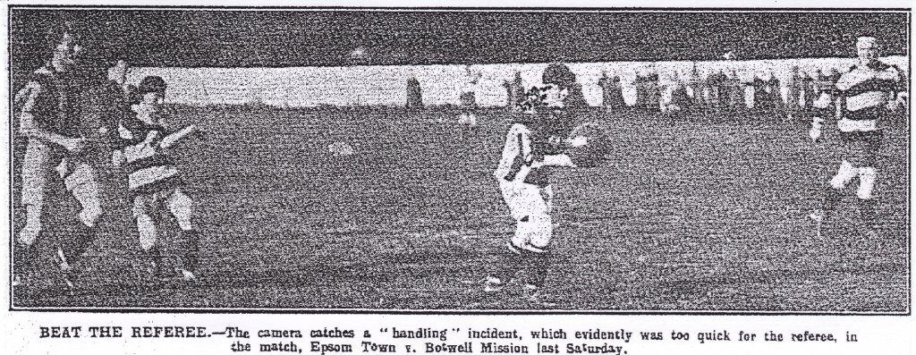
The opening results were somewhat disappointing. A narrow 3-2 win at Godalming was followed by a disappointing exit from the F.A. Cup by the only goal at West Norwood, even though the result was no real surprise as they were an Athenian League club, we had defeated them the previous season in the Amateur Cup and probably fancied our chances. The following Saturday we were crushed 5-1 in a friendly challenge match by Botwell Mission, another good team that would change their name a couple of years later to Hayes F.C. The pictures below were the first ones to appear in the local papers, showing West Street, although admittedly, not much of it!

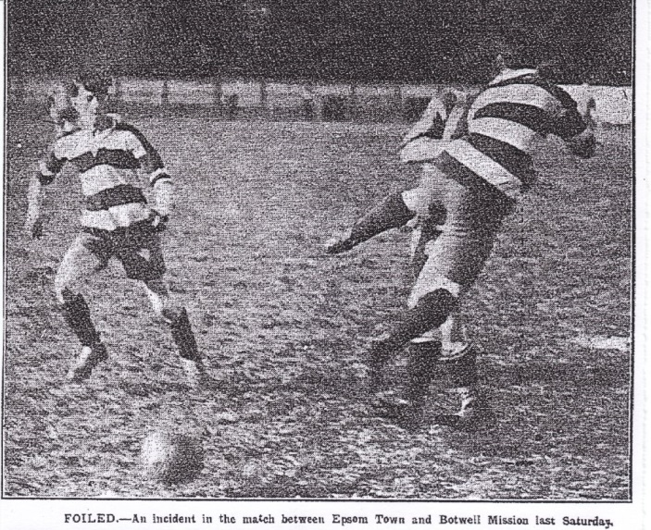
Following that defeat, things got worse as local rivals Sutton United came here on 10th October 1925 and won 1-0 with a second half H.S. Streeter goal, to hand us our first ever senior competition defeat at West Street, although 1,500 were present so clearly the interest was significant.

How significant? Well the following Saturday we hosted the Casuals Reserve team in a friendly and despite this match

not being quite so glamorous, 500 were present to see an F.E. Kent goal in the first half that proved to be the only one of the match.

These matches were part of the competitive calendar back then with what we call friendlies now being described as trial, or pre-season matches. The club included them back then in their official records, so who am I to argue!

We were into mid-October by now and had only played one Surrey Senior League match! We started to play some of these fixtures now, winning 3-1 at Egham and 3-2 at Walton on consecutive Saturdays with Tommy Evans scoring twice in the first match and Thomas Edwards, a regular full back playing in an advanced role scoring twice in the second match, played at Walton’s ground at the time, Mount Felix.

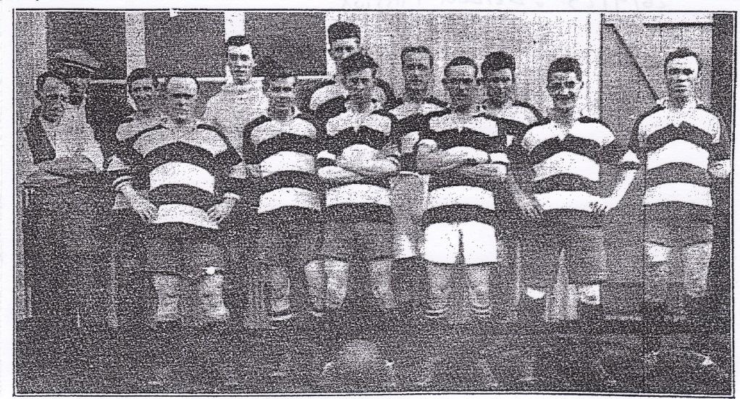
The first ever team photo at West Street in front of the wooden dressing rooms on 26th September 1925 against Botwell Mission.The dressing rooms we recall were built in 1956.
Tom Kirk, A.Puddock (Linesman), S.Perry, Micky Smith, Ernie Sperring, Bronk Challis,
Fred Keeling, Reg Marlow, Sid Bristow, J.Kent, F.Mellish, F.E. Kent, Tom Edwards.

We returned home for a Surrey Senior Cup tie against Godalming who were soundly beaten, despite a scoreline of 3-2. Finally, on Saturday 14th November 1925 we played our first ever home League match at West Street against Leyland Motors. Regrettably the Motormen spoilt the party with a 1-0 victory but we would go on to win our next twenty home League and League Cup ties at West Street, following this match.

The next two Saturdays we had identical trips with identical results as we visited Weybridge, firstly in the League and then in the Surrey Senior Cup; a 1-0 victory being achieved on both occasions. As we entered December we won 3-2 at Pixham Lane, the old home of Dorking F.C. but were handed a lesson by Redhill in the East Surrey Hospital Cup, being defeated 8-2 by the powerful Athenian League team. The score was 8-0 at one point but future Epsom player “Snowy” Goddard left the field injured, enabling us to pull a couple back for a tiny bit of respectability.

We had a week off before Christmas and recommenced on Boxing Day with a comprehensive 8-0 home win over Reigate Priory. We followed this up with a 6-0 defeat of Leyland Motors in the Surrey Senior League Cup in “treacherous conditions” to open up the New Year.

Our club was putting a regular eleven into the field these days, starting with Ernie Sperring, the best keeper in the area, who would shortly earn Surrey Senior League honours and a trial with Charlton Athletic. In front of him in the old style 2-3-5 formation was Fred Keeling, another original player from our 1918 foundation, (although his brother Harold was spending more time in the Reserves by then) and Thomas Edwards, a more experienced defender that had joined us during the 1923/24 season from Ashtead.

One of the benefits of moving up to this level was that we were able to attract untried players with quality from our local surroundings and in our three man midfield we had another former Ashtead player, right half F.Mellish. Alongside him was our Captain and future Trainer Sid Bristow, an experienced player that spent much of his time playing in South London and Kent but had moved to Epsom and joined up when we entered the Surrey Senior League in 1924. To his left was Reg Sperring, the clever left half and younger twin brother of Ernie, who also knew where the goal was.

Up front we were not quite so settled on the right wing, although F.E. Kent would make quite a few appearances at outside right, while inside him was Tommy Evans who had joined that year. The aforementioned H.S. Streeter would join from Sutton in February and take his place, while Reg Coleman would replace Kent around the same time. On the left we had one of the best pairings in the County with Wilfred “Bronk” Challis at outside left and the ill-fated Jack Parr at inside-left. Parr would unfortunately lose his life in a car crash between Epsom and Ashtead in the winter of 1937/38.

The centre-forward was Reg Marlow. Joining from midweek football club Sutton Wednesday in 1924 he had announced his arrival with two goals on his debut and got better from there! Next season would be his real high point with 65 goals in a season, a record that still exists, but he was far from shabby this year with 34 goals in just 30 appearances. He still sits at number two in our all time scoring lists to this day with 254, although Kyle Hough is closing on his mark and at the current rate is just two seasons away from reaching it.

Dorking were defeated 4-2 in a Surrey Senior League fixture in early January before we hosted Athenian League team Summerstown in the last 16 of the Surrey Senior Cup. They were a well-known club, playing in Earlsfield, but despite this, within two years they would lose their ground and fold entirely, although their grandsand would survive until the early nineties at Lower Mead, Wealdstone F.C.

They were at the wrong end of the table and I think our boys believed they could get the win, but it wasn’t to be even though two from Marlow had put us 2-1 up and it was level at half time. We just couldn’t hold on. The programme from this match is the oldest one that I have in my collection. The club were regular issuers from September of 1923 as they realised that with Horton Hospital being unable to collect a gate they needed

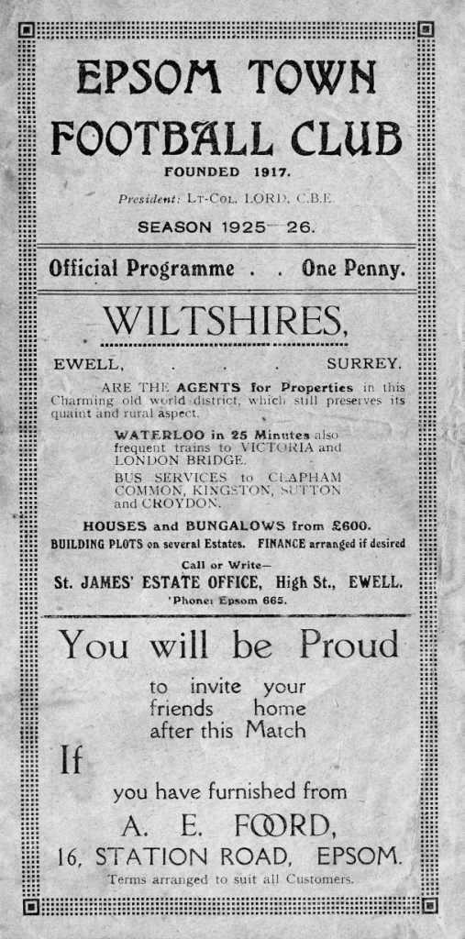
to raise revenue in other ways!

One cup defeat then became two the following Saturday as we slipped up 2-0 at Egham. The club, no connection to the current team from that town who were formed as recently as 1963, played back then at Vicarage Road, a site that now sits under the M25. Just remember that next time you pass by junction 13!

But we still had the League to go for. Last season’s Champions Farnham United Breweries were still the team to beat and we still had them to play twice, but we were in a good position, until February!

We opened up the month with a fine 6-0 win at Addlestone, highlighted by a Parr hat trick, but a 1-1 draw with Camberley & Yorktown at Krooner Park was a bad day at the office. We rebounded with a 5-0 home win over Walton but then lost 2-0 at Leyland Motors. We had suffered two defeats in the league and both had come against them!

This was a blow as next up was the big one. On 6th March we visited Farnham. The papers said that “both teams did their utmost in a very fast game” and “One of the finest exhibitions of football seen in the Surrey Senior League this season" in front of a large crowd.

After a goalless first half the home team took the lead in the opening ten minutes of the second half but while the referee was looking at his watch near the end, Streeter equalised to secure a vital point for us.

We then faced another challenge at Guildford. Although the junior of the two Guildford clubs by that time, they were sharing at Josephs Road for a while and it had boosted their results, with recent wins against Leyland Motors (7-2) and Farnham United

Breweries (7-1). It was a tough and strenuous match but we scored early before conceding in the second half. At the end Bristow missed a penalty that surely would have made the run in a lot more comfortable, but matters were quite clear now, we needed to win our remaining eight matches and we would secure the title.

We were fortunate as seven of those matches were scheduled to be played at home. This then became all eight as the Reigate Priory match on Easter Monday was switched to West Street due to cricket commitments.

We started the important run in at West Street with a 5-0 win over Godalming which took us to the head of the table and then followed it a week later by defeating Egham 3-0. Next up were the Guildford team that we had drawn with recently but they were destroyed 10-3 with Reg Marlow scoring four in front of an attendance of 1,000.

The next match two days later would be easy, or so everyone thought. Reigate Priory were destined to finish at the foot of the table and we had alerady defeated them by eight goals at Christmas. Reg Marlow put us ahead but they equalised right on half time and Marlow netted what proved to be the winner from a Bristow free kick in the second half to give us the narrowest of 2-1 wins.

We then conceded in the first minute at home to Addlestone in our next match but were 4-1 up at the half, winning 5-1 in the end, and on Saturday 17th April we beat Camberley and Yorktown 5-0 in a bad tempered match which ended with a player from each side being sent off, Streeter being the unlucky player for us as he was protecting Reg Sperring who had just been sandwiched. There are however, better ways of protecting a player than swinging a punch in view of the referee!

We had been top for a while, but still couldn’t escape Farnham United Breweries who weren’t giving up their title without a fight. They came to West Street on 24th April 1926, the Saturday after the Camberley match, knowing that a win for them in their remaining games would give them the title instead.

The report advised that the attendance was the largest ever seen at the ground, although a figure wasn’t given. Put it this way, there were many people crowded in the trees surrounding the ground, so it was busy! Some nearly fell out when we extended our lead in the second half, but the lead was reduced and “time crawled” as we saw the match out to win 2-1. We were as good as Champions, as we needed to lose our last match, while they needed to win both of theirs and swing a goal difference of 19!

As it turned out, by the time we hosted Weybridge on Saturday 1st May we were already confirmed, following Farnham’s draw, also with Weybridge in midweek. We strolled through the final match to win 2-1 and Sid Bristow was awarded the trophy that the team then posed with in the photo that was shown at the start of this article.

For “The Town” as they were called back then, this was just the start of a very successful period. We were settled in our brand new home with a league trophy to our name and this would be repeated the following year, with the addition of the League Charity Cup too. The town of Epsom finally had a team of which they could be proud and ninety years on from that success, we continue its legacy.

Player Sponsorship
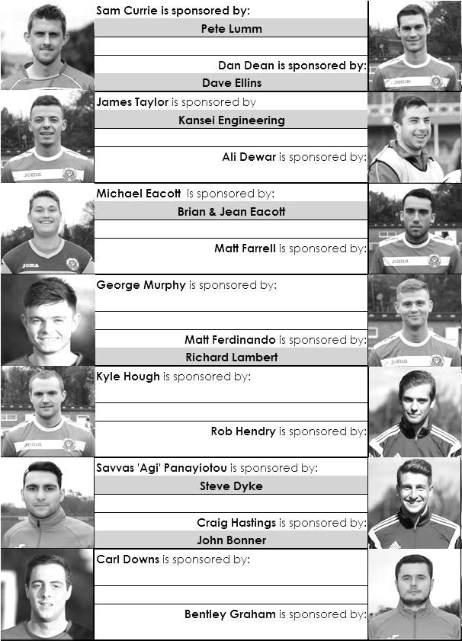

Here is the current list for the 2015/16 season showing all of our players and Management that are currently available for sponsorship this season.

Sponsorship costs just £40 and it is easy to do. Just select a player who has not been previously sponsored and let a Committee Member know that you would like to sponsor them. Beware though. Until we have received the money it is possible for someone to jump in front of you, so don’t delay, sponsor today!
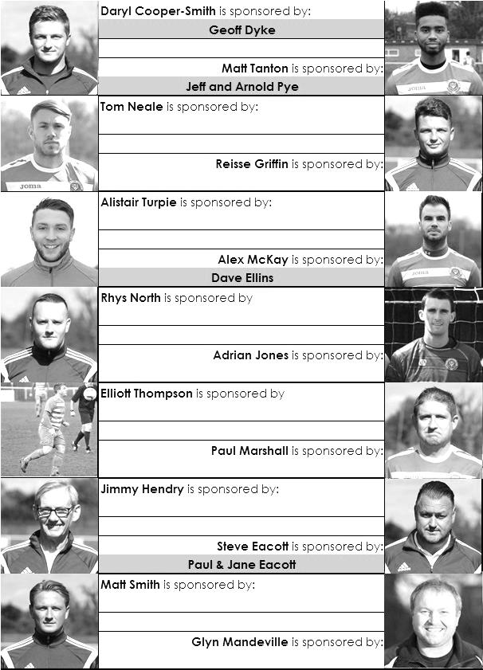

Epsom & Ewell F.C. Club History 1918 - 2015
We were founded in March 1918 as Epsom Juniors Cricket Club and played throughout the summer. In the autumn, Epsom Juniors F.C. came into being and played a handful of games from what is now known as Alexandra Recreation Ground. Competitive football followed as we entered the Surrey Junior League in 1919, and became founder members of the Sutton & District League in 1920.

A change of name in July 1922 to Epsom Town F.C. heralded the start of a very successful era. By now resident at the Horton Hospital Sports Ground, we were unfortunate to lose 2-1 after extra time at Dorking F.C.’s Pixham Lane ground to Caterham Mental Hospital in a replay of the Surrey Junior Cup Final. However, we won three other trophies that season, the Leatherhead Hospital Shield, the Sutton Hospital Cup, and the Epsom Hospital Cup. In addition, we also won the Sutton & District League, and under the forward thinking of their visionary Chairman Hugh Bradley, took the step into Intermediate Football, where we won the Southern Suburban League without losing a match. Senior football was granted as we were unanimously accepted into the Surrey Senior League for 1924/25, where we finished third.

In September 1925, the club relocated to the old Ewell F.C. ground at West Street, which was purchased through the generosity of our future President Robert Bradshaw. In 1925/26 the Championship of the Surrey Senior League was attained, and the following season we defeated Egham 1-0 at Egham in the Charity Cup to complete a League and Cup “double”.

Election to the London League followed, and the title was claimed in the first attempt in 1927/28. Unfortunately, we were unable to repeat this, instead finishing runners-up in 1931/32, 1932/33, 1934/35, 1936/37 and 1937/38. Cup Honours were limited, although in 1929 Redhill defeated us 3-2 in front of 4,600 at Guildford in our first Surrey Senior Cup Final, having seen off Wimbledon 4-1 in the semi-final!

The thirties were a very successful era, and we won the Surrey Charity (Senior) Shield in 1933 with an impressive 5-0 win over Woking at Kingfield. However, the proudest moment of our pre-war history was an appearance in the First Round Proper of the F.A.Cup in 1933/34. Woking, Nunhead, Tooting & Mitcham, Beddington Corner, and Leytonstone were defeated, and a crowd of 9,485 at the Lea Bridge Speedway Stadium witnessed a 4-2 loss against the hosts Clapton Orient. At the end of that season our name changed to Epsom F.C.

In 1939 a newly formed team, Epsom Town (no connection to the earlier name) shared the ground with Epsom F.C. However, this arrangement was suspended when war was declared, and we folded for the duration. Disappointed with the decision, our Club Chairman Charles Pettett threw in his lot with Epsom Town in an attempt to boost morale by keeping the football flag flying. It was successful, as that club competed continuously throughout the war years, winning the Surrey Combination in 1939/40, and reaching the Surrey Senior Cup Final in 1944, losing 3-1 to Tooting & Mitcham, at Sandy Lane. After the war, Epsom F.C. restarted, continuing in the London League and reclaimed West Street. Temporary homes were found for Epsom Town while they competed for a season in the newly created Corinthian League, but disbanded in 1946.

In 1949 we entered the Corinthian League ourselves, where in 1952 we reached the League Memorial Shield Final in 1952, going down 2-1 to Champions Hounslow at Eastbourne after

leading at half-time. Things improved further with the signing of the former English Amateur International Pat Lynch from Hendon, finishing third in 1952/53, while in 1954 we reached the Surrey Senior Cup Final for the second time in our history, losing unluckily 2-0 to Corinthian Casuals in front of 6,159 at Selhurst Park. In 1955 we won the Surrey Senior Shield with a 1-0 win over Carshalton Athletic at West Street.

We appointed our first ever Manager, Kingstonian legend Doug Whitehead in 1955 and the Corinthian League double was almost achieved in 1956/57, but two losses in the final week, along with a 2-0 defeat in the Cup Final to Maidenhead United at Dorking ensured that we ended with neither, finishing fourth. However in 1960, we finally raised the Shield with a 2-0 revenge win over Maidenhead at Vale Farm, home of Wembley F.C.

In 1960 we changed our name once again to Epsom & Ewell F.C. This was not because of any merger with Ewell & Stoneleigh as is often quoted, but was an attempt to increase support across the whole of the Borough. In 1963 the Corinthian League merged with the Athenian and Delphian Leagues, and we were placed in Division One of the new structure, but the sixties were full of poor results and we were relegated in 1965.

Despite a string of managers, most notably ex-Leyton Orient winger Jimmy Smith, and Tony Williams, now famous for his creation of the F.A. Yearbooks, our fortunes did not improve significantly and further relegations were avoided in the early seventies by the benefit of re-election. However in 1973, despite “improving” to finish second from bottom, the Athenian League ran out of patience and cut us loose. This was unfortunate timing as we had just cleared all of our debts, and in addition to a virtually new Committee, former Fulham player Pat O’Connell had taken over as Manager.

The Surrey Senior League took us in at the last minute, and the new squad, including young striker Tommy Tuite, won the League Cup, and the following season, 1974/75 achieved a second Surrey Senior League “double”. However, the season would always be remembered for reaching the Final of the inaugural F.A. Vase, where 9,500 saw the Blues edged out 2-1 by Hoddesdon Town at Wembley Stadium. The Athenian League welcomed us back, and promotion to the top flight was achieved in that first season. In 1976/77 we reached the Athenian League Cup Final, losing 1-0 at Chalfont St Peter.

For 1977/78 many clubs were invited to join the expanding Isthmian League, and we were placed in the new Division Two. Our first match under floodlights took place against Met Police, and the title was clinched the following April. In 1979/80 we won the Southern Combination Cup 7-2 over Hampton on their own pitch, where the opposition were blitzed by five goals from Tuite. The following season a new clubhouse opened at West Street, and we finally won the Surrey Senior Cup, defeating Woking 2-1 at Tooting & Mitcham, although we just missed out on promotion. In 1983/84 we clinched a spot in the Premier Division as runners-up, although this time we missed out in the Surrey Senior Cup Final, defeated 4-0 by Sutton United at Imber Court.

With Adrian Hill as Manager since 1982, we survived comfortably in our first season at the new level, but Hill’s departure to Croydon in 1985 started a decline. Much of the squad left with Hill, and new Manager Alan Webb had too much to do. We were relegated in 1986, and following Webb’s departure soon after, Player / Manager Ricky Kidd nearly but not quite saved us from our second straight relegation. Adrian Hill replaced Kidd for a second spell at the helm in 1990, but we were placed in the new Division Three in 1991 in league

reorganisation following a finish one position below the required half way mark.

In 1993 a large chapter in our history ended as we left West Street and moved in as tenants of Banstead Athletic. The decade was largely one of frustration, although we did reach the Final of the Associate Members Trophy, losing 2-0 to Bedford Town at Hendon’s old Claremont Road ground.

In 2002 Adrian Hill took us back up to Division 1 South, where we topped the table for a month, eventually finishing 9th, but Hill’s retirement at the end of the season led to relegation a year later and in 2006 we were transferred into the Combined Counties League Premier Division. In October 2006 Lyndon Buckwell, a former player became our new Manager, and in his first full season (2007/08) we were back in the top ten. In 2008/09 we exceeded this achievement and finished in fourth place after heading the table for a few months. In 2009/10 the club recovered from a slow start to finish fifth and also reached the last 32 of the F.A. Vase for the first time in 21 years, bowing out 3-2 in Northamptonshire to Long Buckby. In April of 2010 we terminated our seventeen-year ground sharing agreement with Banstead Athletic and spent two unspectacular seasons at Merstham F.C. before relocating to High Road, home of Chipstead F.C. for the 2012/13 season.

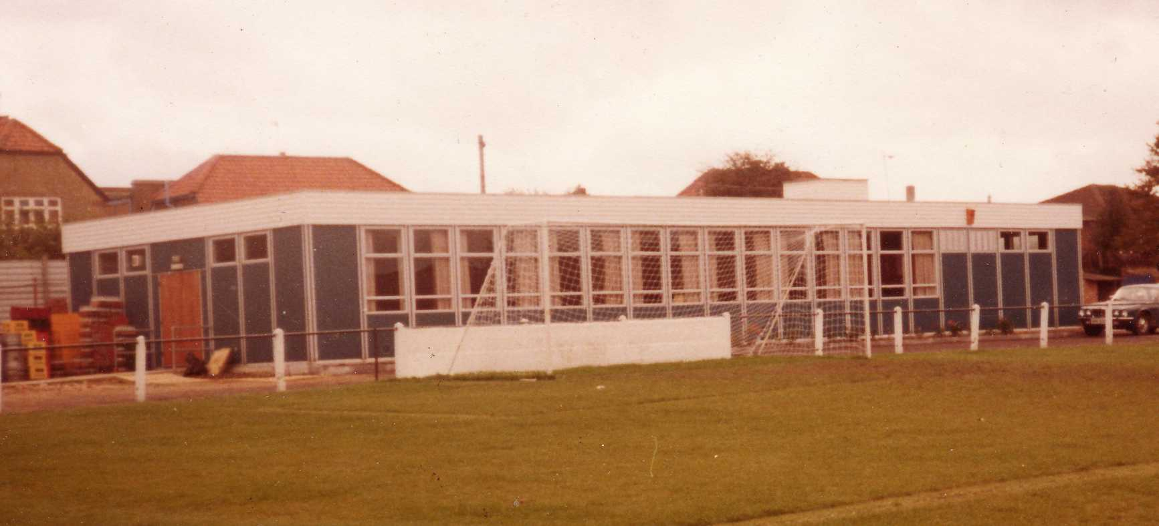
The season brought significant playing success as a slow start was followed by a spectacular run of form, including a club record 12 straight League wins, which put us at the top of the table for over a month before a tough run in resulted in a final position of fifth. However, any disappointment there was tempered by the club’s first silverware since 1981 when we defeated South Park 3-0 at Farnborough to win the Combined Counties League Cup. Lyndon also marked 300 games in charge of the club in early 2013. On a sadder note, 2012/13 also marked one thousand games and twenty seasons since we left West Street.

We carried our fine form into 2013/14 and led the league with eight straight wins but couldn’t hold on and had to settle for third place, our highest league finish since 1984, but the following season Lyndon Buckwell departed and Glyn Mandeville and new Assistant Matt Smith steered the club to seventh place, despite a substantial budget cut. We continue at High Road for 2015/16.

Meanwhile, the search continues for a new ground back in the Borough…..

End of Season Presentation – 2nd May
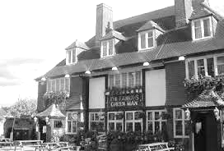
Following our League match at Chessington & Hook United on Monday 2nd May, we will be having our End of Season Presentation. The event starts at 3pm and will run until fairly late at the Famous Green Man pub in Ewell Village, less than quarter of a mile from our old ground in West Street.

What many of you will not know is that the club used to meet here frequently back in the nineteen twenties and thirties! Before we had a Clubhouse this was the venue for our post-match hospitality with many awards and presentations being made here.

Back in those days the after match festivities were quite grand affairs and were all very formal. I suspect ours will be a little less so!

Tickets are £5 and include food, so if you want to come along and meet the team, just let a Committee Member know!

Final words
It is now nine years since I compiled my first match programme and some things have changed significantly in that time, while others have stayed the same.

Take the programme for example. That first match against Colliers Wood United was a clumsily put together 16 page issue that didn’t look like the new Editor knew what he was doing, which was in fairness totally true! Today’s issue, a mammoth 96 pages is the largest that I or the club have ever produced, and bearing in mind that it has just the two mandatory League adverts between its covers, I hope that you have found plenty in here to keep you occupied whether you are a home supporter or even a visitor.

Upon producing a large issue for the League Cup tie with Guernsey a few seasons back, I joked that they could start reading it in the departure lounge at Gatwick and they still wouldn’t have finished by the time they landed back on the island! This time, I hope I’ve given people something to take up their entire summer, or at least to take your minds off things while the England team are playing in the Euros!

Although I enjoy producing the programmes, there is a serious side to this. We obviously have no social facilities to call our own and whilst we are extremely grateful to Chipstead F.C. we are unable to raise revenue through their clubhouse. This means that we have to raise the profile of the club through other means and the programme and website are the routes I have chosen to achieve this.

Another thing that has changed at the club is the playing budget. Most of you would have been unaware that we cut the amount quite significantly at the start of season 2014/15. But to look at our league positions of seventh last season and fourth, you would not have known there had been a difference. It is therefore to our Manager, Staff and Players that I give my first thank you.

We play exciting and entertaining football and whilst we can play some lovely stuff on the deck, we are also able to change our plans if required, as evidenced by or two matches against Camberley this season. How we only ended up with a single point from those two matches is a feeling similar to that of being tricked by the magician Dynamo. You know something has gone missing but have no idea how it happened!

A special congratulation goes to Kyle Hough who has been a model of consistency throughout an almost unbroken run. Although I have been a supporter since before he was born, my time as Programme Editor has coincided with his as a player, as he made his debut against Colliers Wood United back on that very same day of my debut issue, 14th August 2007.

Both of us have had one season away from our roles, but otherwise have been fully committed to the Epsom cause and he has gone on to become a real club legend that thoroughly deserves to be mentioned in the list of truly great players who have represented his club. It was a real privilege to be behind the goal on Saturday when he smashed his 200th in. I really hope he returns next season because all the signs are there for us to have a great season and who knows how many more he could score, given even more opportunities!

Another situation that has remained consistent, albeit somewhat frustratingly, has been our search for a new ground. Without disclosing anything sensitive, I can advise that in my time on the Club Steering Committee, we have considered a number of options within the Borough but have found our way blocked by logistics or cost at almost every turn. Pete has referred earlier in this programme to negotiations that continue and without doubt these are still live. Other options do also remain available to us, but it’s fair to say that if we do not have our own site confirmed within 12 months, we as a Committee may have to make some very unpopular decisions to keep the club alive in the future.

“What can I do to help?” you might ask. Well, on the ground negotiations themselves, very little at present, although this situation could change rapidly even during the summer. All we ask is that you keep supporting the club. That doesn’t just mean turning up, watching and going home. Any ground we create will cost money and we simply no longer have enough, so will be reliant on grants to top up what we have. It therefore goes without saying that the less we spend, the more we have available and the more we can receive in financial help as a result.

So the challenge to ALL supporters is quite clear. Next season should be an exciting one so there is every reason to come and watch, but more than that, bring your friends, relatives, rich uncles etc! Seriously though, anyone can sponsor a match or player and you don’t have to wait until next season to do so. Likewise, if any of you have connections with companies, please consider helping us as I believe such donations are also tax friendly. We have a great kit sponsor but would also love to have a Club Sponsor too. You know where we are, so just drop us a line please!

This is where my next batch of thank yous come in. We are extremely grateful to Intercem, our kit sponsor and also to The Building Shop, Bookham and Kansei Engineering who have all been very generous, while Marvin Hough has gone above and beyond the call of duty by sponsoring three of our matches. Thank you all. I would also like to thank Intercem and their top man Malcolm Shelbourne once again for their contribution towards the costs of today’s programme.

Normally at this stage of the season I throw out an enormous amount of thanks to the people behind the scenes, but our Chairman has covered this eloquently, so there is little point in repetition.

What I will do is to thank those people who have helped me with the programme during the season. All season Glyn Mandeville and Sam Currie have provided me with their views and insight, while Sam also collected and chased all the players for the profiles that you have seen throughout the season’s issues.

I also received some help with the match reporting with Sam Brooker and then later on Patrick Kaloe helping me out when I was provided with an enforced break for giving my personal views on the Surrey F.A. My views haven’t changed; I’m just not allowed to write them, even on my personal account in these sad days where free speech is now no longer as free as it might have been for fear of offending someone out there, or worse still that strange creation, the individual who will be offended on someone else’s behalf. Where did these people actually come from? Political correctness is strangling this country and at some point I will probably transgress again!

I must also thank Gemma Jarman for her fantastic photos. She frequently gets the goals, which is an enormous test of concentration, and when she doesn’t, it’s usually because I’m talking to her

Finally, I will also thank The Print Centre, who are based in Epsom and we have had very few issues this season.

Our supporters have been great and have often outnumbered their opponents on their own grounds. I will not name them as I tried to do last year, because it cost me too much in drinks for the ones I missed! You all know who you are and thank you for your support. I know the players are grateful for the support too.

Consistency can be very good and is something that we have in spades at Epsom & Ewell F.C. We have a number of players with many appearances to their name and in Glyn Mandeville we have just our ninth different full time Manager in 43 years. We still have a number of supporters that remember us playing at West Street, even though our last match there was 23 years ago next Friday. These are all good things. I just hope that by the time we all congregate here next August we will finally have some news on the ground front that means I don’t have to give the same old consistent answer when people ask me if there is any news. “Sorry, nothing yet!”

Match and Ball Sponsorships – 2015/16
Opponent | Date | Match Sponsor | Match Ball Sponsor
Hoddesdon Town | 18/07/15 | Geoff Dyke
Windsor | 08/08/15 | Club President - Stella Lamont
Erith & Belvedere (FAC) | 16/08/15 | Committee Member - Mike Lovett
Raynes Park Vale | 31/08/15 | EEFC Management Committee
Colliers Wood United | 08/09/15 | Bookham Building Shop – www.buildingshop.co.uk
AFC Hayes | 19/09/15 | John Bonner
Farnham Town | 26/09/15 | Ezara and Inaya Beddoe – our youngest supporters!
Chertsey Town | 17/10/15 | Club Media Officer – Richard Lambert
Dorking Wanderers (SSC) | 20/10/15 | Tony Ferdinando
Chessington & Hook United | 07/11/15 | Paul Merritt
Hanworth Villa | 21/11/15 | Maggie Beddoe
Guildford City | 05/12/15 | Pete Lumm
Sutton Common Rovers | 19/12/15 | Marvin Hough
Ashford Town (Mx) (LC) | 12/01/16 | Pete Beddoe & Steve Dyke
Redhill | 02/02/16 | David Lawton
Bedfont Sports | 13/02/16 | Bookham Building Shop – www.buildingshop.co.uk
Hartley Wintney | 23/02/16 | EEFC Management Committee
Horley Town | 27/02/16 | Jeff and Arnold Pye
Spelthorne Sports | 01/03/16 | In memory of Chris Henry
Knaphill | 12/03/16 | Marvin Hough
Cove | 15/03/16 | Mark & Carmel Murphy
Westfield | 26/03/16 | Nathan Lambert
Badshot Lea | 09/04/16 | Tony Coome
Camberley Town | 16/04/16 | Marvin Hough
Ashford Town (Mx) | 30/04/16 | Club President - Stella Lamont
Ashford Town (Mx) | 30/04/16 | Brian Eacott | Steve Dyke
For League, League Cup and Surrey Senior Cup Matches:
Match sponsorship - £40.00 Match ball sponsorship - £25.00. Combined £55.00.

We can still take more sponsors – Any game can have more, or why not sponsor a player?

Sponsorship includes: ( x2 for match, x3 for match and ball )

Admission, programmes, hospitality, advertising and mascot for the day (if required ).
If you are interested, just speak to a Committee Member, or drop me an email at: richard.c.lambert@gmail.com

We also thank our Kit Sponsors INTERCEM

Salts Super Six Predictor
The Salts Super Six Predictor Competition is live for the final time this season and the tickets are on sale at today’s game. We have now had three Super Six winners but the jackpot is building up again already!

The competition is easy to play! To win, you simply need to predict the results of the six matches correctly from the three options, fill in the form and make sure it is back with our sellers before the deadline on the ticket.

If you are a club regular, you just need to place your name on the sheet, although if you aren’t, then we’ll need a contact number from you too. We will announce any winners on the website very quickly, so don’t worry we won’t miss you!
The jackpot is already at £208 and who knows how high it could go this time!

Please note that if there is more than one winner, the prize pot would be shared between the winners. All you need to do now is have a go, as many times as you like!

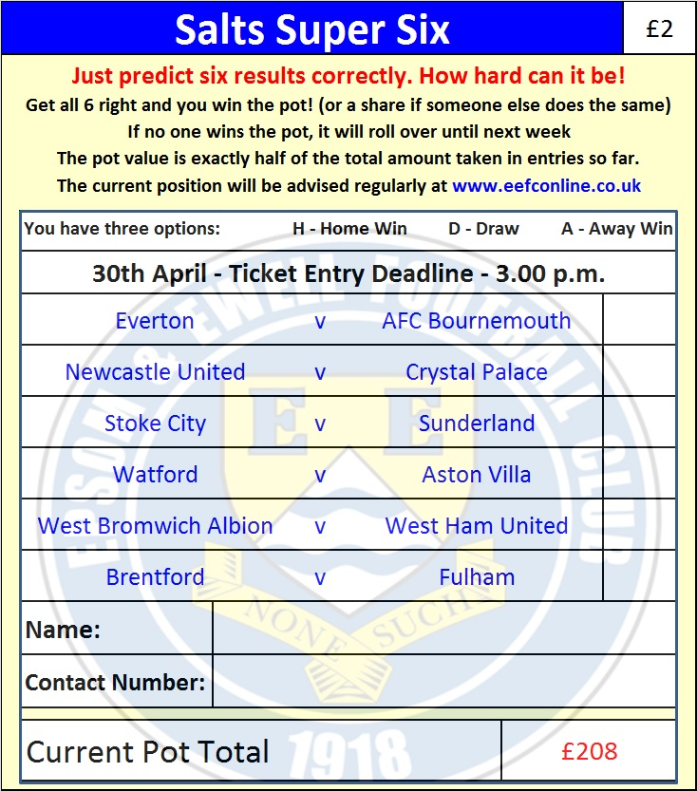

Good luck!

Combined Counties League – Premier Division
Saturday, 30th April 2016 - Kick-off 3.00 p.m.
Epsom and Ewell  (Royal Blue & White hoops) | V |  | Ashford Town (Mx)  (Tangerine & White)
Squad | NUMBERS
Michael Eacott |  |  | Tyler Tobin
James Taylor |  |  | Josh Andrew
Matt Tanton |  |  | Alex Fisher
© Dan Dean |  |  | Will Boye
Craig Hastings |  |  | Bayley Mummery
Bentley Graham |  |  | Samad Kazi
Savvas ‘Agi’ Panayiotou |  |  | Mark Bitmead
Matt Farrell |  |  | Scott Weight
Kyle Hough |  |  | Dan Fleming
Daryl Cooper-Smith |  |  | Tom Brunton
Reisse Griffin |  |  | Jack Beadle
Sam Currie |  |  | Max Webb
Elliott Thompson |  |  | Scott Harris
Rob Hendry |  |  | Bradley Wainwright
Tom Neale |  |  | Russell Canderton
Matt Ferdinando |  |  | Perry Luckins
Alistair Turpie
Alex McKay
Rhys North
George Murphy
Adrian Jones
Glyn Mandeville | MANAGER |  | Ben Murray
Matt Smith | ASSISTANT |  | Mark Green
Steve Eacott / Alex McKay / Jimmy Hendry | COACHES / PHYSIO |  | Pat Munns
REFEREE: Z.Ellis (Wimbledon)
ASSISTANTS: R.Wells (Coulsdon), R. van Niekerk (Sutton)
Today’s Match and Match Ball are sponsored by:
Club President Stella Lamont,
regular supporter Brian Eacott, grandfather of our keeper Michael, and Club Treasurer Steve Dyke

THANK YOU FOR YOUR SUPPORT – SEE YOU NEXT SEASON!

